Manual Thermion Duo
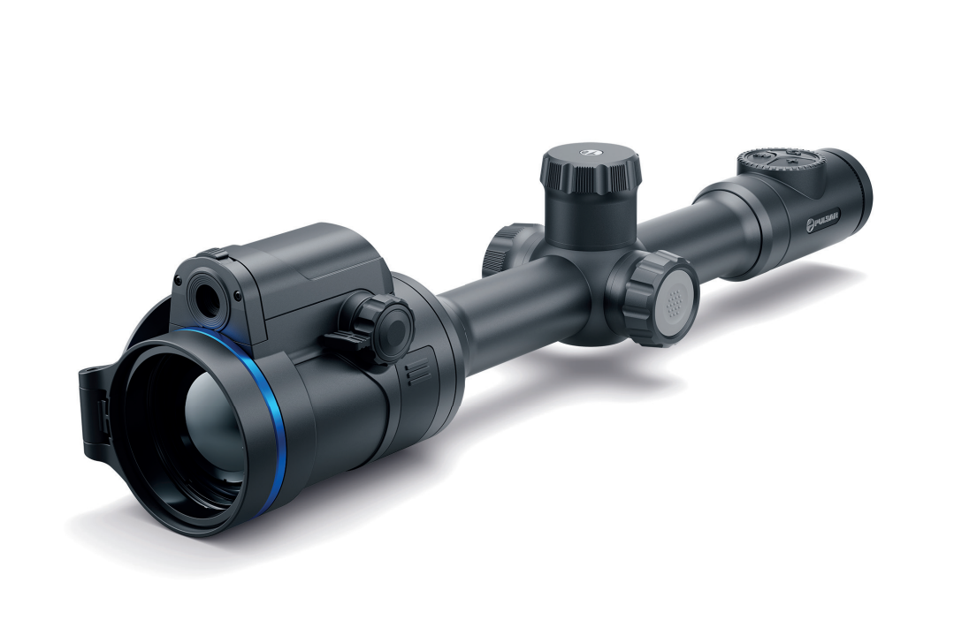

Specifications
You can learn more about the main parameters here.
Model | DXP50 | DXP55
SKU | 76571 | 76572
Microbolometer
Type | uncooled
Resolution, pixels | 640x480
Pixel Pitch, µm | 17
NETD, mK | < 25
Frame refresh rate, Hz | 50
Digital Sensor
Type | CMOS
Resolution, pixels | 3840x2160
Optical Specifications
Lens, mm:  - Thermal imaging channel  - Digital channel | F50 F/1.0  F17 F/4.34 (non-focusing lens) | F50 F/1.0  F35 F/4.34 (non-focusing lens)
Magnification, x:  - Thermal imaging channel  - Digital channel | 2-16  2-16 | 2-16  4-32
Eye relief, mm/inch | 50/1.96
Field of view (H), °/m@100:  - Thermal imaging channel  - Digital channel | 12.4/21.8  12.4/21.8 | 12.4/21.8  6.1/10.6
Diopter adjustment, D | -3/+5
Detection distance (Thermal imaging channel, object of "deer" type), m/y | 1800/1968.5
Aiming Reticle
Click value, mm@100 m – when magnifying, x | 21.3 – 2х  10.7 – 4х  5.3 – 8х  2.7 – 16х | Thermal imaging channel | Digital channel
 |  | 21.3 – 2х  10.7 – 4х  5.3 – 8х  2.7 – 16х | 10.3 – 4х  5.2 – 8х  2.6 – 16х  1.3 – 32х
Click range, mm@100 m (H/V) | 4250/4250
Display
Type | AMOLED
Resolution, pixels | 1024х768
Operating Features
Diameter of the riflescope body to assemble the mounting rings, mm | 30
Power Supply, V | 3–4.2
Battery type / Capacity / Rated Output Voltage | Li-Ion Battery Pack АPS2 / 2000 mAh / DC 3.7 V (removable)  or  Li-Ion Battery Pack APS3 / 3200 mAh / DC 3.7 V (removable)*  Li-Ion Battery Pack APS5 / 4900 mAh / DC 3.7 V (built-in)
External Power Supply | 5 V, 9 V (USB Type-C Power Delivery)
Battery Packs (built-in APS5 and removable APS2) operating time at temp. = 22 °C, hrs** | 6
Max. recoil power on rifled weapon, Joules | 6000
Max. recoil power on smoothbore weapon, caliber | 12
Degree of protection IP code (IEC60529) | IPX7
Operating temperature, °С / °F | -25 – +50 / -13 – +122
Dimensions with an eyecup, mm/inch | 420x78x83.5 / 16.54x3.07x3.29
Weight (with APS2 battery), kg/oz | 0.96 / 33.86
Video Recorder
Photo / video resolution, pixels | 1024x768
Video / photo format | .mp4 / .jpg
Built-in memory | eMMC 16 GB
Wi-Fi Channel***
Frequency | 2.4/5 GHz
Standard | IEEE 802.11 b/g/n/ac
* Purchased separately.
** The actual operating time depends on the intensity of using Wi-Fi, video recorder and operating observation channels.
*** The reception range may vary depending on various factors: obstacles, other Wi-Fi networks.

About the device

Description
The Thermion Duo multispectral riflescopes are designed for use on hunting rifles.
The riflescope allows you to quickly switch between thermal imaging and colour digital channels, and also supports PiP multispectral mode, when the image of one channel is displayed in the main window, and the second – in the PiP “window”.
These riflescopes are designed for hunting, target shooting and recreational shooting, observation and orientation.

To get started, see the sections:
Battery Charging
Battery Installation
Mounting on the Rifle
Powering on and Image Setting
Image Modes (Thermal Imaging/Digital/Multispectral PiP)
How to Zero
Stream Vision 2

Package Contents
- Multispectral riflescope
- Removable rubber eyecup
- АPS2 Battery Pack
- APS battery charger
- Power adapter
- USB Type-C cable with USB Type-A adapter
- Carrying case
- Lens-cleaning cloth
- Quick User Manual
- Warranty card
- APS3 battery cover

Components and Controls
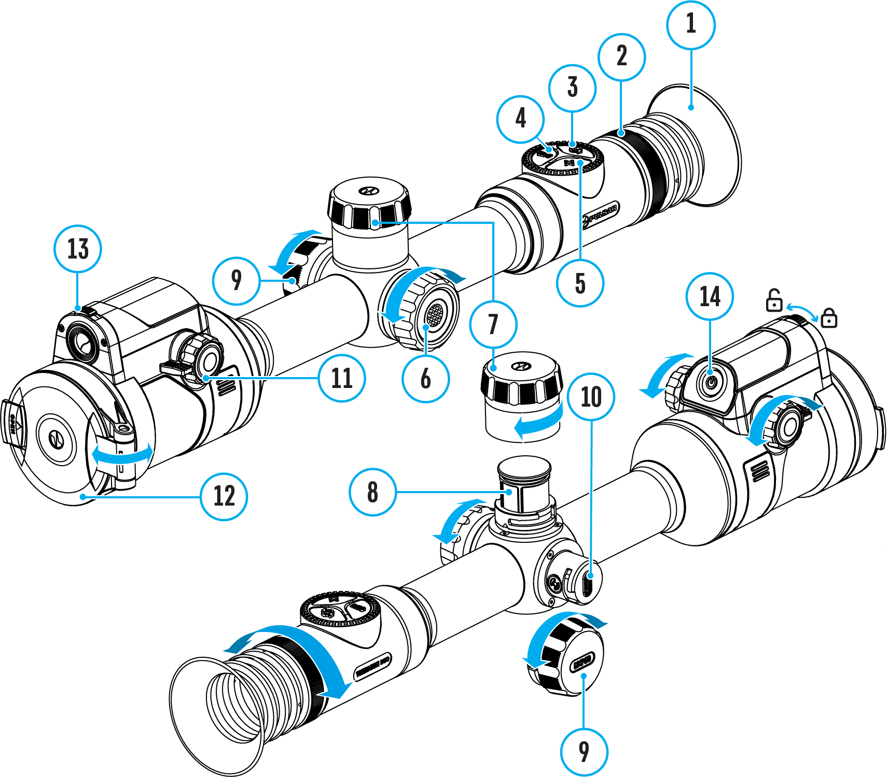

- Eyecup
- Eyepiece diopter adjustment ring
- MODE button
- REC button
- ZOOM button
- Controller
- Battery compartment cover
- Battery APS2
- USB Type-C cover
- USB Type-C port
- Thermal channel lens focus knob
- Thermal channel lens cover
- Digital channel lens open/close switch
- ON/OFF button

Features
- 3 modes of operation: thermal imaging, colour digital and multispectral PiP
- 3 levels of sensitivity enhancement for the thermal imaging channel: Normal, High, Ultra
- 3 microbolometer calibration modes: manual, semi-automatic and automatic
- Smooth Digital Zoom
- Multiple reticle options
- Scalable reticles (proportional to Zoom)
- 5 zeroing profiles (10 distances per profile)
- One-shot “Freeze-Zeroing” function
- Precise “Zoom zeroing” (reducing the MOA per click when zooming in)
- 8 colour palettes in thermal imaging mode and multispectral PiP mode
- Pixel repair function
- “Display-Off” function
- Built-in 3-axis accelerometer gyroscope (slope angle indication)
- Stadiametric rangefinder (estimate distance to object)
- Integrated Wi-Fi for remote control and personal device connectivity
- Device firmware update using the free Stream Vision 2 App
- High-strength aluminium alloy housing
- Recoil rated to .375H&H, 9.3x64 and 12-gauge

Video Recording
- Built-in photo and video recorder with audio
- 16 GB internal memory
- iOS and Android compatible
- Storing photos and videos in Cloud when using the Stream Vision 2 App

Battery Pack
- Built-in 4900 mAh Battery Pack APS5
- Quick-change rechargeable Li-Ion APS2/APS3 battery packs
- Internal and external battery charging via USB Type-C port

Power supply

Precautions
- Only use the charger supplied with the Battery Pack. The use of any other charger may irreparably damage the Battery Pack or the charger and may cause fire.
- Do not charge the Battery Pack immediately after bringing it from a cold environment to a warm one. Wait for 30-40 minutes for the Battery Pack to get warm.
- It is not recommended to charge the batteries with a charger connected to the USB port of a computer or laptop. It can damage the computer.
- Do not leave the Battery Pack unattended while charging.
- Never use a modified or damaged charger.
- Do not leave the Battery Pack with a charger connected to the power adapter after charging is complete.
- Do not expose the Battery Pack to high temperatures or an open flame.
- Do not submerge the Battery Pack in water.
- Do not connect an external device with a current consumption that exceeds permitted levels.
- Do not dismantle or deform the Battery Pack.
- Do not drop or hit the Battery Pack.
- Keep the Battery Pack out of the reach of children.

Recommendations for Battery Use
- During long-term storage, the Battery Pack should be partially charged – the charge level should be between 50% and 80%.
- Charge the Battery Pack at a temperature from 0° C to +45° C (32° F to +113° F), otherwise the battery life will decrease significantly.
- When using the Battery Pack at sub-zero (sub 32° F) temperatures the battery capacity decreases. This is normal and is not a defect.
- Do not use the Battery Pack at temperatures above those shown in the table – this may decrease battery life.
- The Battery Pack is short circuit protected; however, any situation that may cause short-circuiting should be avoided.

Battery Charging
Thermion Duo riflescopes come with a built-in rechargeable lithium-ion Battery Pack APS5 and a removable rechargeable lithium-ion APS2 Battery Pack. The batteries should be charged before first use.
The icons in the status bar will flash when the battery is low. The batteries need to be charged.

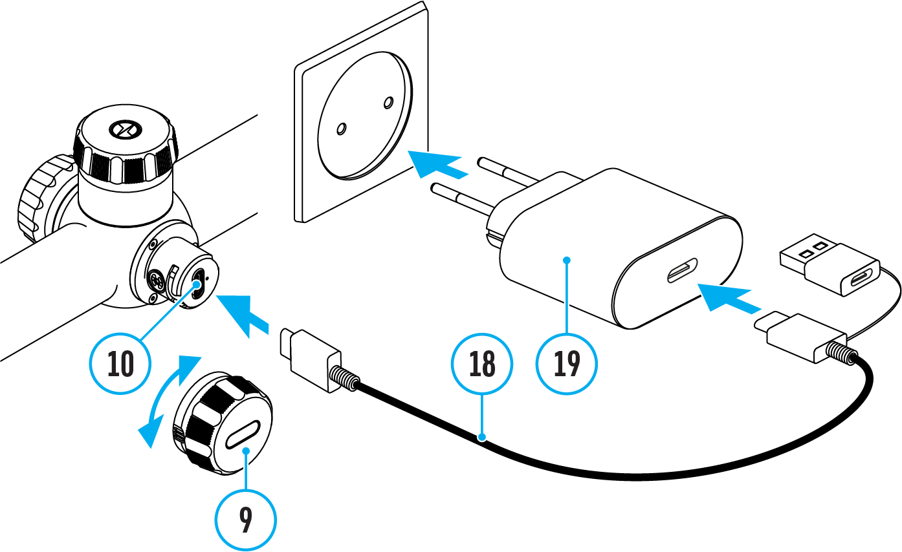
- Open the USB Type-C cover (9) by turning it counterclockwise.
- Connect the USB Type-C plug of the USB cable (18) to the USB Type-C port (10) in the body of the riflescope.
- Connect the second USB plug of the USB cable (18) to the USB port on the power adapter (19).
- Plug the power adapter (19) into a 100–240 V socket.
- Wait until the batteries are fully charged (indication in the status bar: 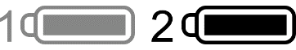).
Attention! When charging rechargeable batteries with a USB Type-C connector (10) in the riflescope body section, charging priority is given to the built-in battery. When the device is off, both batteries are charged at the same time. When using the device, the external battery is discharged first.

The rechargeable lithium-ion APS2 and APS3* Battery Packs may be recharged using the APS** charger
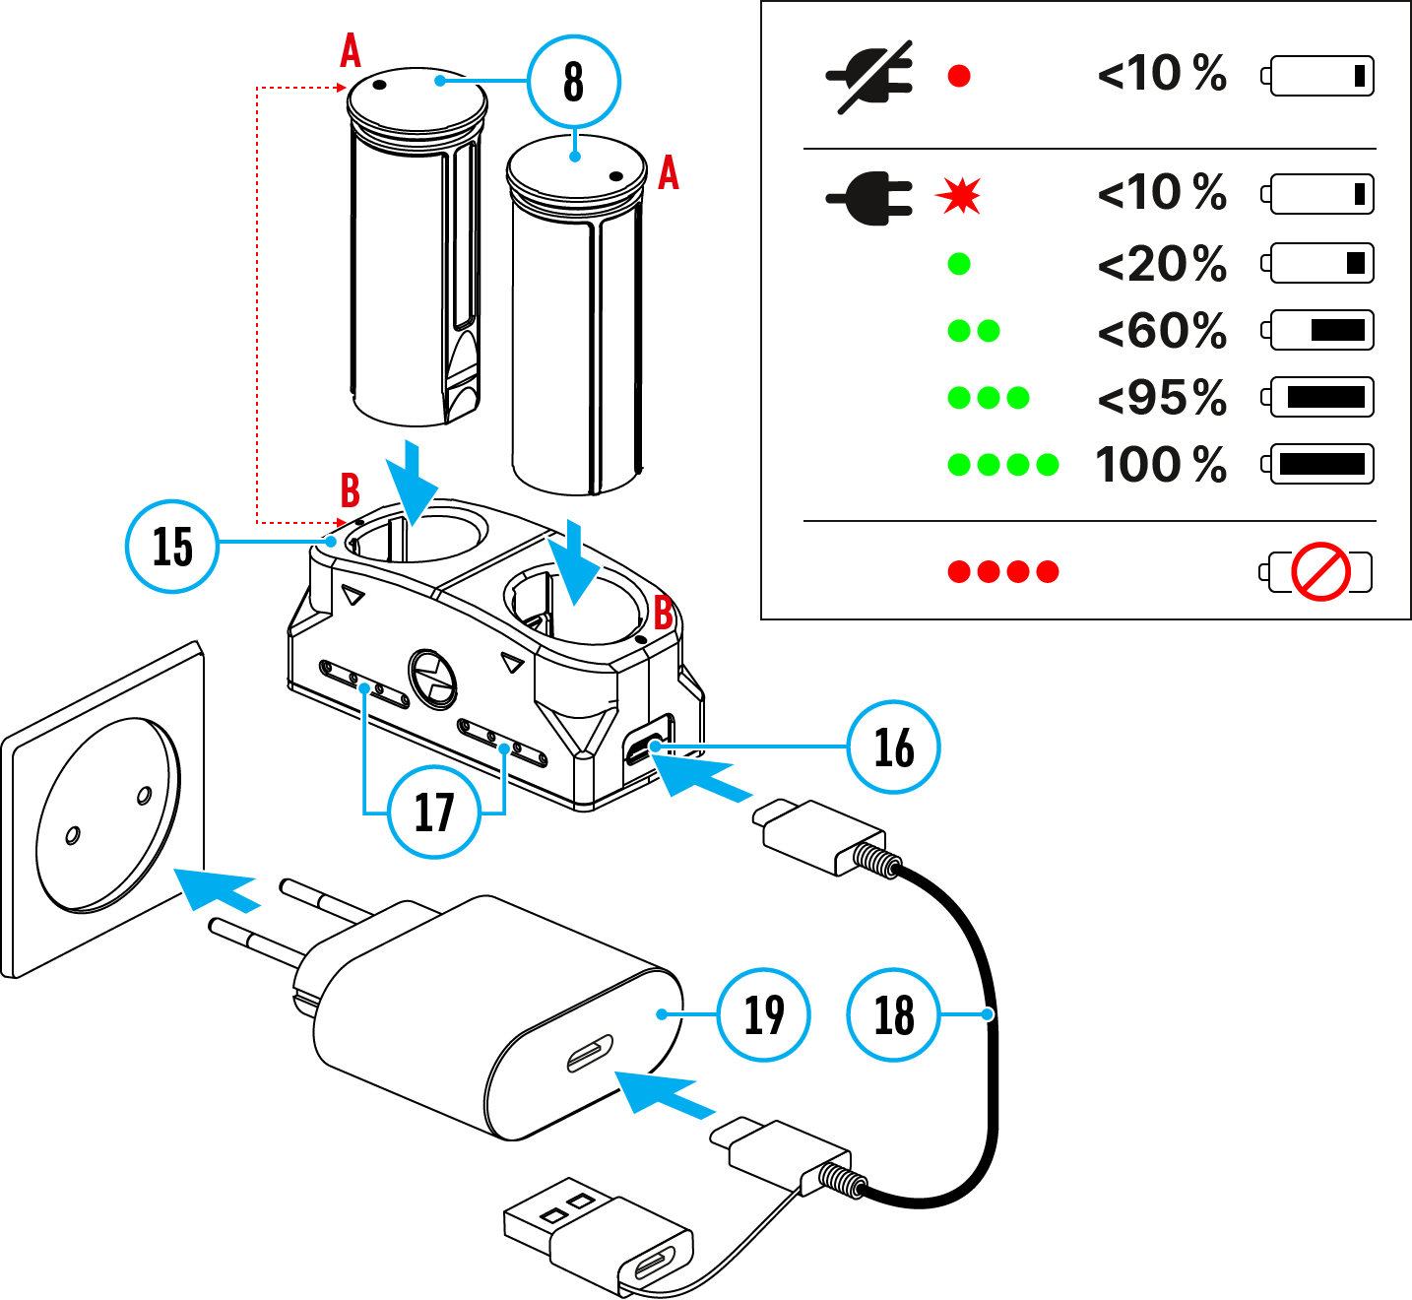
- Insert the Battery Pack (8) along the rail into the APS charger (15) slot as far as it will go. The APS charger is supplied with your device or purchased separately.
- Point A on the battery and point B on the charger should match.
- Connect the USB Type-C plug of the USB cable (18) to the port (16) of the charger (15).
- Connect the second plug of the USB cable (18) to the USB port on the power adapter (19).
- Plug the power adapter (19) into a 100-240 V socket.
- The LED indicator (17) will display battery charge status.
- Wait until the battery is fully charged (LED indication (17): ).
- Two batteries* can be charged at the same time.
(17) LED Indicator*** | Battery Charge Status
 | Battery level is from 0% to 10%. Charger is not connected to a power supply.
 | Battery level is from 0% to 10%. Charger is connected to a power supply.
 | Battery level is from 10% to 20%.
 | Battery level is from 20% to 60%.
 | Battery level is from 60% to 95%.
 | Battery completely charged. Charging will automatically stop. The battery can be disconnected from the charger.
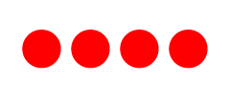 | Defective battery. Do not use the battery.
* Purchased separately.
** Included in the delivery package.
*** LED indicator displays the current battery charge status for 30 seconds when the APS charger is not plugged in. When the power is being supplied, the indicator is constantly displaying the current battery charge status, the LEDs are additionally flickering to display the battery charging process.

Battery Installation
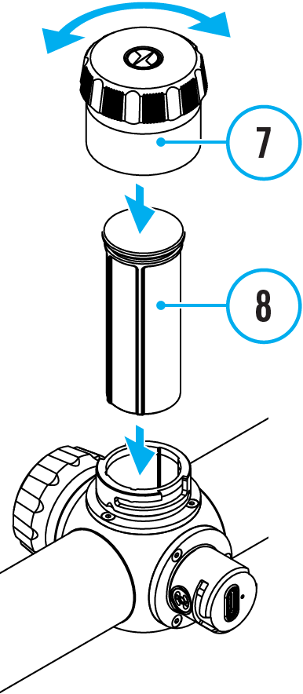
- Turn the battery cover (7) counter clockwise and remove.
- Install the battery (8) into the battery compartment along the special guides in the device casing designed for it.
- When properly installed, the battery is locked into the slot with a special clip.
- Close the battery cover (7) by turning it clockwise.

Switching and Changing the Batteries
Thermion Duo riflescopes are powered by 2 batteries: built-in Battery Pack APS5 and removable Battery Pack APS3/APS2.

- If there are two batteries in the device, two battery icons are displayed in the status bar (1 - built-in battery, 2 - removable battery). The device battery is displayed in grey and white; it is grey when inactive.
- When there is no removable battery in the device, only one icon for the built-in battery displays in white in the status bar.
- When both batteries are fully charged, the device is powered by the removable battery. If there is low removable battery level, the device will switch to the built-in battery.
- Battery charge level is displayed in % above the icon in the status bar while charging.
- It is possible to replace the removable battery even while the device is on.

Attention! When installing a removable battery with a sufficient charge level, the device will automatically switch to it.

External Power Supply
Power can be supplied from an external source such as a 5 V or 9 V power bank.
- Connect the external power supply to the micro USB Type-C port (10) of the riflescope.
- The riflescope switches to external power source, while built-in Battery Pack APS5 and removable Battery Pack APS2 (or APS3*) will gradually recharge.
- A rechargeable battery icon 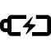 indicating a percentage of the battery life will appear in the status bar.
- When you turn off external power source, the riflescope switches over to the removable battery without turning off. When there is no removable battery or low power level the device switches to the built-in battery.
* Available separately

Warning! Charging APS2 / APS3 / internal APS5 batteries at air temperatures below 0° C (32° F) may reduce battery life. When using external power, connect the Power Bank to the device after it has been turned on and working for several minutes.

Getting Started

Mounting on the Rifle
To ensure accurate shooting the Thermion Duo riflescope should be properly mounted on the rifle.
- Mount the riflescope with 30mm scope rings or a single-piece scope mount, purchased separately. Use only high-quality mounts and rings compatible with your rifle. Follow the mount manufacturer's installation instructions and use the proper tools.
- When mounting the riflescope, adjust the position of the scope on the rifle to achieve optimal, comfortable eye relief as specified by the Technical Specifications. Failure to comply with this recommendation may result in injury to the shooter.
- Install the riflescope as low as comfortably possible without contacting the barrel or receiver.
- In order to avoid pinching the riflescope body, tighten ring screws to a maximum of 2.5 Nm (22.1 in.-lbs). Using a torque wrench is recommended.
- Using the included eyecup (1) is recommended to increase camouflage and avoid detection. The eyecup is mounted on the riflescope's eyepiece via integral magnets.
- Before using the riflescope (especially for hunting), follow instructions in the How to Zero section.

Powering on and Image Setting
1. Open the thermal channel lens cover (12).
2. Open the digital channel lens cover by moving the switch (13) to the left.
3. Turn the unit on with a short press of the ON/OFF (14) button.
4. Adjust the sharpness of the symbols on the display by rotating the dioptre adjustment ring of the eyepiece (2).
5. Turn the focus knob of the thermal imaging channel lens (11) to focus on the observation object in the thermal imaging mode.
6. Briefly press the MODE button (3) to select the desired image mode: thermal or digital.
7. Long press the MODE button (3) to activate the PiP multispectral mode. Briefly press the MODE button (3) to select the image mode of the PiP window: thermal or digital.
8. In thermal imaging and multispectral PiP modes:
- Enter the main menu with a long press of the controller button (6) and select the desired Calibration Mode: manual (M), semi-automatic (SA) or automatic (A).
- Calibrate the thermal image with a short press of the ON/OFF (14) button (when calibration mode SA or M has been selected). Close the thermal channel lens cover before manual calibration.
- Select the required thermal image amplification level (“Normal” , “High” , “Ultra” ) in the quick menu (activate by briefly pressing the controller button (6); for details, see the Quick Menu section).
- Activate the smoothing filter in the main menu to improve the thermal image as the amplification level increases.
- Select one of the colour palettes for the thermal image in the main menu.
9. Adjust the brightness and contrast of the display in the quick menu.
10. Repeatedly press the ZOOM (5) button to change the magnification ratio of the riflescope. While the magnifying glass icon is visible on the screen, rotate the controller ring (6) for smooth digital zooming from the current magnification.
11. Power the device off with a long press of the ON/OFF (14) button.

Observation conditions: time of day, weather, different observation objects affect the image quality. Custom settings for brightness, display contrast as well as the function of adjusting the microbolometer sensitivity level will help to achieve the desired quality in a particular situation.​
Warning! Never point the lens at intensive energy sources such as laser radiation emitting devices or the sun. It can damage electronic components in the device. The warranty does not cover damage arising from failure to comply with operating instructions.

Button Operation
Operation | Button
Power device on | short press
Power device oﬀ | long press for 3 secs
Turn display oﬀ | long press for less than 3 secs
Turn display on | short press
Calibrate the microbolometer (in thermal imaging and multispectral PiP modes) | short press
Control discrete digital zoom | short press
Smooth Zooming | rotation
PiP on/oﬀ (in thermal and digital modes) | long press
Image modes switching (thermal/digital) | short press
PiP multispectral mode activation | long press
PiP window image mode switching (thermal/digital) | short press​
Video Recorder | Button
Start/pause/resume video recording | short press
Stop video recording | long press
Switch to video / photo mode | long press
Capture Photo | short press
Main Menu | Button
Enter main menu | long press
Navigation through menu | rotation
Enter menu items | short press
Confirm value | short press
Exit menu items | long press
Exit main menu | long press
Quick Menu | Button
Enter quick menu | short press
Switch between quick menu options | short press
Parameter change | rotation
Exit quick menu | long press

Zeroing

How to Zero
Zeroing at a temperature close to the riflescope’s operating temperature is recommended.
Digital and thermal imaging channels need to be zeroed separately. Before zeroing, briefly press the MODE (3) button in the main window to set the image mode (thermal imaging or digital) for which you want to zero the riflescope.
If the selected channel is not zeroed, the status bar will show icons:
- Digital channel is not zeroed.
- Thermal imaging channel is not zeroed.

Step 1. Take a shot
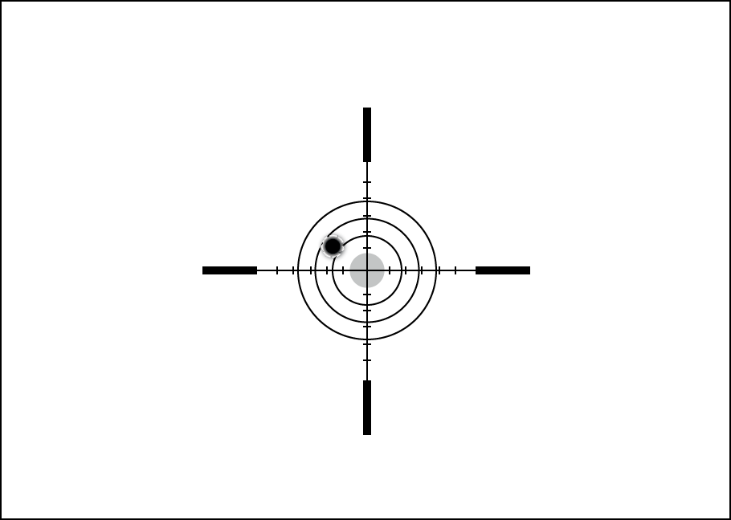
1. Shooting from a benchrest is recommended.
2. Set a target at a known distance.
3. Adjust the riflescope according to the Powering on and Image Setting section.
4. Select the zeroing profile (see Reticle & Zeroing 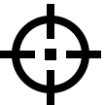 -> Zeroing Profile main menu item)
5. Point the rifle at the center of the target and shoot.

Step 2. Align the reticle with the point of impact
1. Press and hold the controller button (6) to enter the main menu.
2. Add the distance you are aiming at (e.g. 100 meters): Reticle & Zeroing -> Add New Distance . Select the value for each distance digit by rotating the controller ring (6). Press the controller button (6) briefly to switch between digits. After setting the required distance, press and hold the controller button (6) to save it.
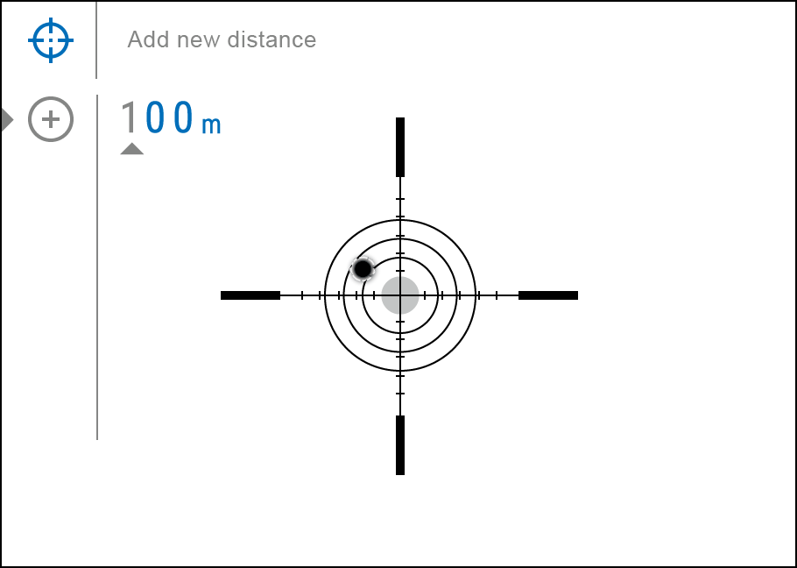
3. After adding the distance, it will switch to the Zeroing parameters settings menu . An auxiliary cross will appear in the center of the display, and X and Y coordinates of the auxiliary cross will appear in the upper right corner.
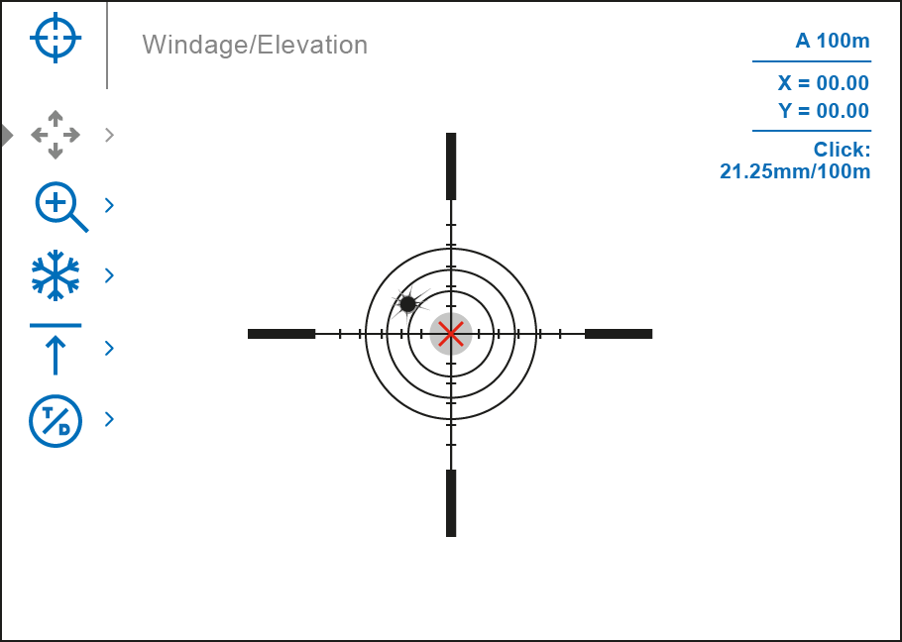
4. Press the controller button (6) briefly to enter the Windage/Elevation submenu.
5. While holding the reticle at the aiming point, move the auxiliary cross until it is aligned with the impact point by rotating the controller ring (6).
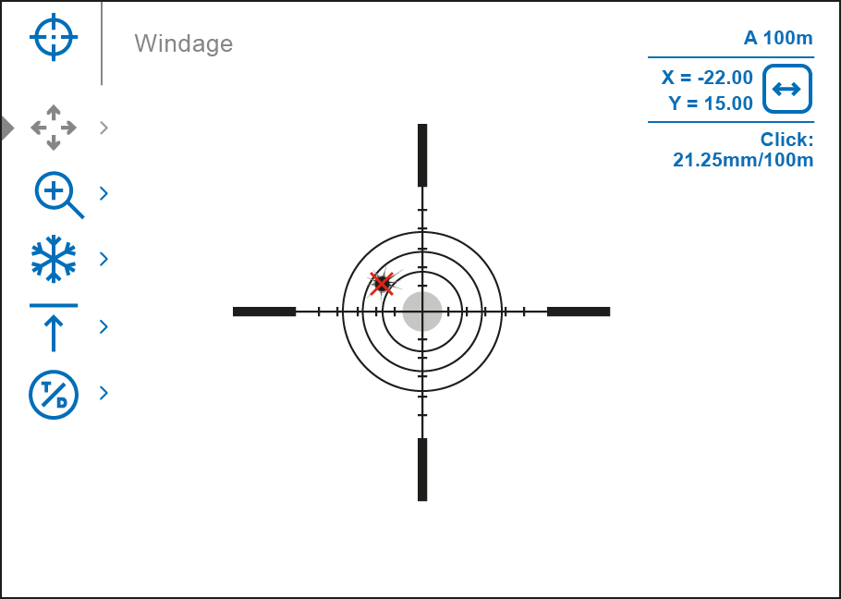
6. To change the direction of the auxiliary cross movement from horizontal to vertical, press the controller button (6) briefly.

Zoom Zeroing function:
To improve the accuracy of zeroing, you can change the magnification in the menu . The larger the magnification, the smaller the step of shifting the reticle on the display relative to the image.
Model | DXP50 | DXP55
Click value, mm@100 m – when magnifying, x | 21.3 – 2х  10.7 – 4х  5.3 – 8х  2.7 – 16х | Thermal imaging channel | Digital channel
 |  | 21.3 – 2х  10.7 – 4х  5.3 – 8х  2.7 – 16х | 10.3 – 4х  5.2 – 8х  2.6 – 16х  1.3 – 32х

One-shot "Freeze Zeroing" function:
Using the Freeze function allows you to make adjustments without the need to hold the rifle precisely at the initial aiming point – freezing the zeroing screen (refer to Reticle & Zeroing menu item => Distance submenu => Zeroing Parameters Settings submenu => Freeze submenu or short pressing of the ON/OFF (14) button. The image will “freeze” and the icon will appear.

Step 3. Save the coordinates
1. Press and hold the controller button (6) to save a new position for the reticle. The reticle will be aligned with the impact point and it will exit the Windage/Elevation submenu.
2. Select the menu item and briefly press the controller button (6) or briefly press the MODE (3) button to select another image channel (thermal or digital) and repeat the zeroing procedure for it.

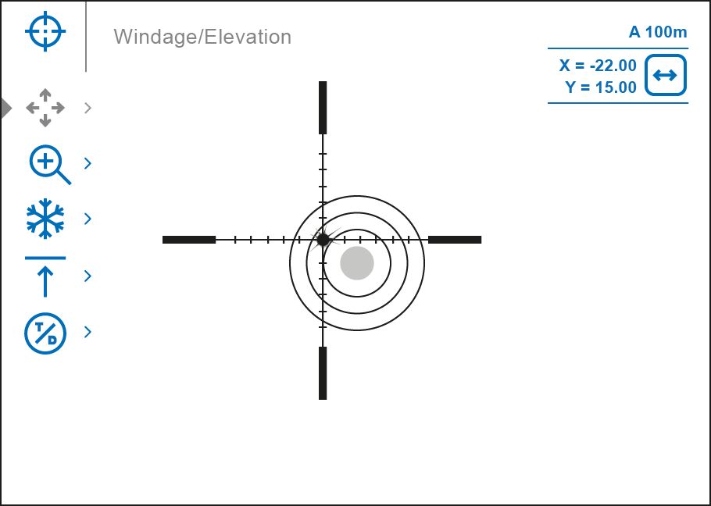
3. The coordinates for the digital and thermal channels will be saved under the same distance name. Zeroed channels are displayed in the status bar with icons and .
4. Press and hold the controller button (6) again to exit the zeroing settings menu - a message will appear confirming the successful operation.
If one channel was not zeroed when exiting the zeroing menu, a window will appear asking you to zero the other channel:
- Select "Yes" to return to the zeroing screen and zero in another channel.
- Select "No" to exit the zeroing screen to the riflescope settings menu.
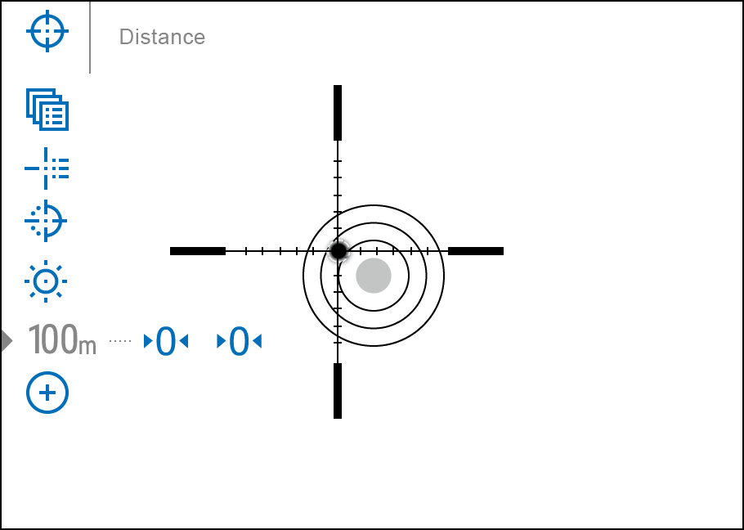
5. Fire a second shot - now the point of impact and the aiming point must be matched.

Notes:
- After zeroing, the reticle may not be in the center of the display.
- The range of movement of the riflescope reticle allows you to successfully zero the riflescope, even on mounts that are far from ideal, minimizing the possible disadvantages of the mounts. The better the mount is installed, the less you have to move the reticle. We recommend mounting the riflescope as low as possible.

Add New Distance
To zero your riflescope, you need to set a zeroing distance first in the range of 1 to 910 m (955 yards).
- Press and hold the controller button (6) to enter the main menu.
- Rotate the controller ring (6) to select the Reticle & Zeroing menu item.
- Press the controller button (6) briefly to enter the Reticle & Zeroing submenu.
- Rotate the controller ring (6) to select Add New Distance menu item.
- Press the controller button (6) briefly to enter the submenu.
- Rotate the controller ring (6) to select a value for each digit. Press the controller button (6) briefly to switch between digits 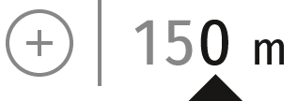.
- Having set the desired distance, press and hold the controller button (6) to save it.

The distance you set first becomes a primary distance – shown with the 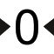 icon on the right of the distance value.
Note: Maximum number of zeroing distances is 10 for each profile.

Zeroing Parameters Settings
- Press and hold the controller button (6) to enter the main menu.
- Rotate the controller ring (6) to select Reticle & Zeroing in the menu. Briefly press the controller button (6) to select it. Zeroed distances are displayed below.
- The values (e.g., +7.0 -15.0) shown on the right of the distance values, stand for the number of clicks along the Y axis for digital and thermal channels, at which the reticle position at other distances differs from the reticle position in the primary distance. Icons and indicate that the channels have not been zeroed.
- To zero at any distance again, rotate the controller ring (6) to select the required distance and briefly press the controller button (6).
- Rotate the controller ring (6) to select the Zeroing Parameters Settings and enter by briefly pressing the controller button (6).
- Zeroing screen, which allows the change of zeroing coordinates, will appear:

Windage/Elevation
Adjust the reticle position through the Windage/Elevation submenu in Zeroing Parameters Settings . For more information, see the How to Zero section.

Magnification (when Zeroing)
Magnification allows you to magnify via the device’s digital zoom when zeroing, which reduces the MOA-per-click values of adjustments and improves zeroing accuracy.
1. In the Zeroing Parameters Settings menu, rotate the controller ring (6) to select the Magnification submenu item and enter by briefly pressing the controller button (6).
2. Rotate the controller ring (6) to select a digital magnification value of the riflescope (e.g., x4).
Model | DXP50 | DXP55
Click value, mm@100 m – when magnifying, x | 21.3 – 2х  10.7 – 4х  5.3 – 8х  2.7 – 16х | Thermal imaging channel | Digital channel
 |  | 21.3 – 2х  10.7 – 4х  5.3 – 8х  2.7 – 16х | 10.3 – 4х  5.2 – 8х  2.6 – 16х  1.3 – 32х

3. Press the controller button (6) briefly to confirm your selection.

Freeze
The “freeze” function allows the user to adjust the reticle on a still image while manipulating the rifle.
- In the Zeroing Parameters Settings menu, rotate the controller ring (6) to move the cursor to the Freeze function.
- Align the reticle with the point of aiming and press the controller (6) or ON/OFF (14) button. A screenshot will be taken, an icon will appear.
- Go to the additional Windage/Elevation submenu and adjust the position of the reticle (see the How to Zero section).
- Select the Freeze submenu item again and briefly press the controller (6) or ON/OFF (14) button - the image will “unfreeze”.

Name Distance
- In the Zeroing Parameters Settings menu, rotate the controller ring (6) to select the Name Distance submenu item and enter it by briefly pressing the controller button (6)​.
- Rotate the controller ring (6) to select a value for each digit. Press the controller button (6) briefly to switch between digits.
- Press and hold the controller button (6) to confirm the selection.

Zeroing Channel
- In the Zeroing Parameters Settings menu, rotate the controller ring (6) to select the Thermal/Digital Channel Selection menu item.
- Briefly press the controller button (6) to select the image channel (thermal imaging or digital) to be zeroed.

Note: the image channel switching is also possible by briefly pressing the MODE button (3).

Change Primary Distance
- Press and hold the controller button (6) to enter the main menu.
- Rotate the controller ring (6) to select the Reticle & Zeroing menu item and enter by briefly pressing the controller button (6) – zeroed distances are displayed at the bottom.
- Select a non-primary distance and enter the submenu for operating the distance with a brief press of the controller button (6).
- Select Change Primary Distance item.
- Press the controller button (6) briefly.
- Icon next to the selected distance confirms the change of primary distance.
There will also be a recalculation of corrections in clicks for other distances relative to the new primary distance.

Delete Distance
- Press and hold the controller button (6) to enter the main menu.
- Rotate the controller ring (6) to select the Reticle & Zeroing menu item and enter by briefly pressing the controller button (6) – zeroed distances are displayed at the bottom.
- Select the distance you wish to delete and enter the submenu for operating the distances with a brief press of the controller button (6).
- Select Delete Distance item.
- Press the controller button (6) briefly.
- Select “Yes” in the appeared dialog box to delete a distance. “No” – to cancel deletion.
- Press the controller button (6) briefly to confirm your selection.

Attention! If the primary distance is deleted, the first distance on the list automatically becomes the new primary distance.

Interface

Status Bar
The status bar at the bottom of the display shows current operating statuses via icons, including:
1. Colour Mode (shown only in thermal imaging mode and Multispectral PiP Thermal):
- White hot
- Black hot
2. Actual zeroing profile (e.g., A)
3. Zeroing distance (e.g., 100 m)
4. Image mode:
Digital mode
Thermal imaging mode
Multispectral PiP Digital
Multispectral PiP Thermal
Multispectral PiP Digital disabled
Multispectral PiP Thermal disabled
The image channel can be disabled with "Observation Channel" in the General Settings section.
5. Amplification level (e.g., Normal; displayed only in thermal imaging mode and Multispectral PiP Thermal)
6. Smoothing Filter (displayed when the function is on; displayed only in thermal imaging mode and Multispectral PiP Thermal)
7. Calibration mode (a countdown timer 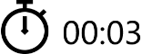 will appear instead of the calibration icon when in automatic calibration mode with 3 seconds remaining until automatic calibration; displayed only in thermal imaging mode and Multispectral PiP Thermal)
8. Microphone
9. Current magnification
10. Wi-Fi connection
11. Auto Shutdown function (e.g., 5 min.)
12. Clock
13. Power supply:
- Battery discharge level 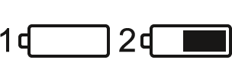 (when riflescope is powered by a built-in or removable battery).
- External battery power indicator (if the riflescope is powered by an external power supply).
- Battery indicator with current percentage of charge (when charging from an external power source).

Quick Menu
The basic settings (adjusting brightness and contrast, information on the distance) can be changed using the quick access menu.
- Press the controller button (6) briefly to enter the quick menu.
- A short press of the controller button (6) enables you to switch between functions, as described below.
Brightness – rotate the controller ring (6) to change the display brightness value from 00 to 20.
Contrast – rotate the controller ring (6) to change the image contrast value from 00 to 20.
Amplification Levels – allows you to select one of three amplifying levels of sensitivity (Normal , High , Ultra ).
Note: To maintain brightness and contrast settings when changing amplifying levels, activate User Mode.
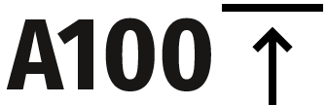 – information on the current profile and zeroing distance in this profile (e.g., profile A, zeroing distance of 100 m). This information is always displayed in the status bar. Rotate the controller ring (6) to switch between the zeroing distances in the selected profile. This function is available if there are two or more distances in the profile.
Tip: To quickly switch between distances while hunting, leave the Zeroing Distance option selected before exiting the quick menu. The menu item will be saved, and the next time you enter the quick menu, you can quickly switch the zeroing distances by turning the controller (6) (for example, 100 m, 150 m, 200 m).
Stadiametric rangefinder – rotating the controller ring (6), change the distance between the special mark points to determine the distance to the observed object (for more details on the rangefinder, see the Stadiametric Rangefinder section).
- Press and hold the controller button (6) to exit the menu or wait 10 seconds to exit automatically.

Main Menu

Enter the Main Menu
- Enter the main menu with a long press of the controller button (6).
- To move through the main menu items, rotate the controller ring (6).
- Press the controller button (6) briefly to open subitems of the main menu.
- Press and hold the controller button (6) to exit from a subitem of the main menu.
- Automatic exit from the main menu occurs after 10 seconds of inactivity.
Note: When entering the main menu, the background image darkens to enhance the menu visibility. This is normal and not a defect.

General View of the Menu

Tab 1
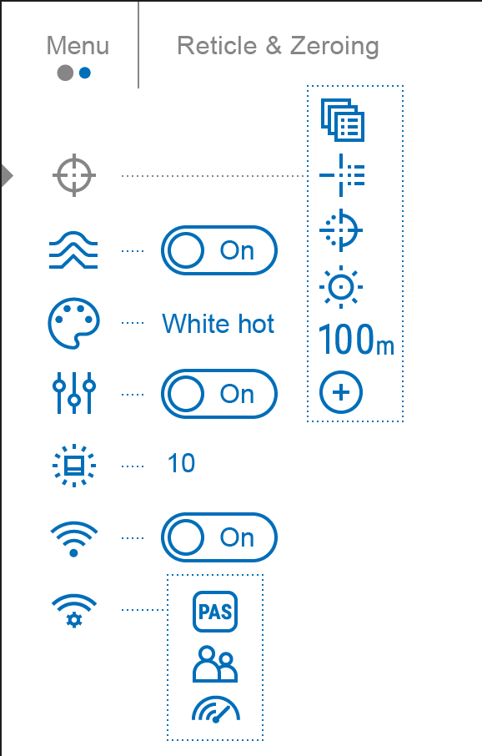

Tab 2
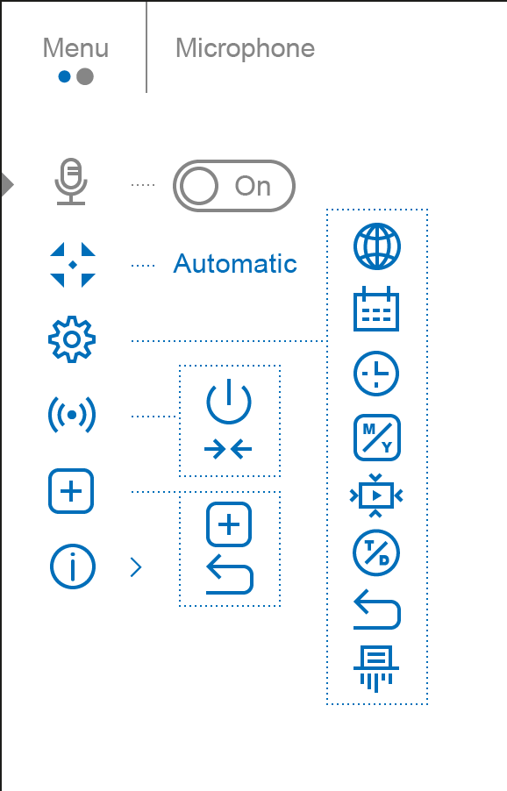

Reticle & Zeroing

Zeroing Profile
This item of the main menu allows you to select one of five profiles (А, В, С, D, E) to use. Each profile stores information on the following parameters:
- A set of zeroed distances
- Reticle color
- Reticle type
Different profiles can be used when using the riflescope on different rifles or when shooting with different bullets.

- Press and hold the controller button (6) to enter the main menu.
- Rotate the controller ring (6) to select the Reticle & Zeroing menu item.
- Press the controller button (6) briefly to enter the Reticle & Zeroing submenu.
- Press the controller button (6) briefly to enter the Zeroing Profile submenu.
- Rotate the controller ring (6) to select one of the zeroing profiles (marked with the letters A, B, C, D, E).
- Confirm your selection with a short press of the controller button (6).
- The name of the selected profile appears in the status bar at the bottom of the display.

Reticle Type

Reticle Colour
Selection of the aiming reticle shape.
- Press and hold the controller button (6) to enter the main menu.
- Rotate the controller ring (6) to select the Reticle & Zeroing menu item.
- Press the controller button (6) briefly to enter the Reticle & Zeroing submenu.
- Rotate the controller ring (6) to select the Reticle Type submenu.
- Press the controller button (6) briefly to enter the Reticle Type submenu.
- Rotate the controller ring (6) to select the desired aiming reticle shape from the list that appears. The reticle type changes as the cursor goes down the reticle list.
- Press the controller button (6) briefly to confirm the selection.

Reticle Brightness
Adjust the brightness level of the aiming reticle.
- Press and hold the controller button (6) to enter the main menu.
- Rotate the controller ring (6) to select the Reticle & Zeroing menu item.
- Press the controller button (6) briefly to enter the Reticle & Zeroing submenu.
- Rotate the controller ring (6) to select the Reticle Brightness submenu.
- Press the controller button (6) briefly to enter the Reticle Brightness submenu.
- Rotate the controller ring (6) to set the desired brightness level (1 to 10).
- Press the controller button (6) briefly to confirm the selection.

Smoothing Filter
It is used to reduce digital image distortions while maintaining a high sensitivity level of the thermal imaging channel.

Smoothing Filter Off
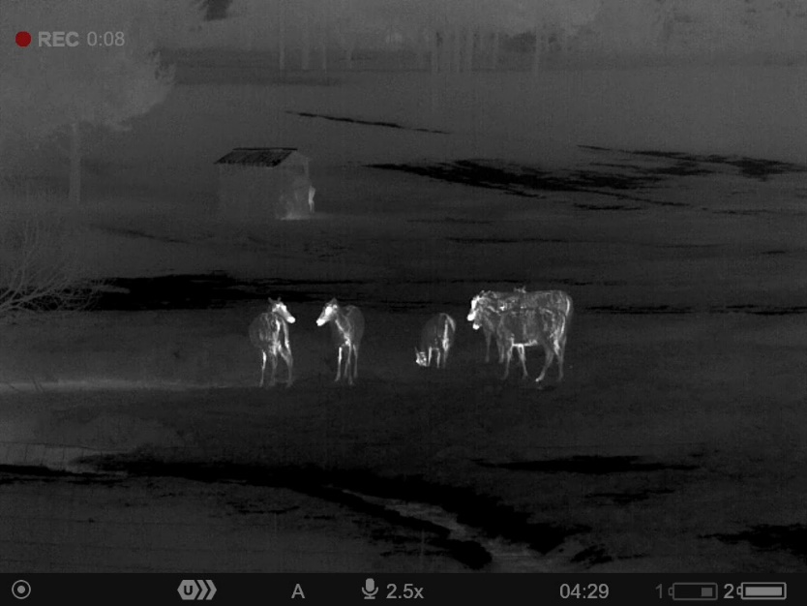

Smoothing Filter On
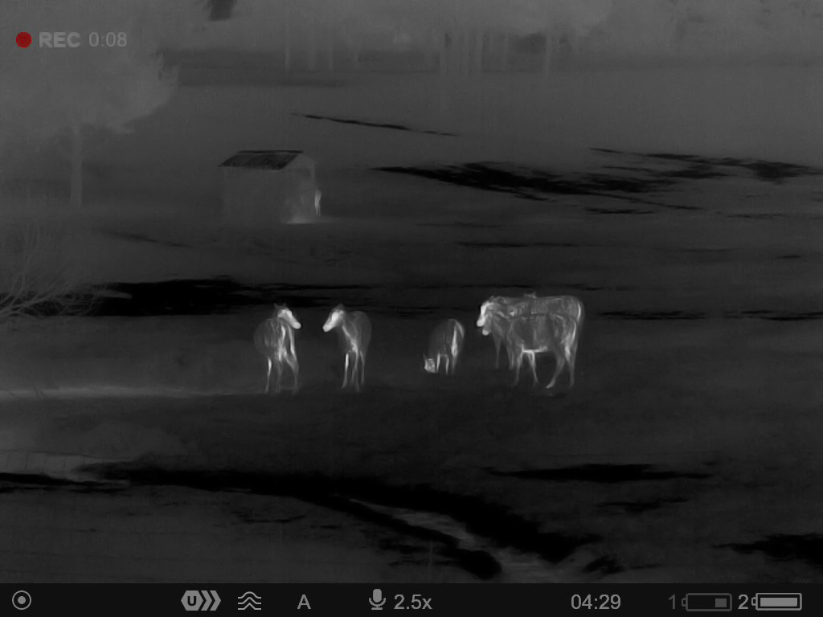

- Press and hold the controller button (6) to enter the main menu.
- Rotate the controller ring (6) to select the Smoothing Filter icon.
- Press the controller button (6) briefly to turn the filter on/off.

Colour Modes
Available in thermal imaging and PiP thermal imaging multispectral mode
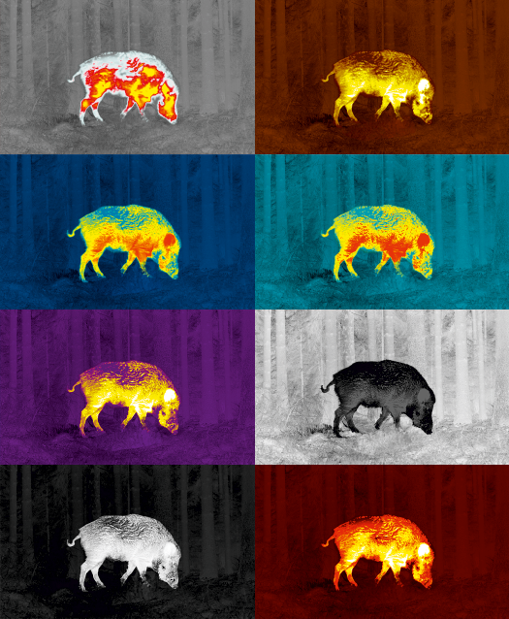
Colour mode selection.
White hot is a default display mode for an observed thermal image.

The Color Modes menu item allows you to select an alternative palette:
- Press and hold the controller button (6) to enter the main menu.
- Select the Color Modes menu item.
- Press the controller button (6) briefly to enter the Color Modes submenu.
- Rotate the controller ring (6) to select one of the palettes described below.
- Press the controller button (6) briefly to confirm your selection.
Tip: to preserve brightness and contrast values when switching palettes, activate User Mode.

- White hot - a black and white palette where black = cold; white = hot
- Black hot - a black and white palette where white = cold; black = hot
- Red Hot
- Red Monochrome
- Rainbow
- Ultramarine
- Violet
- Sepia

Attention! The device should not be used to accurately measure temperature. The images generated are based on temperature contrast rather than true temperature readings.

User Mode
Available in thermal imaging and PiP thermal imaging multispectral mode
This mode is used to save the user’s brightness and contrast settings. The selected settings are retained after restarting the device.

- Press and hold the controller button (6) to enter the main menu.
- Rotate the controller ring (6) to select the User Mode icon.
- Press the controller button (6) briefly to turn the User Mode on/off.

Icon Brightness
Adjust the brightness level of the icons and screensavers (Pulsar, Display off) on the display.
- Press and hold the controller button (6) to enter the main menu.
- Rotate the controller ring (6) to select the Icon Brightness menu item.
- Press the controller button (6) briefly to enter the Icon Brightness submenu.
- Rotate the controller ring (6) to set the desired brightness level (1 to 10).
- Press the controller button (6) briefly to confirm the selection.

Wi-Fi Activation
Turn on/off Wi-Fi
- Press and hold the controller button (6) to enter the main menu.
- Rotate the controller ring (6) to select the Wi-Fi Activation menu item.
- To turn Wi-Fi on, briefly press the controller button (6).
- To turn Wi-Fi off, briefly press the controller button (6).

Wi-Fi Settings
This item enables you to set up your riflescope for operation in a Wi-Fi network.
- Press and hold the controller button (6) to enter the main menu.
- Rotate the controller ring (6) to select the Wi-Fi Settings submenu.
- Press the controller button (6) briefly to enter the submenu
- Rotate the controller ring (6) to select the desired menu item.

Password Setup
This item enables you to set a password to access the riflescope from an external device. The password is used to connect an external device (i.e. smartphone) to the riflescope.
- Press the controller button (6) to enter the Password Setup submenu.
- The default password (12345678) will appear on the screen.
- Rotate the controller ring (6) to set the desired password. Press the controller button (6) to toggle through the digits.
- Press and hold the controller button (6) to save the password and exit from the submenu.

Access Level Setup
This sub-function enables you to configure the appropriate level of access to your device made available to the Stream Vision 2 application.
Owner level. A Stream Vision 2 user has full access to all the device’s functions.
Guest level. A Stream Vision 2 user can only view video footage from the device in real time.
- Press the controller button (6) to enter the Access Level Setup submenu.
- Rotate the controller ring (6) to select Owner or Guest.
- Confirm your selection with a short press of the controller button (6).

Wi-Fi Band
This setting helps to solve smartphone connection issues in the following cases:
- If your smartphone does not support 5 GHz Wi-Fi band, switch to 2.4 GHz.
- Many Wi-Fi networks cause interference. In this case, switching between Wi-Fi bands can improve the connection between the device and the smartphone.
- Press the controller button (6) to enter the Wi-Fi Band 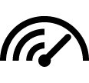 submenu.
- Rotate the controller ring (6) to select the WiFi bandwidth – 5 GHz or 2.4 GHz.
- Confirm your selection with a short press of the controller button (6).

Microphone
Turning on/off Microphone.
This item allows you to enable (or disable) the microphone for recording sound during video recording.
- Press and hold the controller button (6) to enter the main menu.
- Rotate the controller ring (6) to select the Microphone menu item.
- To turn on the microphone, briefly press the controller button (6).
- To turn off the microphone, briefly press the controller button (6).

Calibration Mode
Calibration mode selection.
Calibration allows you to equalize the temperature background of the microbolometer and eliminate the thermal image flaws (such as vertical bars, phantom images, grainy field of view, etc.).
There are three calibration modes: manual, semi-automatic and automatic.
The selected calibration mode is displayed in the status bar (see Status Bar section).

Select the required mode in the Calibration Mode item:
- Press and hold the controller button (6) to enter the main menu.
- Rotate the controller ring (6) to select the Calibration Mode menu item.
- Press the controller button (6) briefly to enter the Calibration Mode submenu.
- Rotate the controller ring (6) to select one of the calibration modes described below.
- Press the controller button (6) briefly to confirm your selection.

M mode (manual)
- Close the lens cover (12) and press the ON/OFF (14) button briefly.
- Open the cover after the calibration is completed.

SA mode (semi-automatic)
- The user independently determines the need for calibration (according to the thermal image being observed).
- Press the ON/OFF (14) button briefly to activate calibration.
- There is no need to close the lens cover (internal shutter covers the microbolometer).

A Mode (automatic)
- The riflescope is calibrated autonomously according to the software algorithm.
- There is no need to close the lens cover (internal shutter covers the microbolometer).
- In this mode, the riflescope may be calibrated by the user with the ON/OFF (14) button.

Note: a display thermal image freezes until the calibration is in progress.

General Settings
- Press and hold the controller button (6) to enter the main menu.
- Rotate the controller ring (6) to select the General settings menu item.
- Press the controller button (6) briefly to enter the submenu.
- Rotate the controller ring (6) to select the desired menu item.
This menu item allows you to configure the following settings:

Language
Language selection:
- Press the controller button (6) briefly to enter the Language submenu.
- Rotate the controller ring (6) to select one of the available interface languages: English, German, Spanish, French, Russian, Italian, Portuguese, Dutch, Danish, Norwegian, Swedish, Polish, Czech, Hungarian.
- Confirm your selection with a short press of the controller button (6).
- Press and hold the controller button (6) to save your selection and exit from the submenu.

Date
Date Setting:
- Press the controller button (6) briefly to enter the Date submenu. The date is displayed in dd/mm/yyyy format.
- Rotate the controller ring (6) to select the desired year, month and date. Press the controller button (6) briefly to switch between digits.
- Press and hold the controller button (6) to save your selected date and exit from the submenu.

Time
Time Setting:
- Press the controller button (6) briefly to enter the Time submenu.
- Rotate the controller ring (6) to select the time format - 24 or AM/PM.
- Press the controller button (6) to proceed to the hour setting.
- Rotate the controller ring (6) to select the hour value.
- Press the controller button (6) to proceed to the minute setting.
- Rotate the controller ring (6) to select the minutes value.
- Press and hold the controller button (6) to save your selected time and exit from the submenu.

Units of Measure
Units of measurement selection:
- Press the controller button (6) briefly to enter the Units of Measure submenu.
- Rotate the controller ring (6) to select the unit of measurement - meters or yards, press the controller button (6).
- Return to submenu will happen automatically.

Video Compression
When set to ON, standard video compression is applied so the video file size is reduced.
When set to OFF, minimal video compression is applied. In this case, the record quality is higher, but its size increases significantly.
Warning! Larger video file size results in reduced video recording time. This may lead to longer download times for video files through the Stream Vision 2 app.

Enable/disable video compression:
- Rotate the controller ring (6) to select the Video Compression 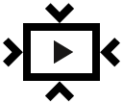 menu item.
- To turn on video compression, briefly press the controller button (6).
- To turn off video compression, briefly press the controller button (6).

Observation Сhannel
This submenu allows you to turn off one of the image channels (thermal imaging or digital) if it is not used.
Turning off the image channel will save battery power.
An icon with a disabled channel will be displayed in the status bar: or .

Turn on/off the image channel:
- Rotate the controller ring (6) to select the Viewing Channel Activation menu item.
- Press the controller button (6) briefly to enter the submenu.
- Rotate the controller ring (6) to select the image mode: thermal imaging or digital.
- Confirm your selection with a short press of the controller button (6).
- Turn on/off the image channel by briefly pressing the controller button (6).

Default Settings
- Press the controller button (6) briefly to enter the Default Settings submenu.
- Rotate the controller ring (6) to select “Yes” to restore default settings or “No” to cancel the action.
- Confirm your selection with a short press of the controller button (6).
- If “Yes” is selected, display will show “Do you want to restore default settings?” with “Yes” and “No” dialogue options. Select “Yes” to restore default settings.
- If “No” option is selected: the action will be aborted and you will return to the submenu.
The following settings will be returned to their defaults:
- Video Recorder Mode – Video
- Amplification Level – Normal
- Smoothing Filter – Off
- User Mode - Off
- Calibration Mode – automatic
- Interface Language – English
- Wi-Fi – Off (default password)
- Magnification – initial value
- PiP – Off
- Color Mode – White hot
- Units of Measurement – metric
- Side Incline – On
- Zeroing Profile – A
- Reticle selection from the riflescope’s memory – 1
- Video Compression – On
- Wi-Fi Band – 5 GHz
- Disabling an Image Channel – both channels are on
Attention! After restoring default settings, the date, time and user pixel map as well as the zeroing profiles data entered by the user are saved.

Format
This menu option allows you to format the device's memory card. All files will be deleted.
Formatting should be carried out in case of a memory card error.
Before formatting, make sure you transfer all footage to other media.
- Press the controller button (6) briefly to enter the Format submenu.
- Rotate the controller ring (6) to select “Yes” to format the memory card, or “No” to return to the submenu.
- Confirm your selection by pressing the controller button (6).
- If “Yes” is selected, display will show “Do you want to format memory?” with “Yes” and “No” dialogue options. Select “Yes” to format the memory card.
- If “No” option is selected: formatting is cancelled and return to the submenu.

Accelerometer

Auto Shutdown
This item allows you to activate the auto shutdown function when your riflescope is in a non-operating position (tilted up or down at an angle of more than 70° / right or left or at an angle of more than 30°). In this case, the controls (buttons, controller) should be inactive.

- Press and hold the controller button (6) to enter the main menu.
- Rotate the controller ring (6) to select the Accelerometer submenu.
- Confirm the selection by briefly pressing the controller (6).
- Rotate the controller ring (6) to select Auto Shutdown .
- Press the controller button (6) briefly to enter the submenu.
- Rotate the controller ring (6) to select the time period (1 min, 3 min, 5 min) upon expiry of which the riflescope will automatically shut down, or select Switch off if you wish to deactivate Auto Shutdown.
- Confirm your selection with a short press of the controller button (6).

Note: If the automatic shutdown function is activated, the status bar shows an icon ​and shutdown time period as 1/3/5 min.

Side Incline
This item allows you to activate or deactivate the “sector” arrows on the sides of the display. These arrows show the direction in which your rifle scope should be rotated to eliminate incline.

There are three modes of incline:
- 5°-10° – one sector arrow;
- 10°-20° - two sector arrow;
- > 20° - three sector arrow.
A side incline of less than 5° is not displayed.

- Press and hold the controller button (6) to enter the main menu.
- Rotate the controller ring (6) to select the Accelerometer menu item.
- Press the controller button (6) briefly to enter the Accelerometer submenu.
- Rotate the controller ring (6) to select Side Incline 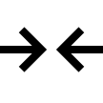.
- Press the controller button (6) briefly to enter the Side Incline submenu.
- Rotate controller ring (6) to select On for turning on the incline indication or Off for turning it off.
- Confirm your selection with a short press of the controller button (6).

How to fix dead pixels of a thermal imaging Microbolometer

Defective Pixel Repair
When using the device, defective (dead) pixels may appear on the microbolometer. These are bright or dark points of a constant brightness that are visible on the thermal image.
Defective pixels on the microbolometer can increase in size relative to the digital-zoom power.
The Thermion Duo thermal riflescope allows the user to remove any defective pixels on the display, as well as cancel removal, via the device’s firmware.
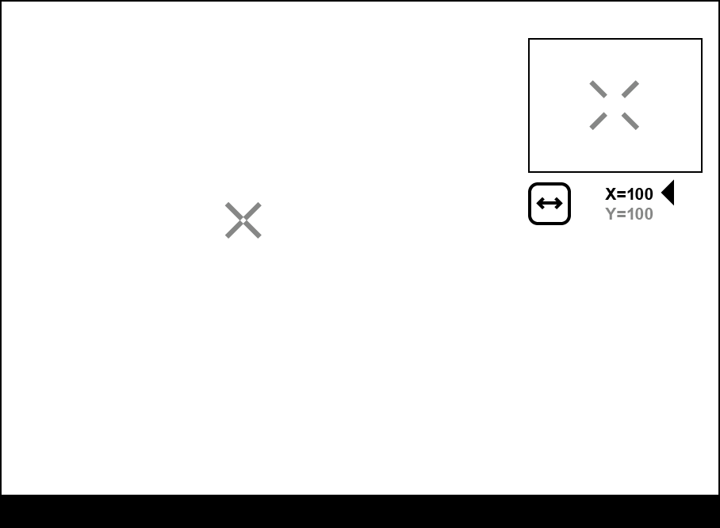

Step 1. Enter the menu to fix the defective pixels
- Select the thermal imaging mode for the main window by briefly pressing the MODE button (3).
- Press and hold the controller button (6) to enter the main menu.
- Rotate the controller ring (6) to select the Defective Pixel Repair menu item.
- Press the controller button (6) to open the submenu.
- Press the controller button (6) briefly to select the icon .

Step 2. Select the defective pixel
- A marker will appear on the left side of the display. A “magnifying glass” will appear on the right side of the display — a rectangle with an enlarged view of the marker for precise pixel selection — and marker coordinates under the “magnifying glass” 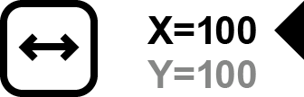.
- Rotate the controller ring (6) to move the marker to align its center with the defective pixel.
- Press the controller button (6) shortly to switch the marker direction from the horizontal to the vertical and vice versa.
- Rotate the controller ring (6) to align the defective pixel with the fixed cross in the frame – the pixel should disappear.

Step 3. Remove the defective pixel
- Delete the defective pixel with a short press of the ON/OFF (14) button.
- Where the pixel has been successfully deleted, the OK message will appear on the screen for a short time.
- Then, by moving the marker across the display, you can delete the next defective pixel.
- Press and hold the controller button (6) to exit the Defective Pixel Repair function.

Restore Default Pixel Map
This option allows the user to return all previously disabled defective pixels to their original state.
- Press and hold the controller button (6) to enter the main menu.
- Rotate the controller ring (6) to select the Defective Pixel Repair icon.
- Press the controller button (6) to enter the submenu.
- Rotate the controller ring (6) to select the Restore Default Pixel Map icon.
- Activate the function by briefly pressing the controller button (6).
- Rotate the controller ring (6) to select Yes if you want to return to the factory pixel map or select No if you do not.
- Confirm your selection with a short press of the controller button (6).

Attention! One or two pixels on the display of the device in the form of bright white, black or colored (blue, red or green) points may appear. These points cannot be removed and are not a defect.

Device Information
- Press and hold the controller button (6) to enter the main menu.
- Rotate the controller ring (6) to select the Device Information menu item.
- Press the controller button (6) briefly to enter the Device Information submenu.

This item allows the user to view the following information about the riflescope:
- Full name of the riflescope
- SKU number
- Serial number of the riflescope
- Riflescope firmware version
- Hardware version
- Service information
- Battery information

Functions

Amplification Level
Available in thermal imaging and PiP thermal imaging multispectral mode
Sensitivity enhancement levels (Normal, High, Ultra) are software algorithms that enhance the quality of detection and recognition in various observation conditions. When the temperature contrast decreases (fog, precipitation, high humidity), it is recommended to increase the amplification level. To optimize the image, activate the Smoothing Filter in the main menu.

Normal
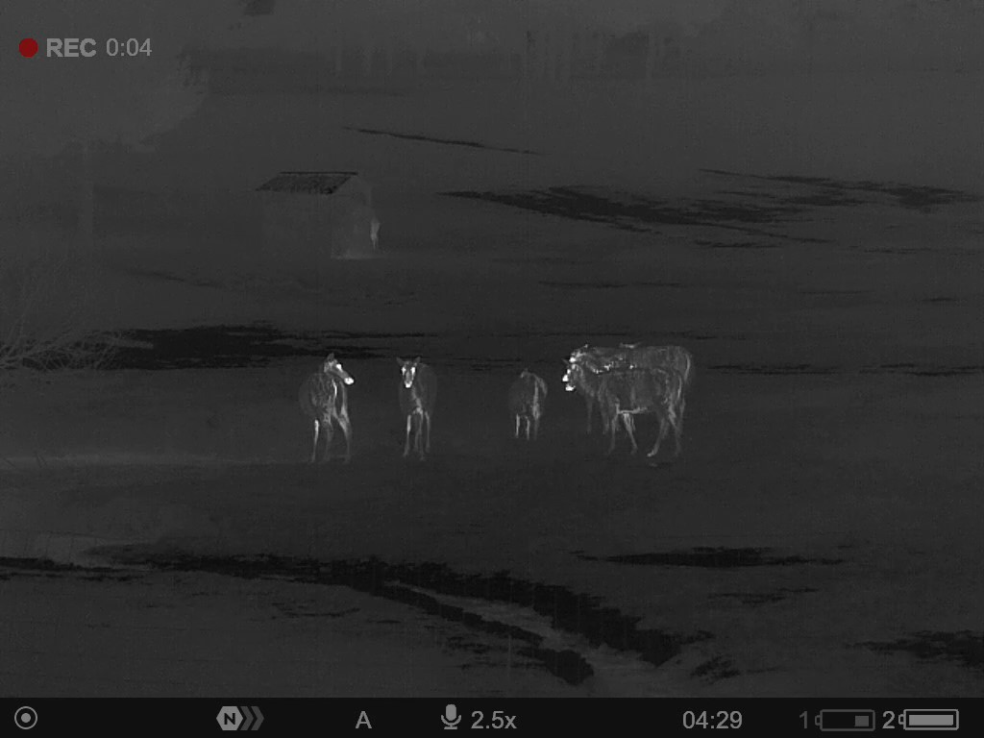

High
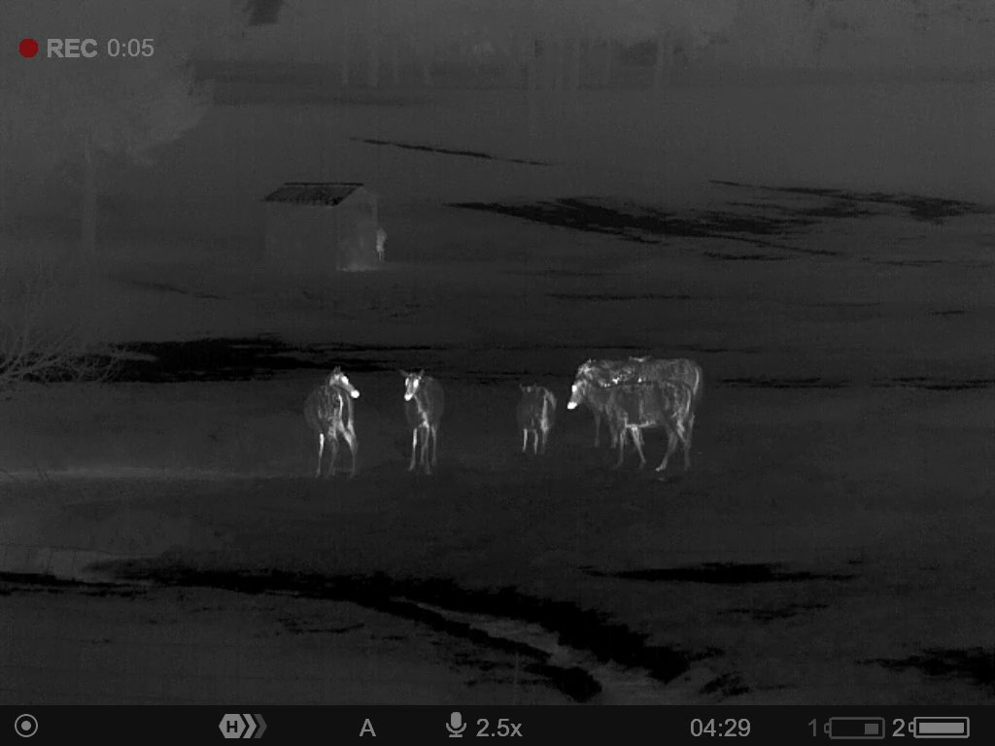

Ultra
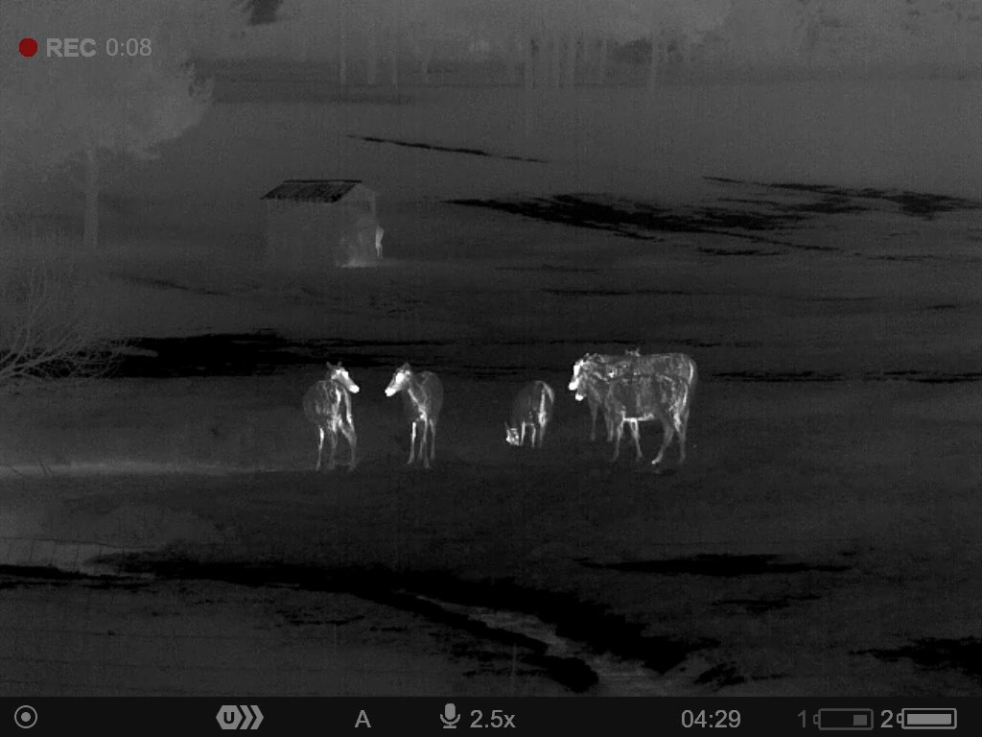

- Press and hold the controller button (6) to enter the quick menu.
- By short pressing the controller button (6) select the menu item Amplification level .
- Rotate the controller ring (6) to select one of the levels: Normal , High , Ultra .
- Press and hold the controller button (6) to exit the menu or wait for 3 seconds to exit automatically.

Image Modes (Thermal Imaging/Digital/Multispectral PiP)
The device has 3 image modes: thermal imaging, digital and multispectral PiP mode.
- Quickly switch between thermal and digital modes by briefly pressing the MODE button (3).
- Activate the multispectral PiP mode by a long press of the MODE button (3).
- In the multispectral PiP mode, the image channels in the PiP window are switched by briefly pressing the MODE button (3).

Thermal Imaging Mode
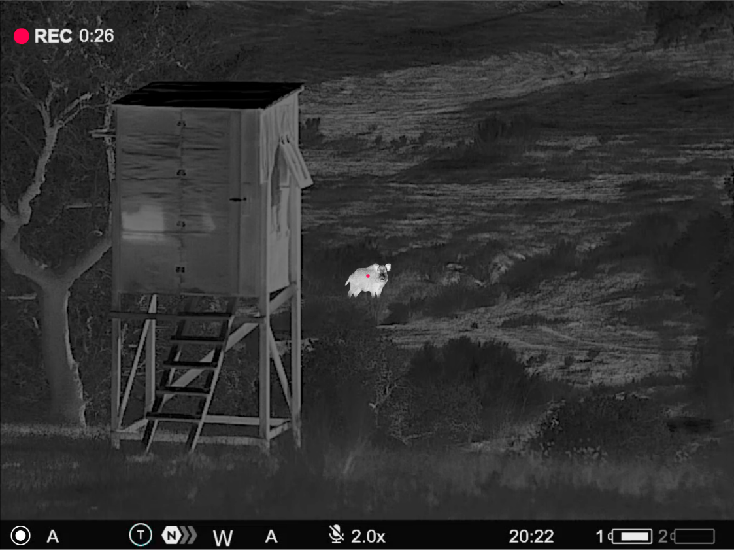
The device displays an image from a thermal imaging microbolometer when using the thermal imaging mode.
This mode allows you to use the device both at night-time and during the day in adverse weather conditions (fog, snow, haze) when there are obstacles (branches, tall grass, dense bushes etc.) that make it difficult to detect the target.
In thermal imaging mode, the riflescope does not need an external light source and is resistant to high light levels.

Digital Mode
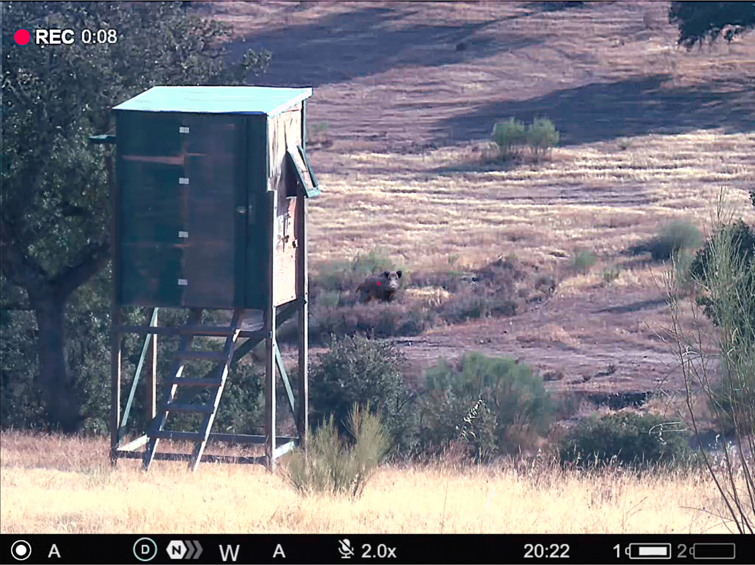
In digital mode, the device generates a colour image from a digital sensor.
The device can be used as a fully-featured daytime riflescope while maintaining all the functions of a digital riflescope (digital zoom, PiP, video recorder, Wi-Fi, etc.).
The digital channel is intended for use only during the day, both in sunny and cloudy weather. This mode is not intended for use at night, including with an IR illuminator, due to the presence of an IR filter.

Multispectral PiP
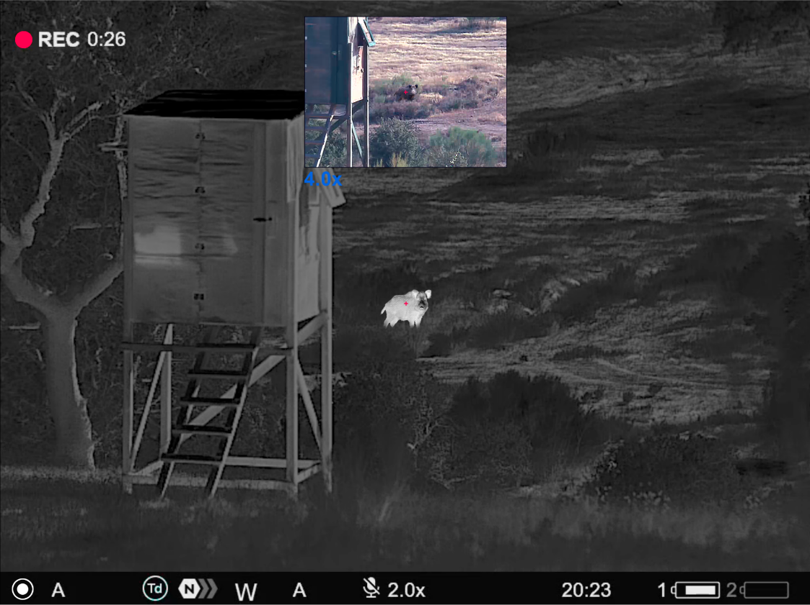,
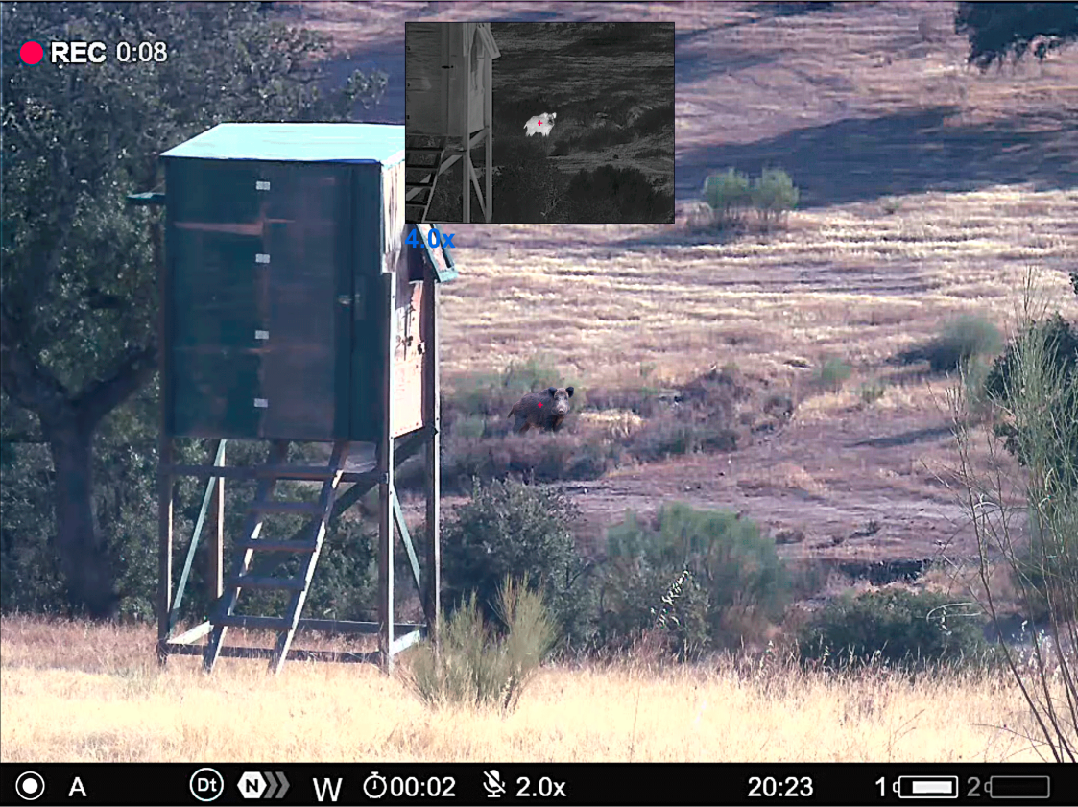
In the multispectral PiP mode, the image of one channel is displayed in the main window, and the image of the second channel is displayed in the PiP window.
In this mode, digital zoom is applied only to the PiP window. The magnification in the main window is set to base.

Video Recording and Photography
The riflescope is capable of video recording and photography. Videos and images are saved on the built-in memory card.
Before using the photo and video functions, read the Date and Time subsections of the General Settings section.

Built-in recorder operates in two modes:
- Photo (photography; the icon is displayed in the upper left corner of the display).
- Video (video recording; the icon is displayed in the upper left corner of the display, the total remaining recording time is given taking into account the current resolution in the HH:MM format (hours:minutes).
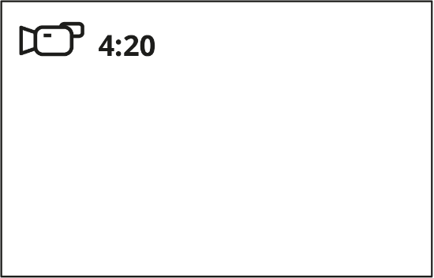
Toggle (switch) between the riflescope operating modes with a long press of the REC (4) button. Switching between the modes is cyclical (Video–> Photo–> Video...).

Photo mode. Capturing an image
1. Switch to the Photo mode with a long press of the REC (4) button.
2. Press the REC (4) button briefly to capture a photo. The icon flashes – the photo file is being saved to the built-in SD card.

Video mode. Recording a video
1. Switch to the Video mode with a long press of the REC (4) button.
2. Press the REC (4) button briefly to start video recording.
3. When the video recording starts, the icon will disappear, instead of it the REC icon as well as the video recording timer displayed in the MM:SS (minutes:seconds) format will appear 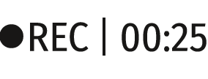.
4. Pause/continue recording by briefly pressing the REC (4) button.
5. Press and hold the REC (4) button to stop video recording.
Video files are stored in the built-in memory card:
- After turning off the video recording;
- Upon powering the riflescope off if recording was on;
- When the memory card is overfilled during recording (Memory Full message appears on the display).

Notes:
- You can enter and navigate the menu during video recording.
- Recorded videos and photos are saved to the built-in memory card of the riflescope in the format img_xxx. jpg (for photos); video_xxx. mp4 (for video).
- Videos are recorded in clips with a maximum duration of 5 minutes. The number of files is limited by the riflescope's built-in memory and video compression ratio.
- Regularly check free memory within the built-in memory card and move the footage to other storage media to free up the memory card space.
- In case of a memory card error, you can use the format function in the General Settings section of the main menu.
- When the Display Off function is activated, video recording continues to run in the background.

Discrete Digital Zoom
Discrete digital zoom allows you to quickly increase the basic magnification (see Magnification line in the table of Technical Specifications) by 2x or 4x, as well as return to the basic magnification.
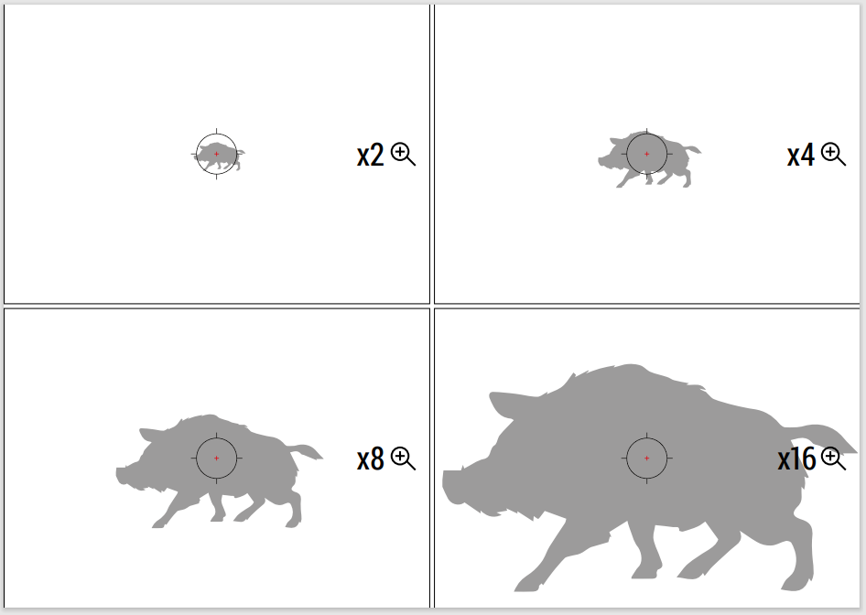
- Press the ZOOM (5) button successively to change the magnification ratio of the riflescope.
- While the icon is visible on the screen, rotate the controller ring (6) for smooth digital zooming from the current magnification.

PiP Function
Available in thermal imaging and digital mode
The PiP function (Picture-in-Picture) allows you to see both a magnified image in a particular dialog box and the main image.
In this mode, the same image channel is displayed in the main window and the PiP window.
To use the multispectral PiP mode, see Image Modes (Thermal Imaging/Digital/Multispectral PiP).
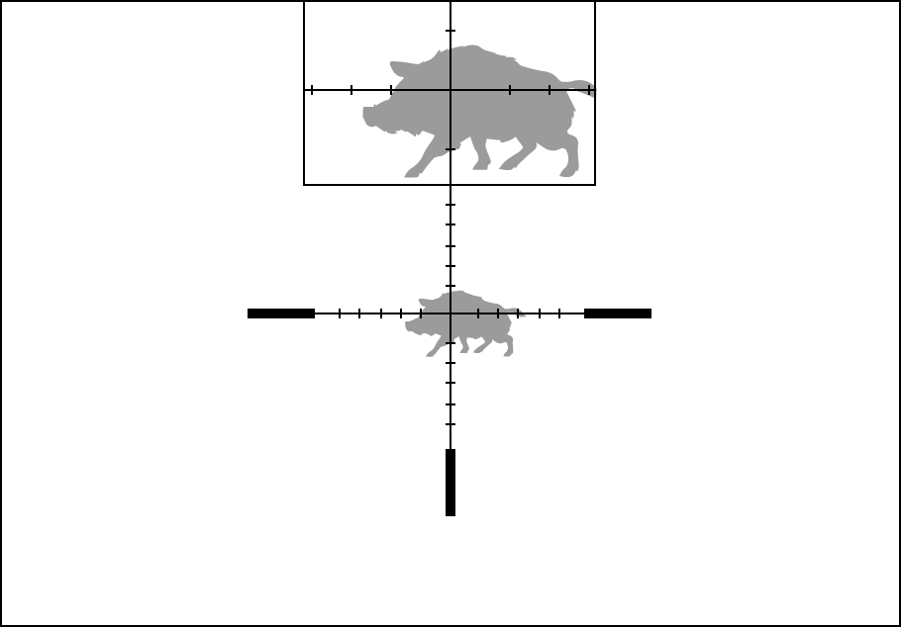
- Press and hold the ZOOM (5) button to turn on/off the PiP function.
- To change the digital zoom in the PiP window, briefly press the ZOOM (5) button or rotate the controller ring (6) until the icon is visible on the screen .
- The magnified image is displayed in a particular dialog box, with the full magnification being used.
- The rest of the image is displayed only with the optical zoom (digital zoom is off).
- When PiP is turned off, the display shows the full magnification set for the PiP mode.

Display-Off Function
This function darkens the screen, which aids the user’s concealment. However, the device stays on.
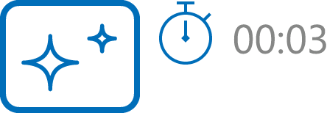

- When the device is on, press and hold the ON/OFF (14) button for less than 3 seconds. The display will turn off, the current time and the "Display off" icon will appear.
- Press the ON/OFF (14) button briefly to turn on the display.
- When you press and hold the ON/OFF (14) button, the display shows the icon "Display off" with a countdown. Holding the button down for the duration of the countdown will power the device off completely.

Wi-Fi Function
The riflescope has a function for wireless communication with mobile devices (smartphone or tablet) via Wi-Fi.
- To enable the wireless module, enter the main menu by long pressing the controller button (6).
- Rotate the controller ring (6) to select the Wi-Fi Activation menu item.
- Press the controller button (6) briefly to turn on/off the Wi-Fi module.

Wi-Fi is displayed in the status bar as follows:
Indication in the Status Bar | Connection Status
 | Wi-Fi is switched off
 | Wi-Fi is switched on by the user, Wi-Fi connection in the riflescope is in progress.
 | Wi-Fi is switched on, there is no connection to the riflescope
 | Wi-Fi is switched on, there is connection to the riflescope
- An external device recognizes the riflescope under the name ThermionDuo_XXXX, where XXXX are the four last digits of the serial number.
- After entering the password (default: 12345678) on a mobile device (see Password Setup subsection of the Wi-Fi Settings section for more information on setting a password) and setting up a connection, the icon in the riflescope status bar will change to .
- Launch Stream Vision 2 application on your mobile device (see Stream Vision 2 section).
- Video broadcasting on a mobile screen starts after the viewfinder button on the mobile screen is activated.
- The Wi-Fi function will turn off automatically if there is not enough battery power for Wi-Fi. The battery icons will turn red and flash. To use the Wi-Fi function again, you need to charge the batteries.

Scalable Reticles
This function is designed to preserve ballistic properties of the scalable reticles X51Fi-300, M56Fi, M57Fi for all magnifications.
- Enter the main menu with a long press of the controller button (6).
- Enter submenu Reticle & zeroing 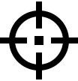 -> Reticle Type .
- Select the reticle X51Fi-300, M56Fi, M57Fi.

Notes:
- When zooming in and out the image, the selected reticle on the display and in the recorded video changes its geometrical size according to the magnification selected.
- In thermal imaging and digital modes, the reticle size is changed both on the main screen and in the PiP window.

Stadiametric Rangefinder
Thermal imaging riflescopes are equipped with a stadiametric rangefinder, which allows you to determine the approximate distance to an object, if its size is known.
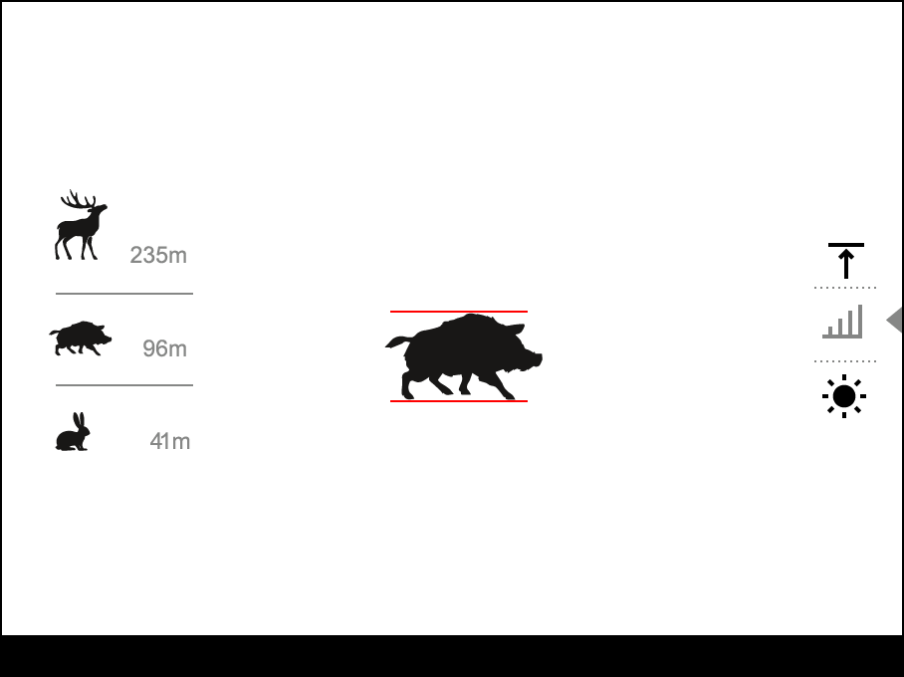
- To select the Stadiametric Rangefinder function, enter the Quick Menu by briefly pressing the controller button (6).
- Press the controller button (6) briefly to select the icon .
- The display will show the lines for measurements, the icons and numbers of the measured distance for three objects.
- Place the bottom fixed line under the object.
- Rotate the controller ring (6) to move the upper line relative to the lower horizontal fixed line so that the object is located directly between the lines. A target range automatically recalculated along with movement.
- To exit the rangefinder mode, briefly press the controller button (6) or wait 10 seconds to exit automatically.

Notes:
- There are three predefined values for objects: Hare – 0.3 m high, Boar – 0.7 m high, Deer – 1.7 m high.
- The measured range value is rounded off before being displayed – for large range values up to 5 m, for shorter range – up to 1 m.
- To select a unit of measurement (meters or yards), go to the General Settings menu item => Units of Measure submenu.

USB Connection
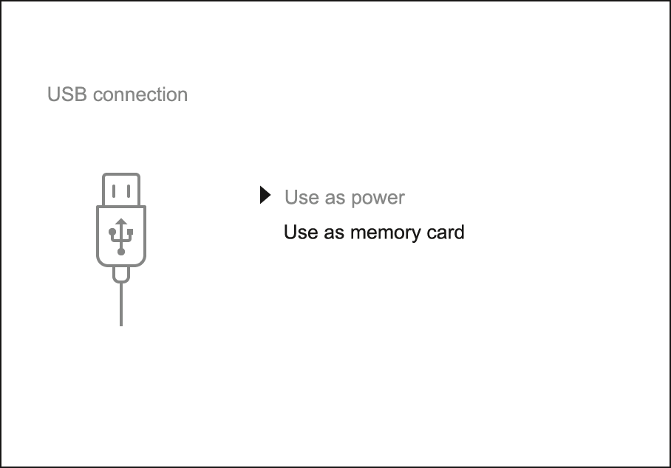
- Press the ON/OFF (14) button briefly to power the riflescope on (the computer will not detect the riflescope if it is turned off).
- Connect one end of the USB cable to the riflescope USB Type-C port (10) and the other one to the port on your computer using a USB Type-A adapter.
- The riflescope is detected by the computer automatically and no installation of drivers is required.
- After a few seconds, two connection options appear on the display: Power and Memory card.
- Rotate the controller ring (6) to select the connection mode.
- Press the controller button (6) briefly to confirm your selection.

Power
- Upon choosing this mode, your PC is used as an external power supply. An icon will appear in the status bar.
- The riflescope continues operating and all functions are accessible.
- Battery recharge feasibility depends on your computer's USB port.

Memory Card
- When selecting this mode, the computer recognizes the riflescope as a memory card. This mode is designed to manage the files saved in riflescope’s memory.
- Even though the riflescope is on, its functions are unavailable in this mode. It will continue to operate after being disconnected from the computer.
- If a video was being recorded at the moment of connection, the recording will stop and will be saved.

USB Disconnection
- When disconnecting from the computer, the device will continue to operate from the battery pack (if it is present and holding enough charge).
- If the riflescope is in Memory Card mode and is disconnected from USB, the device will remain on.

Software

Stream Vision 2
Install the Stream Vision 2 application to download files, update firmware, control the device by remote control and broadcast images from your device to a smartphone or a tablet via WiFi.
We recommend using the latest version – Stream Vision 2.

You can find further guidelines on Stream Vision 2 here.
Download from Google Play
Download from App Store
Find answers to frequently asked questions about using Stream Vision 2 here.

Stream Vision 2 Manual
Android
iOS

Firmware Update
- Download free Stream Vision 2 App in Google Play or App Store.
- Connect your Pulsar device to your mobile device (smartphone or tablet).
- Launch Stream Vision 2 and go to section “Settings”.
- Select your Pulsar device and press “Check firmware update”.
- Wait for the update to download and install. Pulsar device will reboot and will be ready to operate.
Important:
- If your Pulsar device is connected to a phone or mobile device, please enable mobile data transfer (GPRS / 3G / 4G) to download the update;
- If your Pulsar device is not connected to your phone or mobile device, but is already in Settings > My Devices, you can use Wi-Fi to download the update.
Find answers to frequently asked questions about using Stream Vision 2 here.

Maintenance

Technical Maintenance
Maintenance should be carried out at least twice a year and should include the following steps:
- Wipe the exterior surfaces of metal and plastic parts with a cotton cloth. Do not use chemically active substances, solvents, etc. as these will damage the paint.
- Clean the electric contacts of the battery pack and battery slots on the riflescoepe using a non-greasy organic solvent.
- Recharge the battery if necessary (50%-80% is recommended for normal use).
- Check the lenses of the eyepiece and objectives. If necessary, remove dust and sand from the optics (it is preferable to use a non-contact method). Cleaning of the exterior surfaces of the optics should be done with cleaners designed especially for this purpose.

Technical Inspection
It is recommended to inspect your riflescope before each use. Check the following:
- The device should be free of any cracks or deformations.
- The lenses of the eyepiece and objectives should be free of cracks, grease, dirt or debris.
- The state of rechargeable batteries (should be fully charged). Electrical sockets should be free of salts, oxidation, or other debris.
- All controls should be responsive.

Troubleshooting
For technical support please contact support@pulsar-vision.com.
Answers to frequently asked questions about the devices can also be found in the FAQ section.

The device does not turn on
Possible cause
The Battery Pack is empty
Solution
Charge the Battery Pack

The device does not operate from an external power source
Possible cause
USB cable is damaged.
Solution
Replace USB cable.

Possible cause
The external power supply is discharged.
Solution
Charge the external power supply.

The thermal image is fuzzy. There are distortions in the form of bars of different widths lying in different directions, or dots of different size and brightness.
Possible cause
Calibration is required.
Solution
Perform image calibration according to Calibration Mode section.

Black screen after calibration
Solution
If the image does not clear after calibration, you need to recalibrate.

The reticle is blurred and cannot be focused with the dioptre ring
Possible cause
The dioptre adjustment range is not enough for your eyesight.
Solution
If you wear glasses with a range of -3/+5, keep glasses on when looking through the eyepiece.

Coloured lines appeared on display or image has disappeared
Possible cause
The device was exposed to static electricity during operation.
Solution
After exposure to static electricity, the device may either reboot automatically, or require turning off and on again.

The image is too dark
Possible cause
Brightness or contrast level is too low.
Solution
Adjust the brightness or contrast in the Quick Menu.

The reticle is crisp but an object at least 30 m away is blurry
Possible cause
Dust and condensation are covering the outside or inside optical surfaces.
Solution
Wipe the outer surface of the objective lens with a soft cotton cloth. Dry the riflescope. Let it stand for four hours in a warm room.

Possible cause
The lens of the thermal imaging channel is not focused.
Solution
Adjust the clarity of the image by turning the focus knob of the thermal imaging channel lens.

The point of impact shifts after firing rounds
Possible cause
The riflescope is not mounted securely or the mount was not fixed with thread sealant.
Solution
Check that the riflescope has been securely mounted.
Make sure you are shooting the same cartridge and load as when the weapon was first zeroed.
Be advised that changes in season, time of day and/or changes in temperature may slightly shift your point of impact. Double checking your zero before hunting is recommended.

Thermal imaging channel is not focused
Possible cause
Wrong settings.
Solution
Adjust the riflescope according to the Powering on and Image Setting section.
Check the outer surfaces of the lenses of the thermal imaging channel and the eyepiece and, where necessary, wipe away dust, condensation, frost, etc. In cold weather, you can use special anti-fogging coatings (e.g., the same as for corrective glasses).

Smartphone or tablet cannot be connected to the device
Possible cause
Password in the riflescope was changed.
Solution
Delete network and connect again inserting the password saved in the riflescope.

Possible cause
There are too many Wi-Fi networks in the area where the riflescope is located which may cause signal interference.
Solution
To ensure stable Wi-Fi performance, move the riflescope to an area with few or no Wi-Fi networks.
Solution
Switch the device's Wi-Fi bandwidth.

Possible cause
The device has a 5 GHz network enabled, but the smartphone only supports 2.4 GHz.
Solution
Switch the device's Wi-Fi bandwidth to 2.4 GHz.

More information on solving problems with connection to Stream Vision 2 by following the link.

Wi-Fi signal is missing or interrupted
Possible cause
Smartphone or tablet is out of range of a strong Wi-Fi signal. There are obstacles between the device and the smartphone or tablet (e.g., concrete walls).
Solution
Relocate smartphone or tablet into the Wi-Fi signal line of sight.

More information on solving problems with connection to Stream Vision 2 by following the link.

There is no image of the observation object in the thermal imaging mode
Possible cause
The object is behind glass, which obstructs thermal vision.
Solution
Remove the glass.

Poor image quality / Reduced detection distance
Possible cause
These problems may occur during observation in adverse weather conditions (snow, rain, fog etc.).

There are several bright or black dots (pixels) on the riflescope display, microbolometer or digital sensor
Solution
The dots are caused by the peculiarities of the manufacturing technology of microbolometers, digital sensors or display and not a defect.

When the device is used in low temperature conditions the thermal image quality is worse than in positive temperatures.
Possible cause
In warm climates, objects in the background of a thermal image heat up differently because of thermal conductivity, generating a high temperature contrast and a sharper thermal image.
In cold climates, objects in the background of a thermal image will cool down to roughly the same temperature, which leads to a greatly reduced temperature contrast and a degraded image quality. This is normal for all thermal imaging devices.

There is no thermal imaging or digital image
Possible cause
Lens cover closed.
Solution
Open the covers of the thermal imaging and digital channels.

Possible cause
Channel is turned off.
Solution
Turn on the desired channel in the “Viewing Channel Activation” item of the General Settings section in the main menu.

Legal Compliances and Disclaimers
Attention! Thermion Duo multispectral riflescopes require a licence when exported outside your country.
Electromagnetic compatibility. This product complies with the requirements of European standard EN 55032: 2015, Class A.
Caution: operating this product in a residential area may cause radio interference.
The manufacturer reserves the right at any time, without mandatory notice, to make changes to the package contents, design and characteristics that do not impair the quality of the product.
Repair of the device is possible within 5 years.

