Manual Thermion 2 LRF Pro
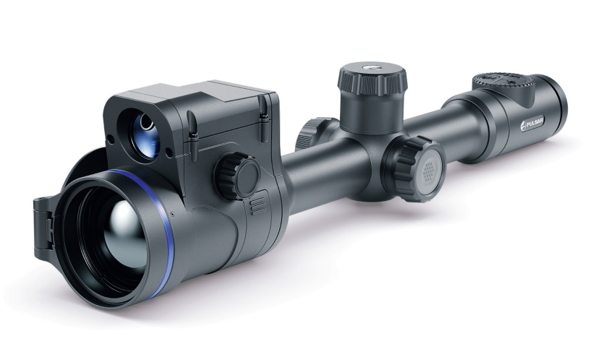

About the device

Description
Thermion 2 LRF Pro thermal imaging riflescopes are designed for use both at night-time and during the day and provide exceptional image quality even in adverse weather conditions (fog, smog, rain) and beyond obstacles like branches, tall grass, dense foliage, etc. known to hinder target detection.
Unlike riflescopes based on electrical-to-optical converters, thermal imaging riflescopes do not require an external light source and are resistant to high levels of illumination.
The riflescopes are equipped with a high precision built-in laser rangefinder which allows distance measurement up to 800 meters.
These riflescopes are designed for hunting, target shooting and recreational shooting, observation and orientation.

To get started, see the sections:
Battery Charging
Battery Installation
Mounting on the Rifle
Powering on and Image Setting
Zeroing
Laser Rangefinder

Package Contents
- Thermal imaging riflescope
- АPS2 Battery Pack
- APS battery charger
- Power adapter
- USB Type-C - Type-C cable
- USB Type-С - Micro USB Type-B cable
- Carrying case
- Lens-cleaning cloth
- Quick User Manual
- Warranty card
- APS3 battery cover

Features
- Built-in laser rangefinder (up to 800 m)
- Built-in 3-axis accelerometer gyroscope (slope angle indication)
- 4 observation modes: Forest, Rocks, Identification and User
- 3 calibration modes: manual, semi-automatic and automatic
- Smooth Digital Zoom
- Multiple reticle options
- Scalable reticles (proportional to Zoom)
- 5 zeroing profiles (10 distances per profile)
- One-shot “Freeze-Zeroing” function
- Precise “Zoom zeroing” (reducing the MOA per click when zooming in)
- 8-colour display palette
- Pixel repair function
- “Display-Off” function
- Integrated Wi-Fi for remote control and personal device connectivity
- Device firmware update using the free Stream Vision 2 App
- High-strength aluminium alloy housing
- Recoil rated to .375H&H, 9.3x64 and 12-gauge

Video Recording
- Built-in photo and video recorder with audio
- 16 GB internal memory
- iOS and Android compatible
- Storing photos and videos in Cloud when using the Stream Vision 2 App

Battery Pack
- Built-in 4900 mAh Battery Pack APS5
- Quick-change rechargeable Li-Ion APS2/APS3 battery packs
- Internal and external battery charging via USB Type-C port

Components and Controls
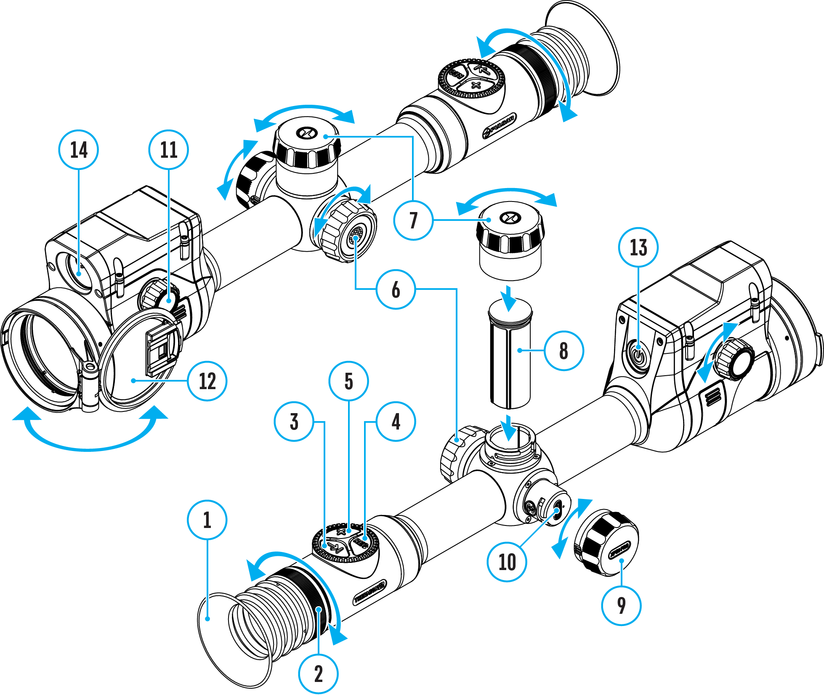

- Eyecup
- Eyepiece diopter adjustment ring
- LRF button
- REC button
- ZOOM button
- Controller
- Battery compartment cover
- Battery APS2
- USB Type-C cover
- USB Type-C port
- Lens focus knob
- Lens cap
- ON/OFF button
- Laser rangefinder

Specifications
Model | LRF XP50 PRO
SKU | 76551
Microbolometer
Type | uncooled
Resolution, pixels | 640x480
Pixel Pitch, µm | 17
NETD, mK | < 25
Frame refresh rate, Hz | 50
Optical Specifications
Lens, mm | F50 F/1.0
Magnification, x | 2-16
Eye relief, mm/inch | 50/1.96
Field of view (H), °/m@100 | 12.4/21.8
Diopter adjustment, D | -3/+5
Detection distance (Object of "deer" type), m/y | 1800/1970
Aiming Reticle
Click value (H/V), mm@100 m – when magnifying, x | 21 – 2х  10.5 – 4х  5.25 – 8х  2.6 – 16х
Click range, mm@100 m (H/V) | 4200/4200
Display
Type | AMOLED
Resolution, pixels | 1024х768
Operating Features
Diameter of the riflescope body to assemble the mounting rings, mm | 30
Power Supply, V | 3–4.2
Battery type / Capacity / Rated Output Voltage | Li-Ion Battery Pack АPS2 / 2000 mAh / DC 3.7 V (removable)  or  Li-Ion Battery Pack APS3 / 3200 mAh / DC 3.7 V (removable)*  Li-Ion Battery Pack APS5 / 4900 mAh / DC 3.7 V (built-in)
External Power Supply | 5 V, 9 V (USB Type-C Power Delivery)
Battery Packs (built-in APS5 and removable APS2) operating time at temp. = 22 °C, hrs** | 10
Max. recoil power on rifled weapon, Joules | 6000
Max. recoil power on smoothbore weapon, caliber | 12
Degree of protection IP code (IEC60529) | IPX7
Operating temperature, °С / °F | -25 – +50 / -13 – +122
Dimensions with an eyecup, mm/inch | 420x78.5x94.5 / 16.54x3.09x3.72
Weight (without removable battery), kg/oz | 0.97 / 34.22
Video Recorder
Photo / video resolution, pixels | 1024x768
Video / photo format | .mp4 / .jpg
Built-in memory | 16 GB
Wi-Fi Channel***
Frequency | 2.4/5 GHz
Standard | IEEE 802.11 b/g/n/ac
Laser Rangefinder
Wavelength, nm | 905
Max. Measurement Range, m/y**** | 800 / 874.9
Measurement Accuracy, m | 1
* Purchased separately.
** The actual operating time depends on the intensity of using Wi-Fi, video recorder, laser rangefinder.
*** The reception range may vary depending on various factors: obstacles, other Wi-Fi networks.
**** Depends on the characteristics of the object under observation and environmental conditions.

Power supply

Battery Charging
Thermion 2 LRF Pro thermal imaging riflescopes come with a built-in rechargeable lithium-ion Battery Pack APS5 and a removable rechargeable lithium-ion APS2 Battery Pack. The batteries should be charged before first use.

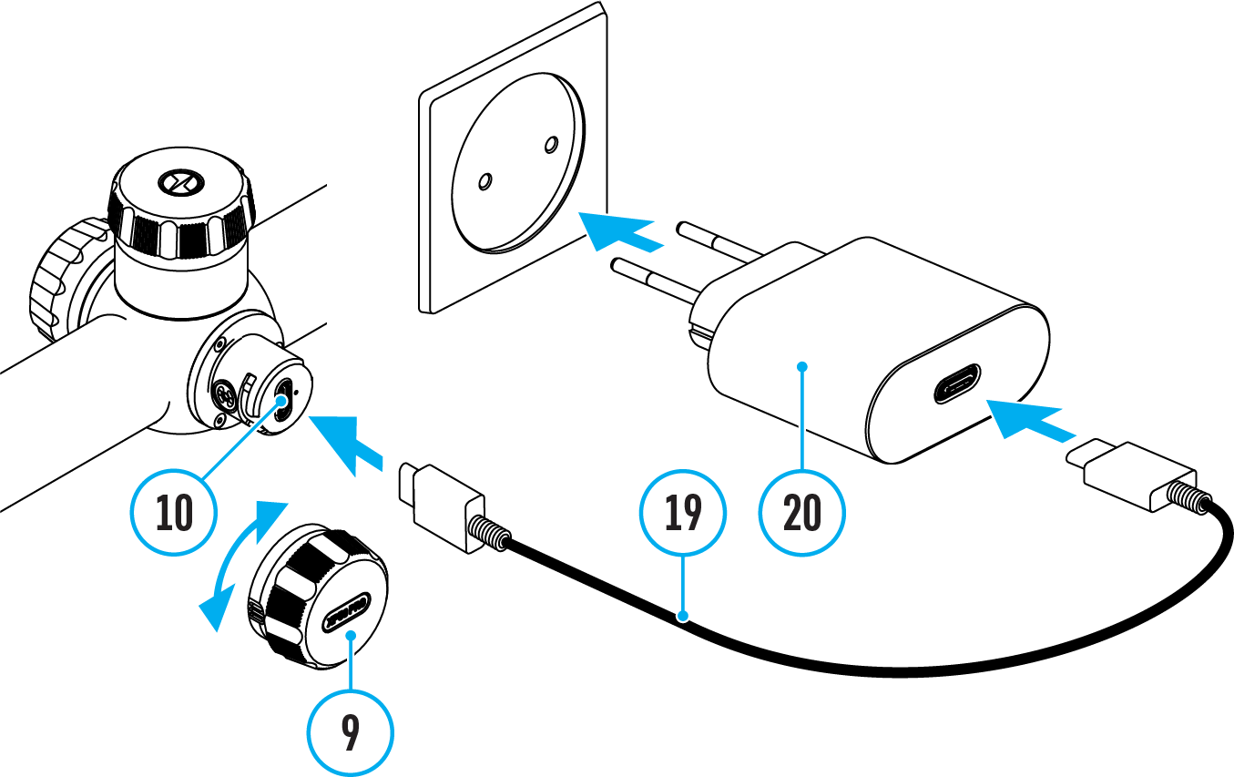
- Open the USB Type-C cover (9) by turning it counterclockwise.
- Connect the USB Type-C plug of the USB cable (19) to the USB Type-C port (10) in the body of the riflescope.
- Connect the second USB plug of the USB cable (19) to the USB port on the power adapter (20).
- Plug the device into a 100–240 V socket.
- Wait until the batteries are fully charged (indication in the status bar: 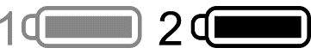).
Attention! When charging rechargeable batteries with a USB Type-C connector (10) in the riflescope body section, charging priority is given to the built-in battery. When the device is off, both batteries are charged at the same time. When using the device, the external battery is discharged first.

The rechargeable lithium-ion APS2 and APS3* Battery Packs may be recharged using the APS** charger
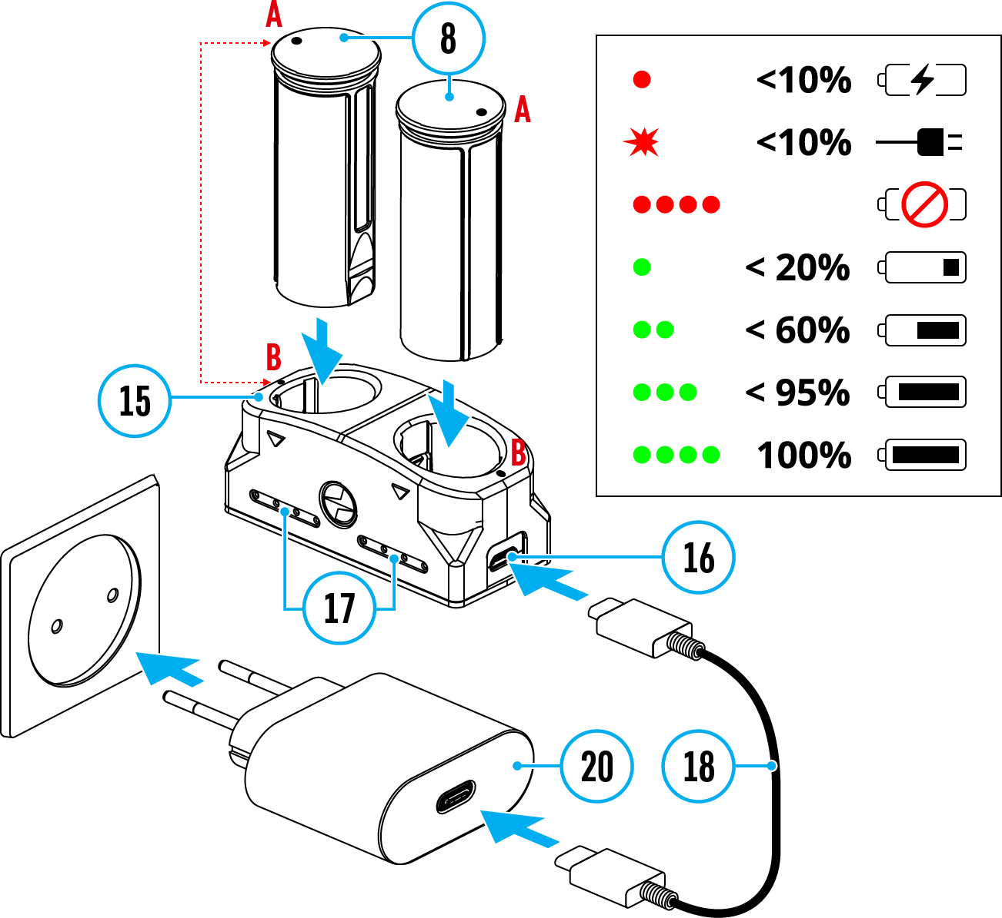
- Insert the Battery Pack (8) along the rail into the APS charger (15) slot as far as it will go. The APS charger is supplied with your device or purchased separately.
- Point A on the battery and point B on the charger should match.
- Connect the Micro USB Type-B plug of the USB cable (18) to the port (16) of the charger (15).
- Connect the second plug of the USB cable (18) to the USB port on the power adapter (20).
- Plug the device into a 100-240 V socket.
- The LED indicator (17) will display battery charge status.
- Wait until the battery is fully charged (LED indication (17): ).
- Two batteries* can be charged at the same time: the second slot is designed for it.
(17) LED Indicator*** | Battery Charge Status
 | Battery level is from 0% to 10%. Charger is not connected to a power supply.
 | Battery level is from 0% to 10%. Charger is connected to a power supply.
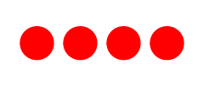 | Defective battery. Do not use the battery.
 | Battery level is from 10% to 20%.
 | Battery level is from 20% to 60%.
 | Battery level is from 60% to 95%.
 | The battery is completely charged and can be disconnected from the charger.
* Purchased separately.
** Included in the delivery package.
*** LED indicator displays the current battery charge status for 30 seconds when the APS charger is not plugged in. When the power is being supplied, the indicator is constantly displaying the current battery charge status, the LEDs are additionally flickering to display the battery charging process.

Battery Installation
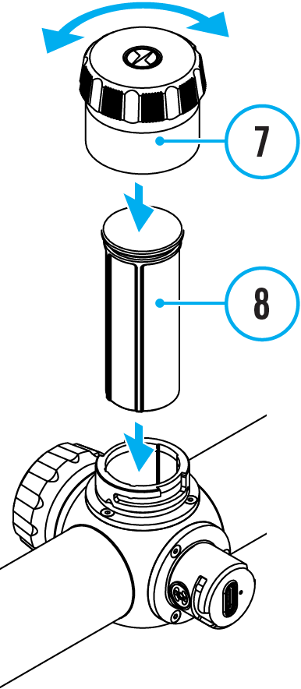
- Turn the battery cover (7) counter clockwise and remove.
- Install the battery (8) into the battery compartment along the special guides in the device casing designed for it.
- When properly installed, the battery is locked into the slot with a special clip.
- Close the battery cover (7) by turning it clockwise.

Switching and Changing the Batteries
Thermion 2 LRF Pro riflescopes are powered by 2 batteries: built-in Battery Pack APS5 and removable Battery Pack APS3/APS2.

- If there are two batteries in the device, two battery icons are displayed in the status bar (1 - built-in battery, 2 - removable battery). The device battery is displayed in grey and white; it is grey when inactive.
- When there is no removable battery in the device, only one icon for the built-in battery displays in white in the status bar.
- When both batteries are fully charged, the device is powered by the removable battery. If there is low removable battery level, the device will switch to the built-in battery.
- Battery charge level is displayed in % above the icon in the status bar while charging.
- It is possible to replace removable battery with device turned on when it is powered by built-in battery (the device will continue to work properly).

Attention! When installing a removable battery with a sufficient charge level, the device will automatically switch to it.

External Power Supply
External power can be supplied from an external source, such as a Power Bank (5 V, 9 V).
- Connect the external power supply to the micro USB Type-C port (10) of the riflescope.
- The riflescope switches to external power source, while built-in Battery Pack APS5 and removable Battery Pack APS2 (or APS3*) will gradually recharge.
- A rechargeable battery icon 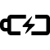 indicating a percentage of the battery life will appear in the status bar.
- When you turn off external power source, the riflescope switches over to the removable battery without turning off. When there is no removable battery or low power level the device switches to the built-in battery.
* Available separately

Warning! Charging APS3 / APS3 / internal APS5 batteries at air temperatures below 0° C (32° F) may reduce battery life. When using external power, connect the Power Bank to the device after it has been turned on and working for several minutes.

Precautions
- Only use the charger supplied with the Battery Pack. The use of any other charger may irreparably damage the Battery Pack or the charger and may cause fire.
- Do not charge the Battery Pack immediately after bringing it from a cold environment to a warm one. Wait for 30-40 minutes for the Battery Pack to get warm.
- Do not leave the Battery Pack unattended while charging.
- Never use a modified or damaged charger.
- Do not leave the Battery Pack with a charger connected to the power adapter after charging is complete.
- Do not expose the Battery Pack to high temperatures or an open flame.
- Do not submerge the Battery Pack in water.
- Do not connect an external device with a current consumption that exceeds permitted levels.
- Do not dismantle or deform the Battery Pack.
- Do not drop or hit the Battery Pack.
- Keep the Battery Pack out of the reach of children.

Recommendations for Use
- During long-term storage, the Battery Pack should be partially charged – the charge level should be between 50% and 80%.
- Charge the Battery Pack at a temperature from 0° C to +45° C (32° F to +113° F), otherwise the battery life will decrease significantly.
- When using the Battery Pack at sub-zero (sub 32° F) temperatures the battery capacity decreases. This is normal and is not a defect.
- Do not use the Battery Pack at temperatures above those shown in the table – this may decrease battery life.
- The Battery Pack is short circuit protected; however, any situation that may cause short-circuiting should be avoided.

Getting Started

Mounting on the Rifle
To ensure accurate shooting the Thermion 2 LRF Pro riflescope should be properly mounted on the rifle.
- Mount the riflescope with 30mm scope rings or a single-piece scope mount, purchased separately. Use only high-quality mounts and rings compatible with your rifle. Follow the mount manufacturer's installation instructions and use the proper tools.
- When mounting the riflescope, adjust the position of the scope on the rifle to achieve optimal, comfortable eye relief as specified by the Technical Specifications. Failure to comply with this recommendation may result in injury to the shooter.
- Install the riflescope as low as comfortably possible without contacting the barrel or receiver.
- In order to avoid pinching the riflescope body, tighten ring screws to a maximum of 2.5 Nm (22.1 in.-lbs). Using a torque wrench is recommended.
- Using the included eyecup (1) is recommended to increase camouflage and avoid detection. The eyecup is mounted on the riflescope's eyepiece via integral magnets.
- Before using the riflescope (especially for hunting), follow instructions in the Zeroing section.

Powering on and Image Setting
- Remove the lens cover (12).
- Turn the unit on with a short press of the ON/OFF (13) button.
- Adjust the sharpness of the symbols on the display by rotating the dioptre adjustment ring of the eyepiece (2).
- Rotate the lens focus knob (11) to focus on the object being observed.
- Enter the main menu with a long press of the controller button (6) and select the desired Calibration Mode: manual (M), semi-automatic (SA) or automatic (A).
- Calibrate the image with a short press of the ON/OFF (13) button (when calibration mode SA or M has been selected). Close the lens cap before manual calibration.
- Select the required operating mode (Forest, Rocks, Identification, User) in the main menu. User mode allows you to configure and save custom brightness and contrast settings, as well as one of three modes as a base.
- Activate the quick menu by briefly pressing the controller button (6) to adjust the brightness and contrast of the display (see the Quick Menu Functions section).
- Press the ZOOM (5) button successively to change the magnification ratio of the riflescope. While the icon is visible on the screen, rotate the controller ring (6) for smooth digital zooming from the current magnification.
- Power the device off with a long press of the ON/OFF (13) button.

Warning! Never point the lens at intensive energy sources such as laser radiation emitting devices or the sun. It can damage electronic components in the device. The warranty does not cover damage arising from failure to comply with operating instructions.

Button Operation
Operation | Button
Power device on | short press
Power device oﬀ | long press for 3 secs
Turn display oﬀ | long press for less than 3 secs
Turn display on | short press
Calibrate the microbolometer | short press
Control discrete digital zoom | short press
Smooth Zooming | rotation
PiP on/oﬀ | long press
Change observation modes | long press
Video Recorder | Button
Start/pause/resume video recording | short press
Stop video recording | long press
Switch to video / photo mode | long press
Capture Photo | short press
Main Menu | Button
Enter main menu | long press
Navigation through menu | rotation
Enter menu items | short press
Confirm value | short press
Exit menu items | long press
Exit main menu | long press
Quick Menu | Button
Enter quick menu | short press
Switch between quick menu options | short press
Parameter change | rotation
Exit quick menu | long press
Rangefinder | Button
Activate rangefinder | short press
Measure distance | short press
Start/stop SCAN mode | long press

Zeroing
Zeroing at a temperature close to the riflescope’s operating temperature is recommended.
Step 1. Take a shot
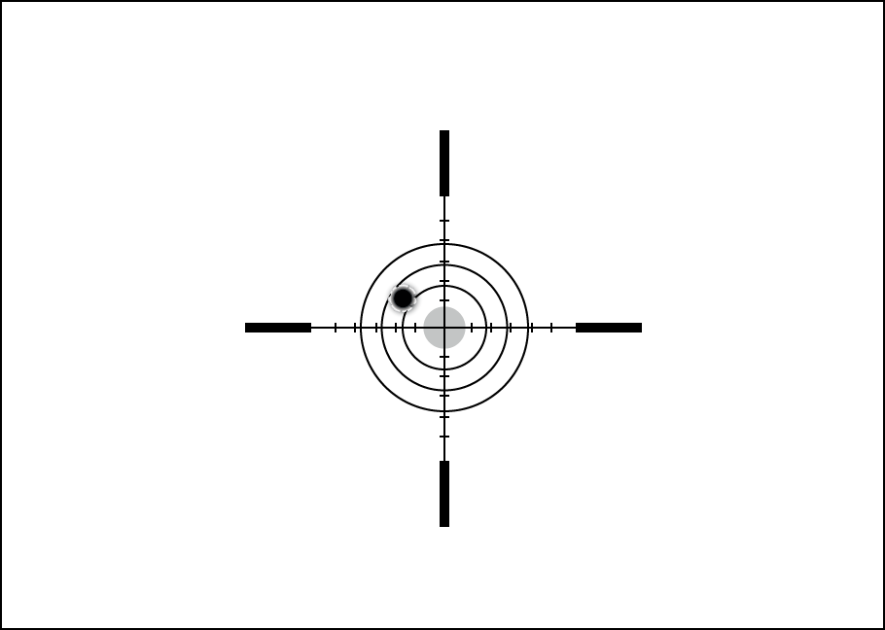
1. Shooting from a benchrest is recommended.
2. Set a target at a known distance.
3. Adjust the riflescope according to the Powering on and Image Setting section.
4. Select the zeroing profile (see Reticle & Zeroing 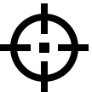 -> Zeroing Profile main menu item)
5. Point the rifle at the center of the target and shoot.

Step 2. Align the reticle with the point of impact
1. Press and hold the controller button (6) to enter the main menu.
2. Add the distance you are aiming at (e.g. 100 meters): Reticle & Zeroing -> Add New Distance . Select the value for each distance digit by rotating the controller ring (6). Press the controller button (6) briefly to switch between digits. After setting the required distance, press and hold the controller button (6) to save it.
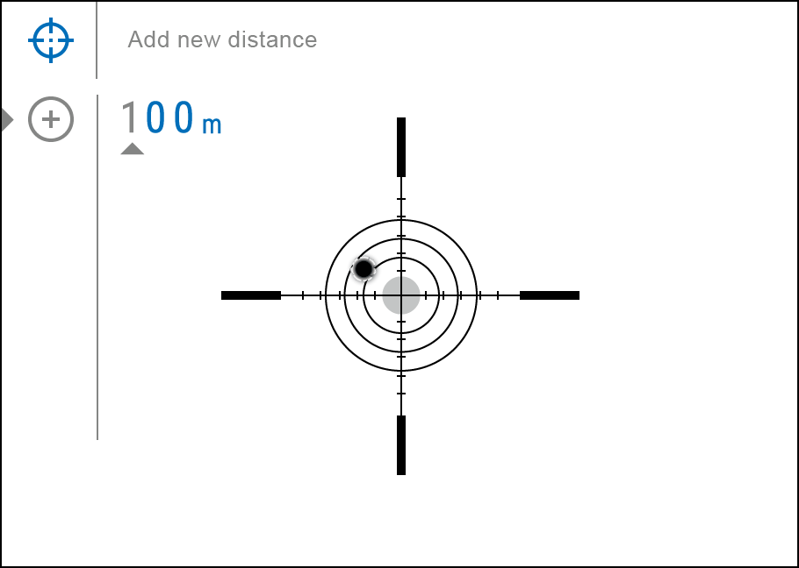
3. After adding the distance, it will switch to the Zeroing parameters settings menu . An auxiliary cross will appear in the center of the display, and X and Y coordinates of the auxiliary cross will appear in the upper right corner.
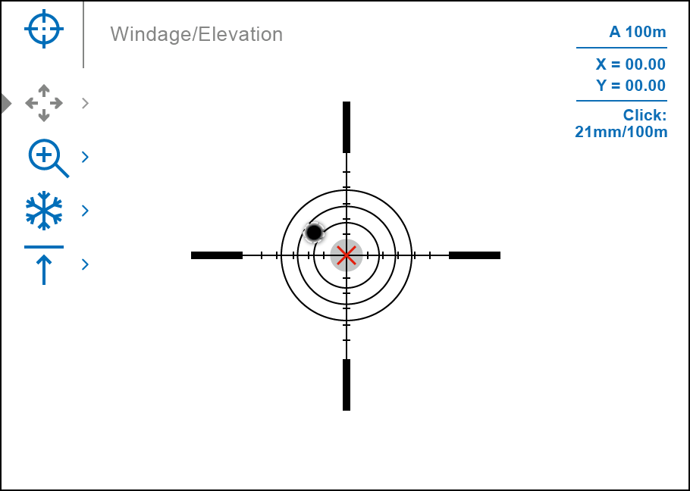
4. Press the controller button (6) briefly to enter the Windage/Elevation submenu.
5. While holding the reticle at the aiming point, move the auxiliary cross until it is aligned with the impact point by rotating the controller ring (6).
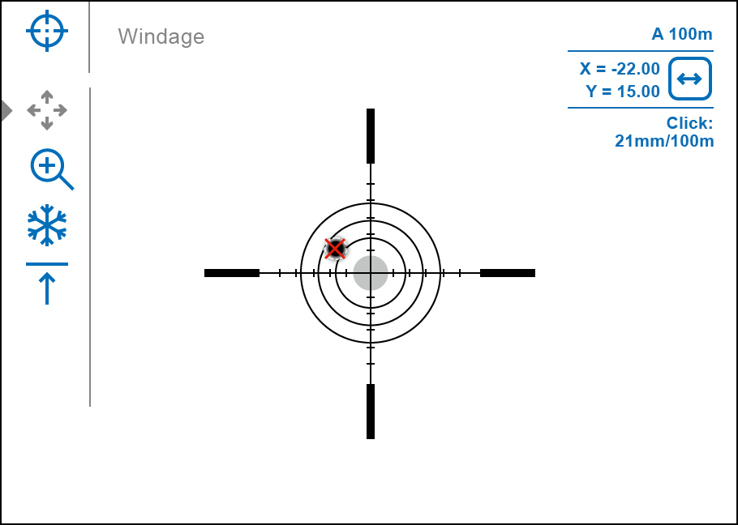
6. To change the direction of the auxiliary cross movement from horizontal to vertical, press the controller button (6) briefly.

One-shot "Freeze Zeroing" function:
Using the Freeze function allows you to make adjustments without the need to hold the rifle precisely at the initial aiming point – freezing the zeroing screen (refer to Reticle & Zeroing menu item => Distance submenu => Zeroing Parameters Settings submenu => Freeze submenu or short pressing of the ON/OFF (13) button. The image will “freeze” and the icon will appear.

Step 3. Save the coordinates
1. Press and hold the controller button (6) to save a new position for the reticle. The reticle will be aligned with the impact point and it will exit the Windage/Elevation submenu.
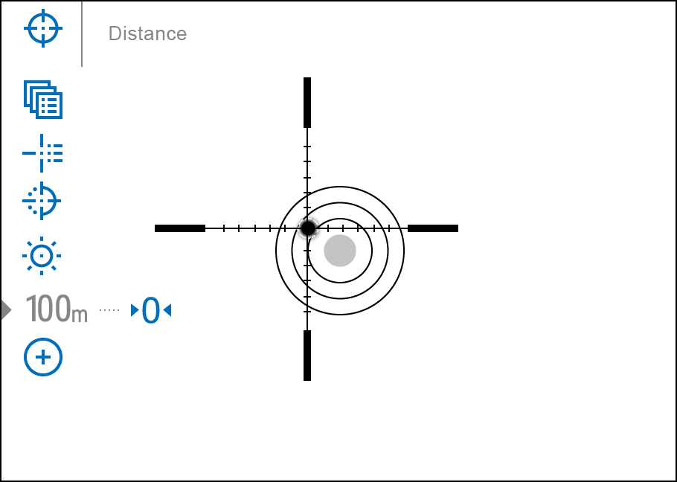
2. Press and hold the controller button (6) again to exit the zeroing settings menu - the message “Zeroing coordinates saved” appears, confirming the successful operation.
3. Fire a second shot - now the point of impact and the aiming point must be matched.

Interface

Status Bar
The status bar at the bottom of the display shows current operating statuses via icons, including:
- Colour Mode (shown only when the Black Hot colour mode is selected)
- Actual zeroing profile (e.g., A)
- Zeroing distance (e.g., 100 m)
- Observation mode (e.g., Identification)
- Calibration mode (a countdown timer 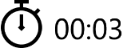 will appear instead of the calibration icon when in automatic calibration mode with 3 seconds remaining until automatic calibration)
- Current magnification
- Microphone
- Wi-Fi connection
- Auto Shutdown function (e.g., 5 min.)
- Clock
- Power supply:
- Battery discharge level 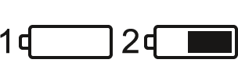 (when riflescope is powered by a built-in or removable battery).
- External battery power indicator (if the riflescope is powered by an external power supply).
- Battery indicator 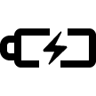 with current percentage of charge (when charging from an external power source).

Quick Menu Functions
The basic settings (adjusting brightness and contrast, information on the distance) can be changed using the quick access menu.
- Press the controller button (6) briefly to enter the quick menu.
- A short press of the controller button (6) enables you to switch between functions, as described below.
Brightness – rotate the controller ring (6) to change the display brightness value from 00 to 20.
Contrast – rotate the controller ring (6) to change the image contrast value from 00 to 20.
Base mode – it allows you to select one of the three observation modes (Forest, Rocks, Identification) as a base for the User mode.
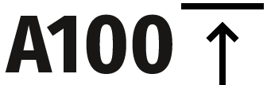 – information on the current profile and zeroing distance in this profile (e.g., profile A, zeroing distance of 100 m). This information is always displayed in the status bar. Rotate the controller ring (6) to switch between the zeroing distances in the selected profile. This function is available if there are two or more distances in the profile.
- Press and hold the controller button (6) to exit the menu or wait 10 seconds to exit automatically.

Main Menu Functions

Enter the Main Menu
- Enter the main menu with a long press of the controller button (6).
- To move through the main menu items, rotate the controller ring (6).
- Press the controller button (6) briefly to open subitems of the main menu.
- Press and hold the controller button (6) to exit from a subitem of the main menu.
- Automatic exit from the main menu occurs after 10 seconds of inactivity.

General View of the Menu

Tab 1
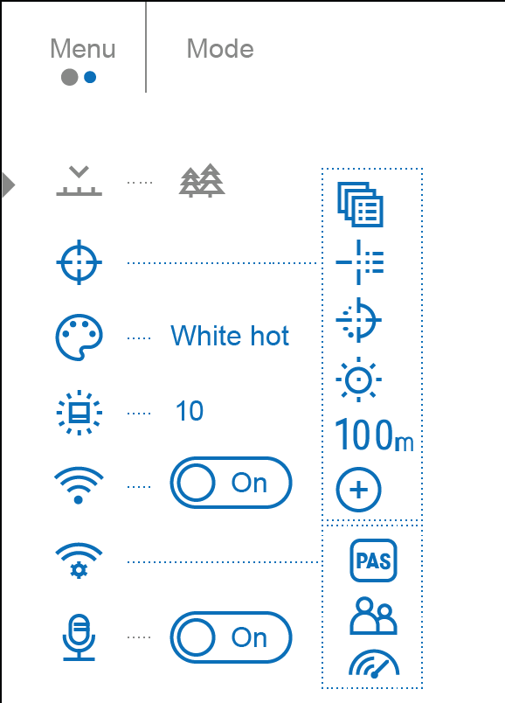

Tab 2
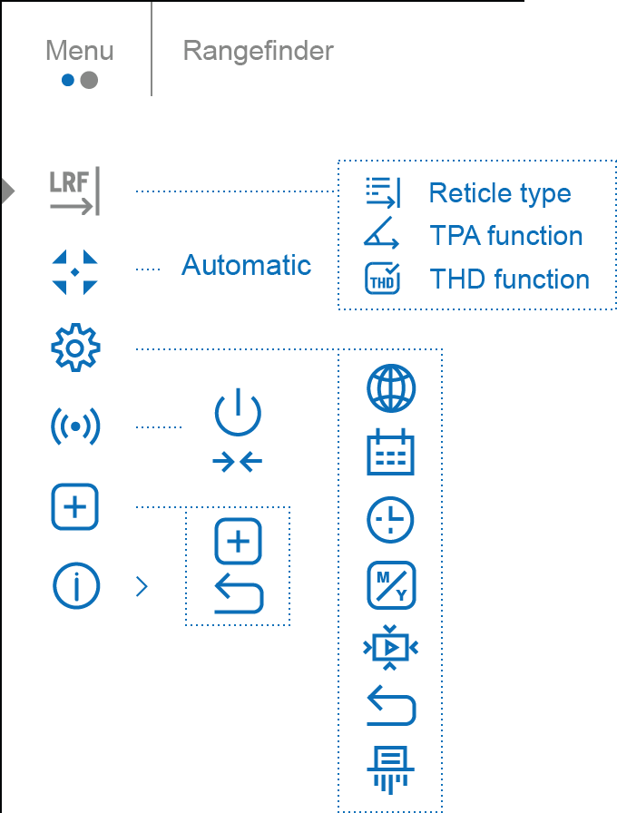

Mode
Thermal riflescopes have three operating modes of the thermal imager: Forest (observation mode of objects within low thermal contrast conditions), Rocks (observation mode of objects within high thermal contrast conditions), Identification (high detalization mode), User (individual brightness and contrast settings).
Each mode has been created to provide the best image quality of a wild nature object being observed within various observation conditions.

- Press and hold the controller button (6) to enter the main menu.
- Rotate the controller ring (6) to select the Mode 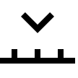 menu item.
- Press the controller button (6) briefly to enter the Mode submenu.
- Rotate the controller ring (6) to select one of the modes: Forest, Rocks, Identification, User.
- Press the controller button (6) briefly to confirm the selection.

Forest
This is the best mode when searching and observing within field conditions, against the background of leaves, bushes and grass. The mode is highly informative about an object being observed as well as landscape details.
Rocks
This is the best mode when observing objects after a sunny day or within urban conditions.
Identification
This is the best mode when observing objects within adverse weather conditions (fog, mist, rain and snow). It allows you to recognize the characteristics of an object being observed more clearly. Zoom increase may be accompanied by insignificant image graininess.
User
It allows you to configure and save custom brightness and contrast settings, as well as one of the three modes (Forest, Rocks, Identification) as basic.

Reticle & Zeroing

Zeroing Profile
This item of the main menu allows you to select one of five profiles (А, В, С, D, E) to use. Each profile stores information on the following parameters:
- A set of zeroed distances
- Reticle colour
- Reticle type
Different profiles can be used when using the riflescope on different rifles or when shooting with different bullets.

- Press and hold the controller button (6) to enter the main menu.
- Rotate the controller ring (6) to select the Reticle & Zeroing menu item.
- Press the controller button (6) briefly to enter the Reticle & Zeroing submenu.
- Press the controller button (6) briefly to enter the Zeroing Profile submenu.
- Rotate the controller ring (6) to select one of the zeroing profiles (marked with the letters A, B, C, D, E).
- Confirm your selection with a short press of the controller button (6).
- The name of the selected profile appears in the status bar at the bottom of the display.

Reticle Type
Selection of the aiming reticle shape.
- Press and hold the controller button (6) to enter the main menu.
- Rotate the controller ring (6) to select the Reticle & Zeroing menu item.
- Press the controller button (6) briefly to enter the Reticle & Zeroing submenu.
- Rotate the controller ring (6) to select the Reticle Type submenu.
- Press the controller button (6) briefly to enter the Reticle Type submenu.
- Rotate the controller ring (6) to select the desired aiming reticle shape from the list that appears. The reticle type changes as the cursor goes down the reticle list.
- Press the controller button (6) briefly to confirm the selection.

Reticle Colour
Selection of reticle colour.
- Press and hold the controller button (6) to enter the main menu.
- Rotate the controller ring (6) to select the Reticle & Zeroing menu item.
- Press the controller button (6) briefly to enter the Reticle & Zeroing submenu.
- Rotate the controller ring (6) to select the Reticle Colour 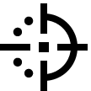 submenu.
- Press the controller button (6) briefly to enter the Reticle Colour submenu.
- Rotate the controller ring (6) to select one of the colour options for the reticle: Black/Red, White/Red, Black/Green, White/Green, Red, Green, Yellow, Blue, Orange, Black/White, White/Black.
- Press the controller button (6) briefly to confirm the selection.

Reticle Brightness
Adjust the brightness level of the aiming reticle.
- Press and hold the controller button (6) to enter the main menu.
- Rotate the controller ring (6) to select the Reticle & Zeroing menu item.
- Press the controller button (6) briefly to enter the Reticle & Zeroing submenu.
- Rotate the controller ring (6) to select the Reticle Brightness submenu.
- Press the controller button (6) briefly to enter the Reticle Brightness submenu.
- Rotate the controller ring (6) to set the desired brightness level (1 to 10).
- Press the controller button (6) briefly to confirm the selection.

Zeroing

Add New Distance
To zero your riflescope, you need to set a zeroing distance first in the range of 1 to 910 m (955 yards).
- Press and hold the controller button (6) to enter the main menu.
- Rotate the controller ring (6) to select the Reticle & Zeroing menu item.
- Press the controller button (6) briefly to enter the Reticle & Zeroing submenu.
- Rotate the controller ring (6) to select Add New Distance menu item.
- Press the controller button (6) briefly to enter the submenu.
- Rotate the controller ring (6) to select a value for each digit. Press the controller button (6) briefly to switch between digits 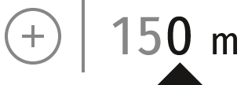.
- Having set the desired distance, press and hold the controller button (6) to save it.

The distance you set first becomes a primary distance – shown with icon 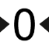 on the right to the distance value.
Note: Maximum number of zeroing distances is 10 for each profile.

Zeroing Parameters Settings
- Press and hold the controller button (6) to enter the main menu.
- Rotate the controller ring (6) to select the Reticle & Zeroing menu item and enter by briefly pressing the controller button (6) – zeroed distances are displayed at the bottom.
- The values (e.g., +7.0) shown on the right of the distance values, stand for the number of clicks along the Y axis, at which the reticle position at other distances differs from the reticle position in the primary distance.
- To zero at any distance again, rotate the controller ring (6) to select the required distance and briefly press the controller button (6).
- Rotate the controller ring (6) to select the Zeroing Parameters Settings and enter by briefly pressing the controller button (6).
- Zeroing screen, which allows the change of zeroing coordinates, will appear:

Windage/Elevation

The Windage/Elevation additional menu item in the Zeroing Parameters Settings menu allows you to adjust the reticle position. For a detailed description of the reticle adjusting, refer to the Zeroing section.

Magnification (when Zeroing)
Magnification allows you to magnify via the device’s digital zoom when zeroing, which reduces the MOA-per-click values of adjustments and improves zeroing accuracy.
- In the Zeroing Parameters Settings menu, rotate the controller ring (6) to select the Magnification submenu item and enter by briefly pressing the controller button (6).
- Rotate the controller ring (6) to select a digital magnification value of the riflescope (e.g., x4).
- Press the controller button (6) briefly to confirm your selection.
The minute of angle click when using the Magnification function is indicated in the Table of Technical Specifications.

Freeze
The “freeze” function allows the user to freely move or manipulate the rifle without losing reticle placement on the point of aim during adjustments.
- In the Zeroing Parameters Settings menu, rotate the controller ring (6) to move the cursor to the Freeze function.
- Align the reticle with the point of aiming and press the controller (6) or ON/OFF (13) button. A screenshot will be taken, an icon will appear.
- Go to the additional Windage/Elevation submenu and adjust the position of the reticle (see the Zeroing section).
- Select the Freeze submenu item again and briefly press the controller (6) or ON/OFF (13) button - the image will “unfreeze”.

Name Distance
- In the Zeroing Parameters Settings menu, rotate the controller ring (6) to select the Name Distance 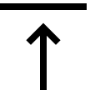 submenu item and enter it by briefly pressing the controller button (6)​.
- Rotate the controller ring (6) to select a value for each digit. Press the controller button (6) briefly to switch between digits.
- Press and hold the controller button (6) to confirm the selection.

Change Primary Distance
- Press and hold the controller button (6) to enter the main menu.
- Rotate the controller ring (6) to select the Reticle & Zeroing menu item and enter by briefly pressing the controller button (6) – zeroed distances are displayed at the bottom.
- Select a non-primary distance and enter the submenu for operating the distance with a brief press of the controller button (6).
- Select Change Primary Distance item.
- Press the controller button (6) briefly.
- Icon next to the selected distance confirms the change of primary distance.
There will also be a recalculation of corrections in clicks for other distances relative to the new primary distance.

Delete Distance
- Press and hold the controller button (6) to enter the main menu.
- Rotate the controller ring (6) to select the Reticle & Zeroing menu item and enter by briefly pressing the controller button (6) – zeroed distances are displayed at the bottom.
- Select the distance you wish to delete and enter the submenu for operating the distances with a brief press of the controller button (6).
- Select Delete Distance item.
- Press the controller button (6) briefly.
- Select “Yes” in the appeared dialog box to delete a distance. “No” – to cancel deletion.
- Press the controller button (6) briefly to confirm your selection.
Attention! If the primary distance is deleted, the first distance on the list automatically becomes the new primary distance.

Icon Brightness
Adjust the brightness level of the icons and screensavers (Pulsar, Display off) on the display.
- Press and hold the controller button (6) to enter the main menu.
- Rotate the controller ring (6) to select the Icon Brightness menu item.
- Press the controller button (6) briefly to enter the Icon Brightness submenu.
- Rotate the controller ring (6) to set the desired brightness level (1 to 10).
- Press the controller button (6) briefly to confirm the selection.

Colour Modes
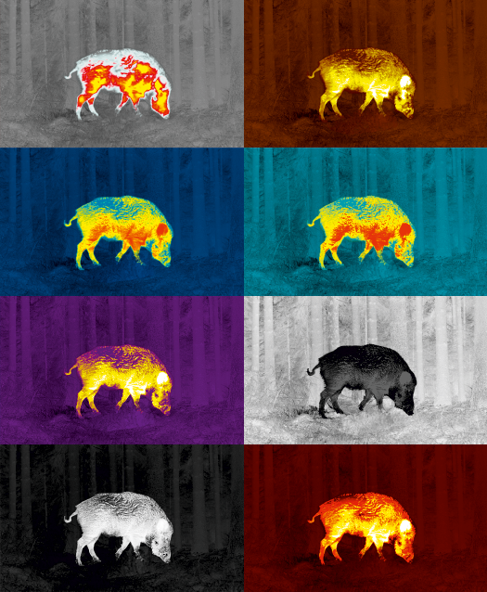
Colour mode selection.
White hot is a default display mode for an observed image.

The Colour Modes menu item allows you to select an alternative palette:
- Press and hold the controller button (6) to enter the main menu.
- Select the Colour Modes menu item.
- Press the controller button (6) briefly to enter the Colour Modes submenu.
- Rotate the controller ring (6) to select one of the palettes described below.
- Press the controller button (6) briefly to confirm your selection.

- White hot – a black and white palette (the black colour corresponds to cold temperature, the white colour – hot temperature)
- Black hot – a black and white palette (the white colour corresponds to cold temperature, the black colour – hot temperature)
- Red Hot
- Red Monochrome
- Rainbow
- Ultramarine
- Violet
- Sepia

Attention! The device does not measure the temperature of objects being observed. The image is formed based on the temperature differences of the objects.

Wi-Fi Activation
Turn on/off Wi-Fi
- Press and hold the controller button (6) to enter the main menu.
- Rotate the controller ring (6) to select the Wi-Fi Activation menu item.
- To turn Wi-Fi on, briefly press the controller button (6). 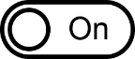
- To turn Wi-Fi off, briefly press the controller button (6).

Wi-Fi Settings
This item enables you to set up your riflescope for operation in a Wi-Fi network.
- Press and hold the controller button (6) to enter the main menu.
- Rotate the controller ring (6) to select the Wi-Fi Settings submenu.
- Press the controller button (6) briefly to enter the submenu
- Rotate the controller ring (6) to select the desired menu item.

Password Setup
This item enables you to set a password to access the riflescope from an external device. The password is used to connect an external device (i.e. smartphone) to the riflescope.
- Press the controller button (6) to enter the Password Setup submenu.
- The default password (12345678) will appear on the screen.
- Rotate the controller ring (6) to set the desired password. Press the controller button (6) to toggle through the digits.
- Press and hold the controller button (6) to save the password and exit from the submenu.

Access Level Setup
This sub-function enables you to configure the appropriate level of access to your device made available to the Stream Vision 2 application.
Owner level. A Stream Vision 2 user has full access to all the device’s functions.
Guest level. A Stream Vision 2 user can only view video footage from the device in real time.
- Press the controller button (6) to enter the Access Level Setup submenu.
- Rotate the controller ring (6) to select Owner or Guest.
- Confirm your selection with a short press of the controller button (6).

WiFi Bandwidth
- Press the controller button (6) to enter the WiFi Bandwidth 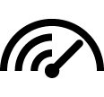 submenu.
- Rotate the controller ring (6) to select the WiFi bandwidth – 5 GHz or 2.4 GHz.
- Confirm your selection with a short press of the controller button (6).

Microphone
Turning on/off Microphone.
This item allows you to enable (or disable) the microphone for recording sound during video recording.
- Press and hold the controller button (6) to enter the main menu.
- Rotate the controller ring (6) to select the Microphone menu item.
- To turn on the microphone, briefly press the controller button (6).
- To turn off the microphone, briefly press the controller button (6).

Rangefinder
Menu item Rangefinder allows you to set up built-in rangefinder’s parameters as follows:
- Enter the main menu with a long press of the controller button (6).
- Rotate the controller ring (6) to select the submenu Rangefinder 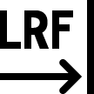 .
- Enter the submenu with a short press of the controller button (6).
- Rotate the controller ring (6) to select the desired menu item.

Reticle Type
- Rotate the controller ring (6) to select the Reticle Type menu item.
- Press briefly the controller button (6) to enter submenu.
- Rotate the controller ring (6) to select one of the three reticle shapes 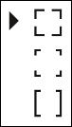 .
- Confirm selection with a brief press of the controller button (6).
- The selected reticle will appear on the display.
- The reticle will disappear from the display if the rangefinder is not used longer than 4 seconds.

TPA
Function "TPA" (Target Position Angle) allows you to measure the angle of target location (angle of elevation). When the function is activated, the angle is shown continuously.
- Rotate the controller ring (6) to select TPA .
- Turn TPA on/off with a short press of the controller button (6).

THD
"THD" (True Horizontal Distance) function allows you to measure true horizontal distance to a target based on the angle of elevation value.
- Rotate the controller ring (6) to select THD .
- Turn THD on/off with a short press of the controller button (6).
- Hereinafter the message THD will appear above the distance readings.

Calibration Mode
Calibration mode selection.
Calibration eliminates image flaws (such as vertical bars, phantom images, grainy field of view, etc.) by equalizing the microbolometer background temperature.
There are three calibration modes: manual, semi-automatic and automatic.
The selected calibration mode is displayed in the status bar (see Status Bar section).

Select the required mode in the Calibration Mode item:
- Press and hold the controller button (6) to enter the main menu.
- Rotate the controller ring (6) to select the Calibration Mode menu item.
- Press the controller button (6) briefly to enter the Calibration Mode submenu.
- Rotate the controller ring (6) to select one of the calibration modes described below.
- Press the controller button (6) briefly to confirm your selection.

M mode (manual)
- Close the lens cover (12) and press the ON/OFF (13) button briefly.
- Open the cover after the calibration is completed.

SA mode (semi-automatic)
- The user independently determines the need for calibration (according to the image being observed).
- Press the ON/OFF (13) button briefly to activate calibration.
- There is no need to close the lens cover (internal shutter covers the microbolometer).

A Mode (automatic)
- The riflescope is calibrated autonomously according to the software algorithm.
- There is no need to close the lens cover (internal shutter covers the microbolometer).
- In this mode, the riflescope may be calibrated by the user with the ON/OFF (13) button.
Note: a display image freezes until the calibration is in progress.

General Settings
- Press and hold the controller button (6) to enter the main menu.
- Rotate the controller ring (6) to select the General settings menu item.
- Press the controller button (6) briefly to enter the submenu.
- Rotate the controller ring (6) to select the desired menu item.
This menu item allows you to configure the following settings:

Language
Language selection:
- Press the controller button (6) briefly to enter the Language submenu.
- Rotate the controller ring (6) to select one of the available interface languages: English, German, Spanish, French, Russian, Italian, Portuguese, Dutch, Danish, Norwegian, Swedish, Polish, Czech, Hungarian.
- Confirm your selection with a short press of the controller button (6).
- Press and hold the controller button (6) to save your selection and exit from the submenu.

Date
Date Setting:
- Press the controller button (6) briefly to enter the Date submenu. The date is displayed in dd/mm/yyyy format.
- Rotate the controller ring (6) to select the desired year, month and date. Press the controller button (6) briefly to switch between digits.
- Press and hold the controller button (6) to save your selected date and exit from the submenu.

Time
Time Setting:
- Press the controller button (6) briefly to enter the Time submenu.
- Rotate the controller ring (6) to select the time format - 24 or AM/PM.
- Press the controller button (6) to proceed to the hour setting.
- Rotate the controller ring (6) to select the hour value.
- Press the controller button (6) to proceed to the minute setting.
- Rotate the controller ring (6) to select the minutes value.
- Press and hold the controller button (6) to save your selected time and exit from the submenu.

Units of Measure
Units of measurement selection:
- Press the controller button (6) briefly to enter the Units of Measure submenu.
- Rotate the controller ring (6) to select the unit of measurement - meters or yards, press the controller button (6).
- Return to submenu will happen automatically.

Video Compression
When set to ON, standard video compression is applied so the video file size is reduced.
When set to OFF, minimal video compression is applied. In this case, the quality of the recorded video is better, but its size is significantly increased.
Warning! Larger video file size results in shorter total video recording time. This may lead to longer download times for video files through the Stream Vision 2 mobile application.

Enable/disable video compression:
- Rotate the controller ring (6) to select the Video Compression 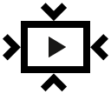 menu item.
- To turn on video compression, briefly press the controller button (6).
- To turn off video compression, briefly press the controller button (6).

Default Settings
- Press the controller button (6) briefly to enter the Default Settings 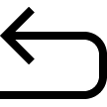 submenu.
- Rotate the controller ring (6) to select “Yes” to restore default settings or “No” to cancel the action.
- Confirm your selection with a short press of the controller button (6).
- If “Yes” is selected, display will show “Do you want to restore default settings?” and “Yes” and “No” options. Select “Yes” to restore default settings.
- If “No” option is selected: the action will be aborted and you will return to the submenu.
The following settings will be returned to their defaults:
- Video Recorder Mode – Video
- Observation Mode – Forest
- Calibration Mode – automatic
- Interface Language – English
- Wi-Fi – Off (default password)
- Magnification – initial value
- PiP – Off
- Colour Mode – White hot
- Units of Measurement – metric
- Side Incline – On
- Zeroing Profile – A
- Reticle selection from the riflescope’s memory – 1
- Video Compression – On
- WiFi Bandwidth – 5 GHz
Attention! After restoring default settings, the date, time and user pixel map as well as the zeroing profiles data entered by the user are saved.

Format
This menu option allows you to format the device's memory card. All files will be deleted.
- Press the controller button (6) briefly to enter the Format submenu.
- Rotate the controller ring (6) to select “Yes” to format the memory card, or “No” to return to the submenu.
- Confirm your selection by pressing the controller button (6).
- If the “Yes” option has been selected, the "Do you want to format memory?" message and “Yes” and “No” options will appear on the display. Select “Yes” to format the memory card.
- If “No” option is selected: formatting is cancelled and return to the submenu.

Accelerometer

Auto Shutdown
This item allows you to activate auto shutdown function for riflescope in a non-operating position (tilt up or down at an angle of more than 70°, right or left - at an angle of more than 30°). In this event, the controls (buttons, controller) are disabled.

- Press and hold the controller button (6) to enter the main menu.
- Rotate the controller ring (6) to select the Accelerometer submenu.
- Confirm the selection by briefly pressing the controller (6).
- Rotate the controller ring (6) to select Auto Shutdown .
- Press the controller button (6) briefly to enter the submenu.
- Rotate the controller ring (6) to select the time period (1 min, 3 min, 5 min) upon expiry of which the riflescope will automatically shut down, or select Switch off if you wish to deactivate Auto Shutdown.
- Confirm your selection with a short press of the controller button (6).

Note: If the automatic shutdown function is activated, the status bar shows an icon ​and shutdown time period as 1 min.

Side Incline
This item allows you to turn on/off the indication of horizontal (side) incline of the rifle. Side incline is indicated by “sector” arrows to the right and left of the reticle. Arrows show the direction in which you should move your rifle to eliminate incline.

There are three modes of incline:
- 5°-10° – one sector arrow;
- 10°-20° - two sector arrow;
- > 20° - three sector arrow.
A side incline of less than 5° is not displayed.

- Press and hold the controller button (6) to enter the main menu.
- Rotate the controller ring (6) to select the Accelerometer menu item.
- Press the controller button (6) briefly to enter the Accelerometer submenu.
- Rotate the controller ring (6) to select Side Incline 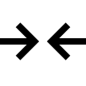.
- Press the controller button (6) briefly to enter the Side Incline submenu.
- Rotate controller ring (6) to select On for turning on the incline indication or Off for turning it off.
- Confirm your selection with a short press of the controller button (6).

Defective Pixel Repair

Defective Pixel Repair
When using the device, defective (dead) pixels may appear on the microbolometer. These are bright or dark points of a constant brightness that are visible on the image.
Defective pixels on the microbolometer can increase in size relative to the digital-zoom power.
The Thermion 2 LRF Pro thermal riflescope allows the user to remove any defective pixels on the display, as well as cancel removal, via the device’s firmware.
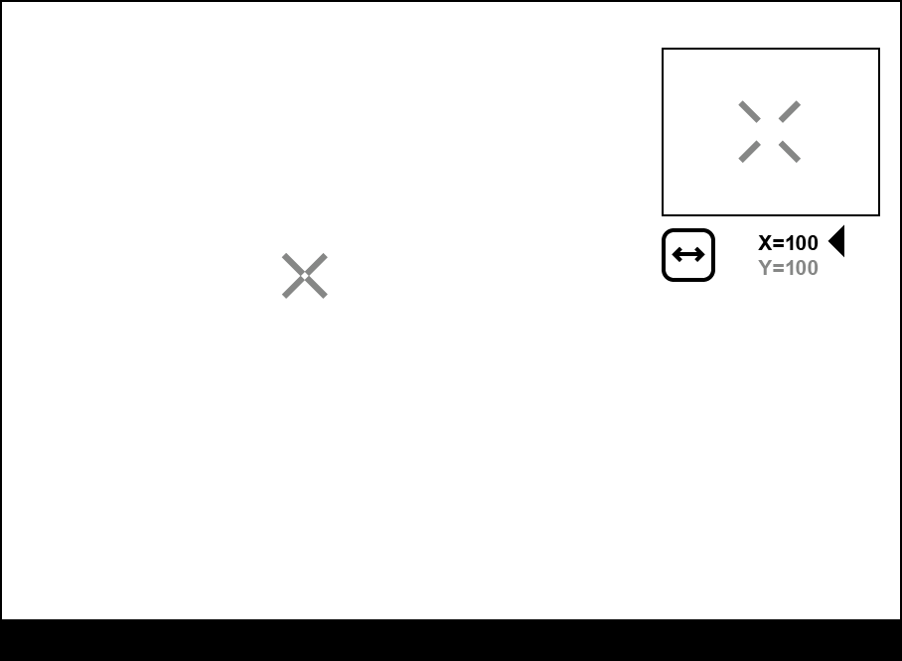

Step 1. Enter the menu to fix the defective pixels
- Press and hold the controller button (6) to enter the main menu.
- Rotate the controller ring (6) to select the Defective Pixel Repair menu item.
- Press the controller button (6) to open the submenu.
- Press the controller button (6) briefly to select the icon .

Step 2. Select the defective pixel
- A marker will appear on the left side of the display. A “magnifying glass” will appear on the right side of the display — a rectangle with an enlarged view of the marker for precise pixel selection — and marker coordinates under the “magnifying glass” 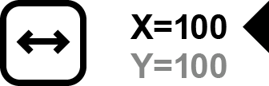.
- Rotate the controller ring (6) to move the marker to align its center with the defective pixel.
- Press the controller button (6) shortly to switch the marker direction from the horizontal to the vertical and vice versa.
- Rotate the controller ring (6) to align the defective pixel with the fixed cross in the frame – the pixel should disappear.

Step 3. Remove the defective pixel
- Delete the defective pixel with a short press of the ON/OFF (13) button.
- Where the pixel has been successfully deleted, the OK message will appear on the screen for a short time.
- Then, by moving the marker across the display, you can delete the next defective pixel.
- Press and hold the controller button (6) to exit the Defective Pixel Repair function.

Restore Default Pixel Map
This option allows the user to return all previously disabled defective pixels to their original state.
- Press and hold the controller button (6) to enter the main menu.
- Rotate the controller ring (6) to select the Defective Pixel Repair icon.
- Press the controller button (6) to enter the submenu.
- Rotate the controller ring (6) to select the Restore Default Pixel Map icon.
- Activate the function by briefly pressing the controller button (6).
- Rotate the controller ring (6) to select Yes if you want to return to the factory pixel map or select No if you do not.
- Confirm your selection with a short press of the controller button (6).
Attention! One or two pixels on the display of the device in the form of bright white, black or coloured (blue, red or green) points may appear. These points cannot be removed and are not a defect.

Device Information
- Press and hold the controller button (6) to enter the main menu.
- Rotate the controller ring (6) to select the Device Information menu item.
- Press the controller button (6) briefly to enter the Device Information submenu.

This item allows the user to view the following information about the riflescope:
- Full name of the riflescope
- SKU number
- Serial number of the riflescope
- Riflescope firmware version
- Hardware version
- Service information
- Battery information

Functions

Video Recording and Photography
The riflescope is equipped with a function for video recording (photography) of the observed image that is saved on the built-in memory card.
Before using the photo and video functions, read the Date and Time subsections of the General Settings section.

Built-in recorder operates in two modes:
- Photo (photography; the icon is displayed in the upper left corner of the display).
- Video (video recording; the icon is displayed in the upper left corner of the display, the total remaining recording time is given taking into account the current resolution in the HH:MM format (hours:minutes).
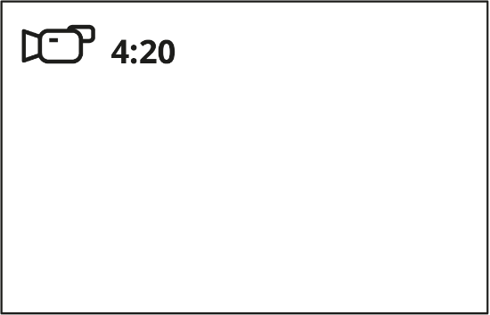
Toggle (switch) between the riflescope operating modes with a long press of the REC (4) button. Switching between the modes is cyclical (Video–> Photo–> Video...).

Photo mode. Capturing an image
1. Switch to the Photo mode with a long press of the REC (4) button.
2. Press the REC (4) button briefly to capture a photo. The icon flashes – the photo file is being saved to the built-in SD card.

Video mode. Recording a video
1. Switch to the Video mode with a long press of the REC (4) button.
2. Press the REC (4) button briefly to start video recording.
3. When the video recording starts, the icon will disappear, instead of it the REC icon as well as the video recording timer displayed in the MM:SS (minutes:seconds) format will appear 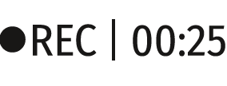.
4. Pause/continue recording by briefly pressing the REC (4) button.
5. Press and hold the REC (4) button to stop video recording.
Video files are stored in the built-in memory card:
- After turning off the video recording;
- Upon powering the riflescope off if recording was on;
- When the memory card is overfilled during recording (Memory Full message appears on the display).

Notes:
- You can enter and navigate the menu during video recording.
- Recorded videos and photos are saved to the built-in memory card of the riflescope in the format img_xxx. jpg (for photos); video_xxx. mp4 (for video).
- Maximum duration of a recorded video file is 5 minutes. After this time expires, the video is recorded to a new file. The number of recorded files is limited by the capacity of unit’s internal memory.
- Regularly check free memory within the built-in memory card and move the footage to other storage media to free up the memory card space.

Laser Rangefinder
The riflescope is equipped with a built-in rangefinder (14), allowing you to measure distance to objects up to 800 m away.
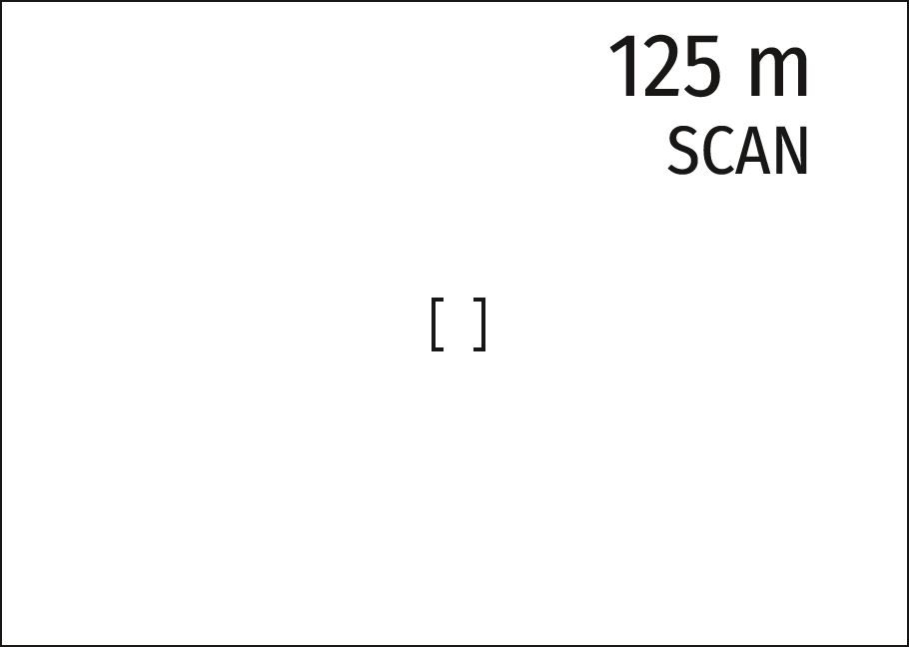

How the rangefinder works:
- Turn on the riflescope, adjust image according to section Powering on and Image Setting.
- Press LRF (3) button — rangefinding reticle appears (and aiming reticle disappears), dashes of distance values with unit of measurement appear in the top right corner of the display, i.e. the rangefinder enters stand-by mode. 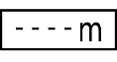
- If PiP mode is on, the aiming reticle disappears upon activation of the rangefinder, but in the PiP window remains active.
- If PiP mode is off, the activation of the rangefinder automatically turns on the PiP window with the last digital magnification set for it and a reticle in it.
- Point the rangefinding reticle at an object and press LRF (3) button.
- In the top right corner of the display you will see distance in meters (or yards depending on settings). 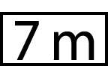
Notes:
- If the rangefinder is idle longer than three seconds, it turns off automatically and aiming reticle appears.
- The point of aiming of the rangefinding reticle and the aiming reticle in the PiP window might not coincide due to aiming reticle shift after zeroing.

Operation in SCAN mode:
- Turn on the rangefinder by briefly pressing the LRF (3) button.
- Hold down LRF (3) button for longer than two seconds. Measurement readings will be changing in real time as you point the riflescope at different objects. In the top right corner a message SCAN appears.
- In case of unsuccessful measurement dashes will appear on the display.
- To exit SCAN mode and to return to stand-by mode, press LRF (3) button briefly.
- To turn off the rangefinder hold the LRF (3) button.
Notes:
- To select a rangefinding reticle, please go to submenu Rangefinder in the main menu.
- To select units of measurement (meters or yards) go to submenu General Settings in the main menu.
- While you measure the distance in the SCAN mode you can use the reticle of the PiP window to make a shot.

Additional Information:
- Accuracy of measurement and maximum range depend on the reflection ratio of the target surface, the angle at which the emitting beam falls on the target surface and environmental conditions. Reflectivity is also affected by surface texture, colour, size and shape of the target. A shiny or brightly coloured surface is normally more reflective than a dark surface.
- Accuracy of measurement can also be affected by light conditions, fog, haze, rain, snow etc. Ranging performance can degrade in bright conditions or when ranging towards the sun.
- Measuring range to a small sized target is more difficult than to a large sized target.

Discrete Digital Zoom
Discrete digital zoom allows you to quickly increase the basic magnification (see Magnification line in the table of Technical Specifications) by 2x, 4x or 8x, as well as return to the basic magnification.
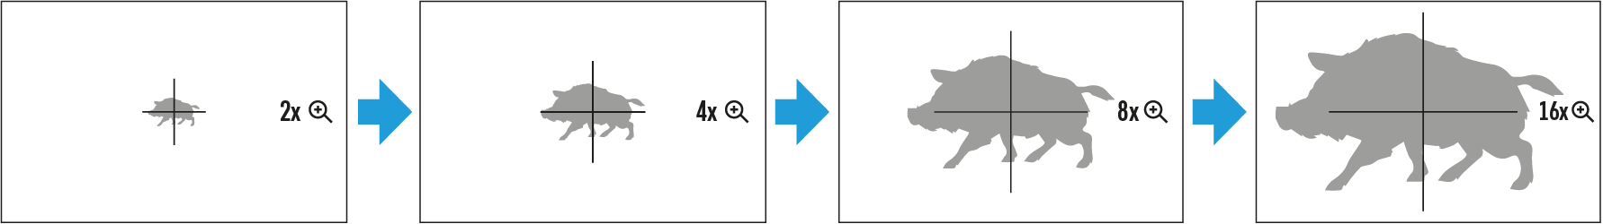
- Press the ZOOM (5) button successively to change the magnification ratio of the riflescope.
- While the icon is visible on the screen, rotate the controller ring (6) for smooth digital zooming from the current magnification.

PiP Function
The PiP function (Picture-in-Picture) allows you to see both a magnified image in a particular dialog box and the main image.
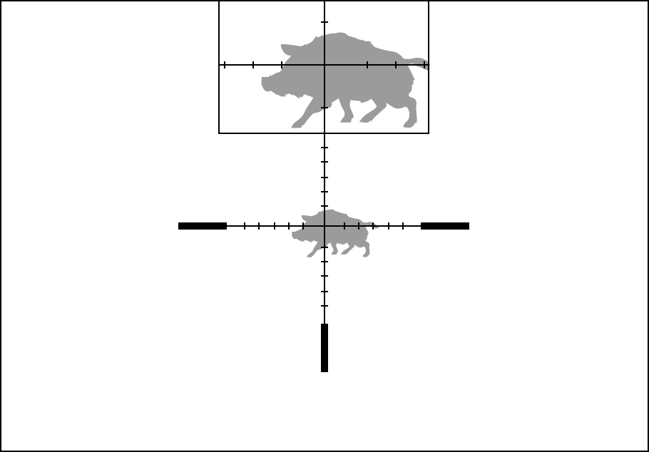
- Press and hold the ZOOM (5) button to turn on/off the PiP function.
- To change the digital zoom in the PiP window, briefly press the ZOOM (5) button or rotate the controller ring (6) until the icon is visible on the screen .
- The magnified image is displayed in a particular dialog box, with the full magnification being used.
- The rest of the image is displayed only with the optical zoom (digital zoom is off).
- When PiP is turned off, the display shows the full magnification set for the PiP mode.

Display-Off Function
This function deactivates the image transmission to the display by minimizing its brightness. This helps prevent accidental disclosure. However, the device stays on.
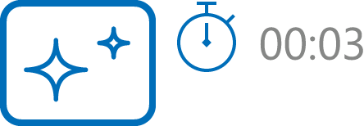

- When the device is on, press and hold the ON/OFF (13) button for less than 3 seconds. The display will turn off, the current time and the "Display off" icon will appear.
- Press the ON/OFF (13) button briefly to turn on the display.
- When you press and hold the ON/OFF (13) button, the display shows the icon "Display off" with a countdown. Holding the button down for the duration of the countdown will power the device off completely.

Wi-Fi Function
The riflescope has a function for wireless communication with mobile devices (smartphone or tablet) via Wi-Fi.
- To enable the wireless module, enter the main menu by long pressing the controller button (6).
- Rotate the controller ring (6) to select the Wi-Fi Activation menu item.
- Press the controller button (6) briefly to turn on/off the Wi-Fi module.
Wi-Fi is displayed in the status bar as follows:
Indication in the Status Bar | Connection Status
 | Wi-Fi is switched off
 | Wi-Fi is switched on by the user, Wi-Fi connection in the riflescope is in progress.
 | Wi-Fi is switched on, there is no connection to the riflescope
 | Wi-Fi is switched on, there is connection to the riflescope
- An external device recognizes the riflescope under the name Thermion2_XXXX, where XXXX are the four last digits of the serial number.
- After entering the password (default: 12345678) on a mobile (see Password Setup subsection of the Wi-Fi Settings section for more information on setting a password) and setting up a connection, the icon in the riflescope status bar changes to .
- Launch Stream Vision 2 application on your mobile device (see Stream Vision 2 section).
- Video broadcasting on a mobile screen starts after the viewfinder button on the mobile screen is activated.

Scalable Reticles
This function is designed to preserve ballistic properties of the scalable reticles X51Fi-300, M56Fi, M57Fi for all magnifications.
- Enter the main menu with a long press of the controller button (6).
- Enter submenu Reticle & zeroing 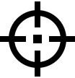 -> Reticle Type .
- Select the reticle X51Fi-300, M56Fi, M57Fi.

Notes:
- When zooming in and out the image, the selected reticle on the display and in the recorded video changes its geometrical size according to the magnification selected.
- The reticle scale changes both on the main display and in the PiP mode.

USB Connection
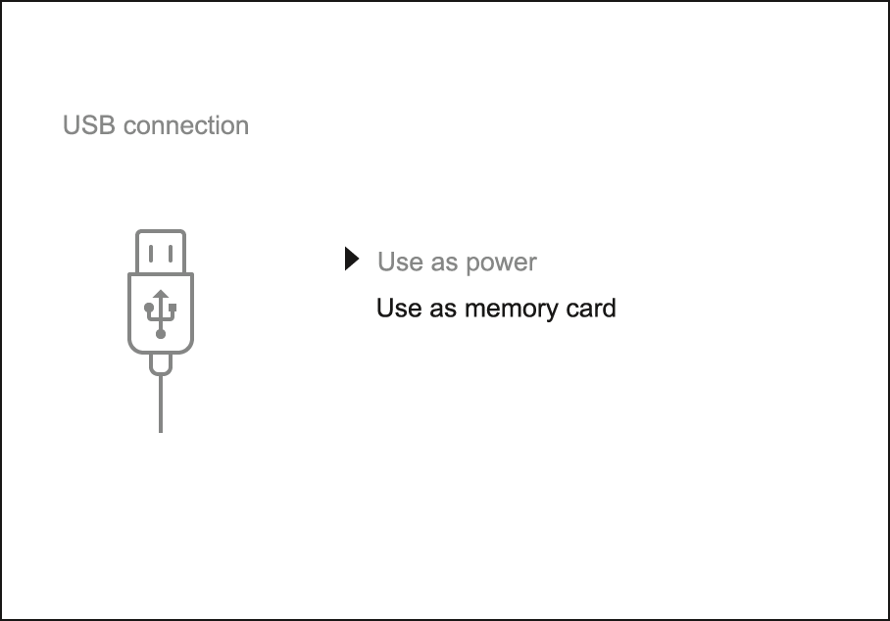
- Press the ON/OFF (13) button briefly to power the riflescope on (the computer will not detect the riflescope if it is turned off).
- Connect one end of the USB cable to the riflescope USB Type-C port (10) and the other one to the port on your computer.
- The riflescope is detected by the computer automatically and no installation of drivers is required.
- After a few seconds, two connection options appear on the display: Power and Memory card.
- Rotate the controller ring (6) to select the connection mode.
- Press the controller button (6) briefly to confirm your selection.

Power
- Upon choosing this mode, your PC is used as an external power supply. An icon will appear in the status bar.
- The riflescope continues operating and all functions are accessible.
- Battery recharge feasibility depends on your computer's USB port.

Memory Card
- When selecting this mode, the computer recognizes the riflescope as a memory card. This mode is designed to manage the files saved in riflescope’s memory.
- The riflescope’s functions are not available in this mode; the riflescope turns on. The device continues to operate after being disconnected from the computer.
- If a video was being recorded at the moment of connection, the recording will stop and will be saved.

USB Disconnection
- When disconnecting from the computer, the device will continue to operate from the battery pack (if it is present and holding enough charge).
- When the USB is disconnected from the riflescope connected in the Memory Card mode, the riflescope remains switched on.

Software

Stream Vision 2
Install the Stream Vision 2 application to download files, update firmware, control the device by remote control and broadcast images from your device to a smartphone or a tablet via WiFi.
We recommend using the latest version – Stream Vision 2.

You can find further guidelines on Stream Vision 2 here.
Download from Google Play
Download from App Store
Find answers to frequently asked questions about using Stream Vision 2 here.

Firmware Update
- Download free Stream Vision 2 App in Google Play or App Store.
- Connect your Pulsar device to your mobile device (smartphone or tablet).
- Launch Stream Vision 2 and go to section “Settings”.
- Select your Pulsar device and press “Check firmware update”.
- Wait for the update to download and install. Pulsar device will reboot and will be ready to operate.
Important:
- if your Pulsar device is connected to phone, please turn on mobile data transfer (GPRS/3G/4G) to download update;
- if your Pulsar device is not connected to your phone but is already listed in “Settings” > “My devices” section, you may use Wi-Fi to download update.

Maintenance

Technical Inspection
It is recommended to carry out a technical inspection each time before using the riflescope. Check the following:
- The riflescope appearance (there should be no cracks on the body).
- The state of the lenses of the objective, eyepiece and rangefinder (there should be no cracks, greasy spots, dirt or other deposits).
- The state of the rechargeable battery (must be charged to 50-70%) and the electric contacts (should be no signs of salts, oxidation or debris).
- The controls should be in working order.

Technical Maintenance
The maintenance should be carried out at least twice a year and includes the following steps:
- Wipe the exterior surfaces of metal and plastic parts off dust and dirt with a cotton cloth. To avoid damage to the paint coating, do not use chemically active substances, solvents, etc.
- Clean the electric contacts of the battery pack and battery slots on the riflescoepe using a non-greasy organic solvent.
- Check the lenses of the eyepiece, objective and rangefinder. If necessary, remove dust and sand from the optics (it is preferable to use a non-contact method). Cleaning of the exterior surfaces of the optics should be done with cleaners designed especially for this purpose.

Troubleshooting

The device does not turn on
Possible cause
The Battery Pack is empty
Solution
Charge the Battery Pack

The device does not operate from an external power source
Possible cause
USB cable is damaged.
Solution
Replace USB cable.

Possible cause
The external power supply is discharged.
Solution
Charge the external power supply.

The image is fuzzy. There are distortions in the form of bars of different widths lying in different directions, or dots of different size and brightness.
Possible cause
Calibration is required.
Solution
Perform image calibration according to Calibration Mode section.

Black screen after calibration
Solution
If the image does not clear after calibration, you need to recalibrate.

The reticle is blurred and cannot be focused with the dioptre ring
Possible cause
The dioptre adjustment range is not enough for your eyesight.
Solution
If you wear glasses with a range of -3/+5, keep glasses on when looking through the eyepiece.

Coloured lines appeared on display or image has disappeared
Possible cause
The device was exposed to static electricity during operation.
Solution
After exposure to static electricity, the device may either reboot automatically, or require turning off and on again.

The image is too dark
Possible cause
Brightness or contrast level is too low.
Solution
Adjust the brightness or contrast in the Quick Menu.

The reticle is crisp but an object at least 30 m away is blurry
Possible cause
Dust and condensation are covering the outside or inside optical surfaces.
Solution
Wipe the outer surface of the objective lens with a soft cotton cloth. Dry the riflescope. Let it stand for four hours in a warm room.

Possible cause
The lens is not focused.
Solution
Adjust the image by rotating the lens focus knob.

The point of impact shifts after firing rounds
Possible cause
The riflescope is not mounted securely or the mount was not fixed with thread sealant.
Solution
Check that the riflescope has been securely mounted.
Make sure that the same cartridge type and load bullets are being used as when the scope was initially zeroed.
If your riflescope was zeroed during the summer, and is now being used in the winter (or the other way round), in the day or night, or through extreme temperature changes) slight shifts in points of impact are possible. Double-checking your zero before hunting is recommended.

The riflescope will not focus
Possible cause
Wrong settings.
Solution
Adjust the riflescope according to the Powering on and Image Setting section.
Check the outer surfaces of the objective lenses and eyepiece and, where necessary, wipe away dust, condensation, frost, etc. In cold weather, you can use special anti-fogging coatings (e.g., the same as for corrective glasses).

Smartphone or tablet cannot be connected to the device
Possible cause
Password in the riflescope was changed.
Solution
Delete network and connect again inserting the password saved in the riflescope.

Possible cause
There are too many Wi-Fi networks in the area where the riflescope is located which may cause signal interference.
Solution
To ensure stable Wi-Fi performance, move the riflescope to an area with few or no Wi-Fi networks.

Possible cause
The device has a 5 GHz network enabled, but the smartphone only supports 2.4 GHz.
Solution
Switch the device's WiFi bandwidth to 2.4 GHz.

More information on solving problems with connection to Stream Vision 2 by following the link.

Wi-Fi signal is missing or interrupted
Possible cause
Smartphone or tablet is out of range of a strong Wi-Fi signal. There are obstacles between the device and the smartphone or tablet (e.g., concrete walls).
Solution
Relocate smartphone or tablet into the Wi-Fi signal line of sight.

The image of the object being observed is missing
Possible cause
Observation through glass.
Solution
Remove the glass from the field of vision.

Poor image quality / Reduced detection distance
Possible cause
These problems may occur during observation in adverse weather conditions (snow, rain, fog etc.).

There are several light or black dots (pixels) on riflescope’s display or microbolometer
Solution
The presence of dots is caused by peculiarities of microbolometer or display production technology and is not a defect.

When the device is used in low temperature conditions the image quality is worse than in positive temperatures.
Possible cause
In positive temperature conditions, objects being observed (surroundings and background) heat up differently because of thermal conductivity, thereby generating a high temperature contrast. Consequently, the image quality produced by the thermal imager will be better.
In low-temperature conditions, objects being observed (background) will cool down to roughly the same temperature, which leads to a greatly reduced temperature contrast and a degraded image quality. This is normal for all thermal imaging devices.

Rangefinder will not measure distance
Possible cause
There is an object in front of the receiver or emitter lens preventing signal transmission.
Solution
Make sure that: the lenses are not blocked by your hand or fingers; the lenses are clean.

Possible cause
The device is not being held steadily when measuring.
Solution
Do not stress the device when measuring.

Possible cause
Distance to the object exceeds 800 m.
Solution
Pick an object at a distance not longer than 800m.

Possible cause
Low reflection ratio (for example, tree leaves).
Solution
Pick an object with higher reflection ratio (see point Additional Information in section Laser Rangefinder).

Large measurement error
Possible cause
Inclement weather conditions (rain, mist, snow).

Legal Compliances and Disclaimers
Attention! Thermion thermal imaging riflescopes require a licence when exported outside your country.
Electromagnetic compatibility. This product complies with the requirements of European standard EN 55032: 2015, Class A.
Caution: operating this product in a residential area may cause radio interference.
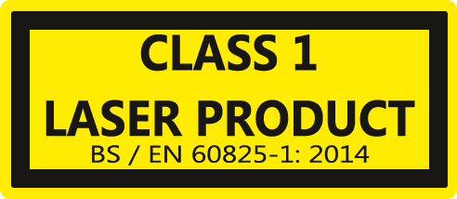
Caution: use of controls or adjustments or performance of procedures other than those specified herein may result in hazardous radiation exposure.
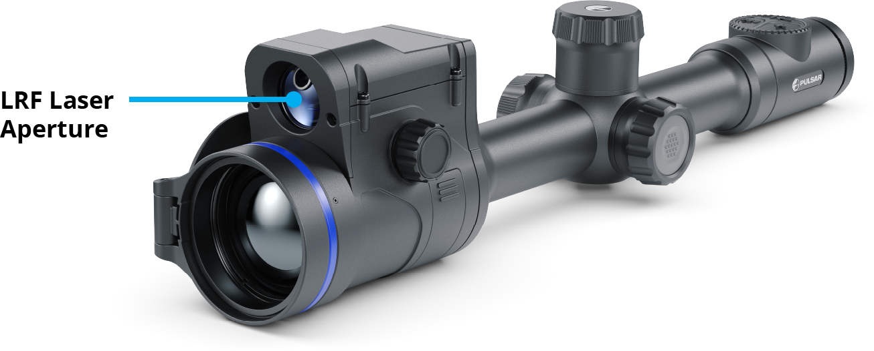
Improvements may be made to the design of this product to enhance its user features.
Repair of the device is possible within 5 years.

