Manual Talion XQ38
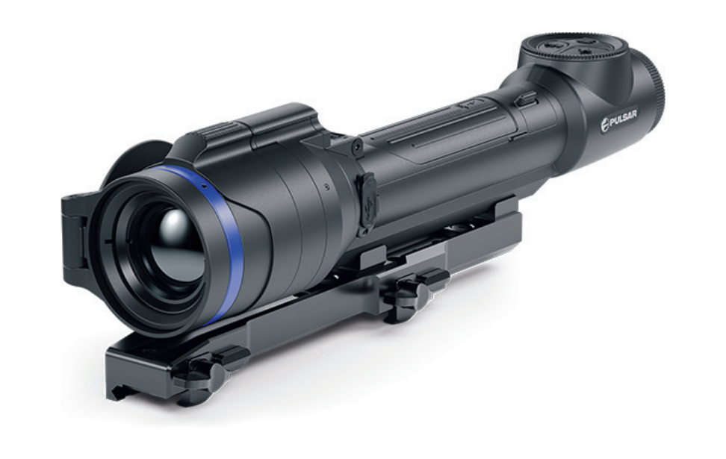

About the device

Description
Talion thermal imaging riflescopes are designed for use both at night-time and during the day and provide exceptional image quality even in adverse weather conditions (fog, smog, rain) and beyond obstacles like branches, tall grass, dense foliage, etc. known to hinder target detection.
Unlike riflescopes based on electrical-to-optical converters, thermal imaging riflescopes do not require an external light source and are resistant to high levels of illumination.
These riflescopes are designed for hunting, target shooting and recreational shooting, observation and orientation.

To get started, see the sections:
Battery Charging
Battery Installation
Mounting on the Rifle
Powering on and Image Setting
Zeroing

Package Contents
- Thermal imaging riflescope Talion
- Removable rubber eyecup
- АPS5 Battery Pack
- Adapter for APS5 battery (2 pcs.)
- APS5 battery charger
- Power adapter
- USB Type-C cable with USB Type-A adapter
- Carrying case
- Lens-cleaning cloth
- Quick User Manual
- Warranty card

Features
- Built-in 3-axis accelerometer gyroscope (slope angle indication)
- 3 levels of sensitivity enhancement: Normal, High, Ultra
- 3 calibration modes: manual, semi-automatic and automatic
- Smooth Digital Zoom
- Multiple reticle options
- Scalable reticles (proportional to Zoom)
- 5 zeroing profiles (10 distances per profile)
- One-shot “Freeze-Zeroing” function
- Precise “Zoom zeroing” (reducing the MOA per click when zooming in)
- 8-colour display palette
- Pixel repair function
- “Display-Off” function
- Integrated Wi-Fi for remote control and personal device connectivity
- Device firmware update using the free Stream Vision 2 App
- Recoil rated to .375H&H, 9.3x64 and 12-gauge

Video Recording
- Built-in photo and video recorder with audio
- 16 GB internal memory
- iOS and Android compatible
- Storing photos and videos in Cloud when using the Stream Vision 2 App

Battery Pack
- Quick-change rechargeable Li-Ion 4900 mAh Battery Pack APS5
- Charging via USB Type-C port

Components and Controls
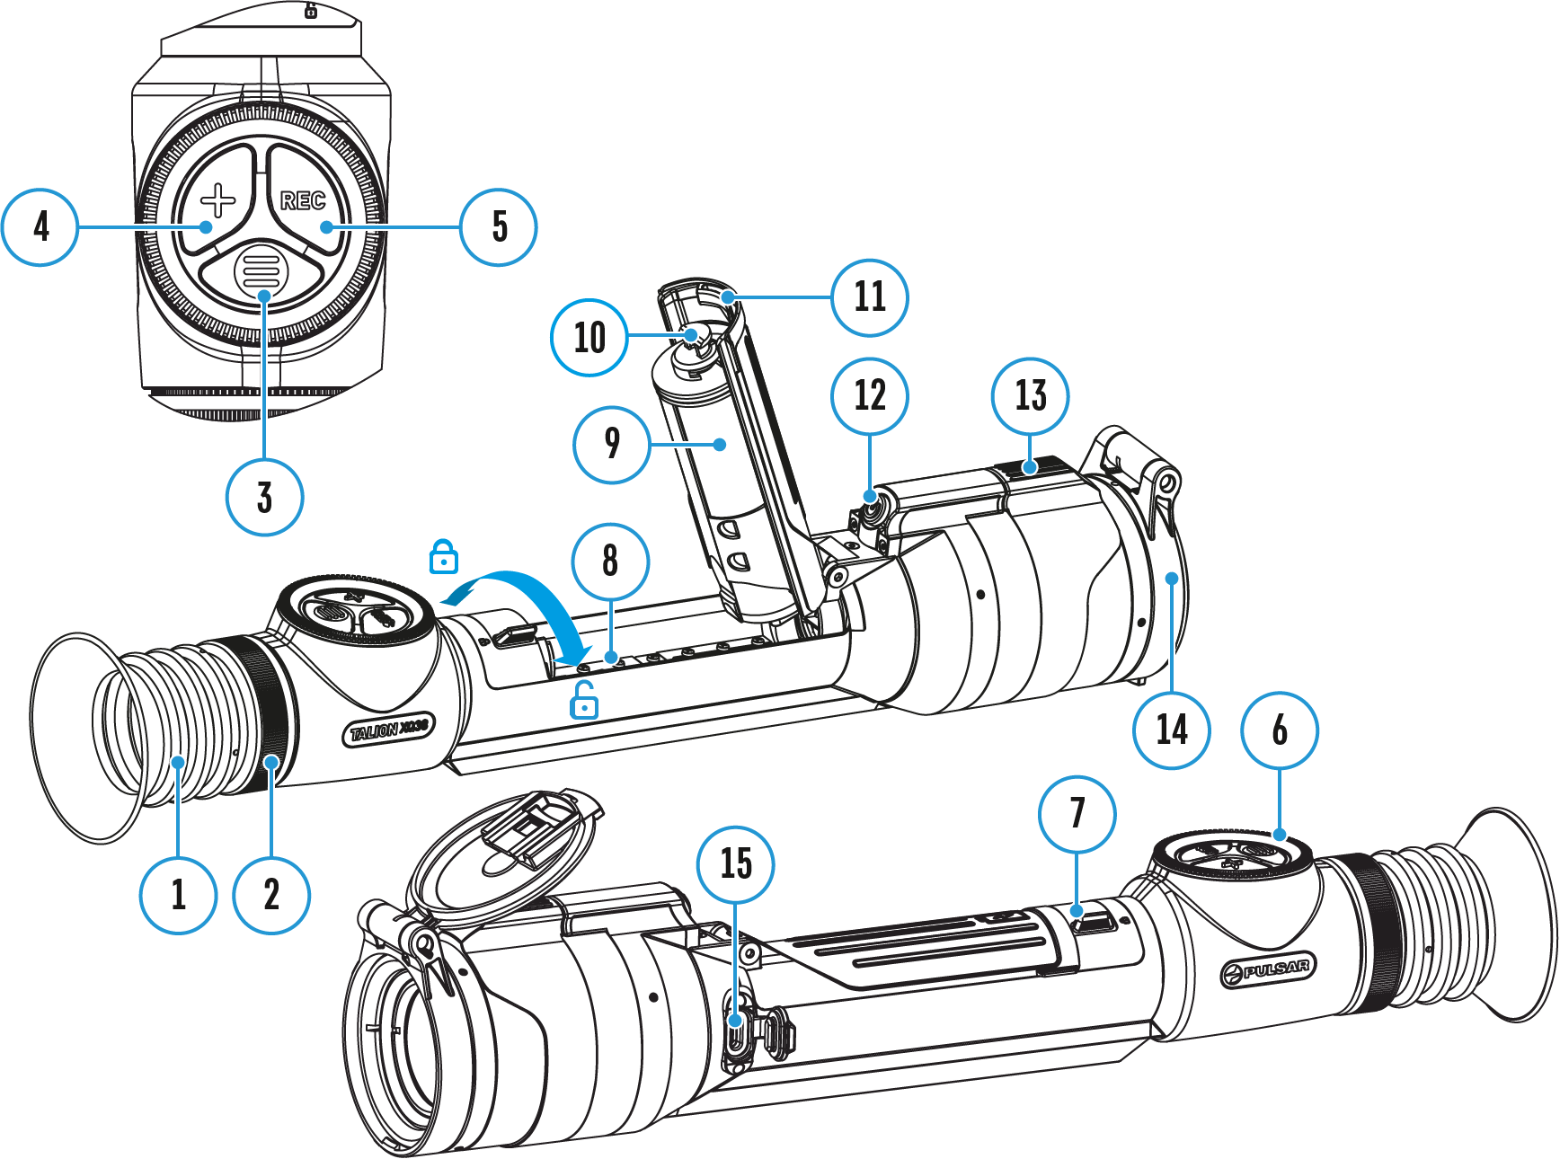

- Eyecup
- Eyepiece diopter adjustment ring
- MENU button
- ZOOM button
- REC button
- Controller
- Battery compartment cover lock
- Battery compartment
- Battery APS 5
- APS 5 adapter
- Battery compartment cover
- ON/OFF button
- Lens focus control
- Lens cap
- USB Type-C port

Specifications
Model | XQ38 | XG35
SKU | 76561 | 76563
Microbolometer
Type | uncooled
Resolution, pixels | 384x288 | 640x480
Pixel Pitch, µm | 17 | 12
NETD, mK | < 40
Frame refresh rate, Hz | 50
Optical Specifications
Lens, mm | F38 F/1.2 | F35 F/1.0
Magnification, x | 2.5-10 | 2-16
Eye relief, mm/inch | 50/1.96
Field of view (H), °/m@100 | 9.8/17.2 | 12.5 / 21.9
Diopter adjustment, D | -3/+4
Detection distance (Object of "deer" type), m/y | 1350/1476 | 1750 / 1914
Aiming Reticle
Click value (H/V), mm@100 m – when magnifying, x | 17 – 2.5х  8.5 – 5х  4.25 – 10х | 21 – 2х  10.5 – 4х  5.25 – 8х  2.6 – 16х
Click range, mm@100 m (H/V) | 3400/3400 | 4200/4200
Display
Type | AMOLED
Resolution, pixels | 1024х768
Operating Features
Diameter of the riflescope body to assemble the mounting rings, mm | 30
Power Supply, V | 3–4.2
Battery type / Capacity / Rated Output Voltage | Li-Ion Battery Pack АPS5 / 4900 mAh / DC 3.7 V (removable)
External Power Supply | 5 V, 9 V (USB Type-C Power Delivery)
Battery Pack operating time at temp. = 22 °C, hrs** | 9 | 7
Max. recoil power on rifled weapon, Joules | 6000
Max. recoil power on smoothbore weapon, caliber | 12
Degree of protection IP code (IEC60529) | IPX7
Operating temperature, °С / °F | -25 – +50 / -13 – +122
Dimensions with an eyecup, mm/inch | 330x57x67 / 12.99x2.24x2.64
Weight (without removable battery), kg/oz | 0.7 / 24.69
Video Recorder
Photo / video resolution, pixels | 1024x768
Video / photo format | .mp4 / .jpg
Built-in memory | 16 GB
Wi-Fi Channel***
Frequency | 2.4/5 GHz
Standard | IEEE 802.11 b/g/n/ac
* Purchased separately.
** Actual battery life may vary depending on the use of Wi-Fi and the built-in video recorder.
*** The reception range may vary depending on various factors: obstacles, other Wi-Fi networks.

Power supply

Battery Charging
Talion thermal imaging riflescopes come with a built-in rechargeable lithium-ion Battery Pack APS5. The batterу should be charged before first use.

Option 1
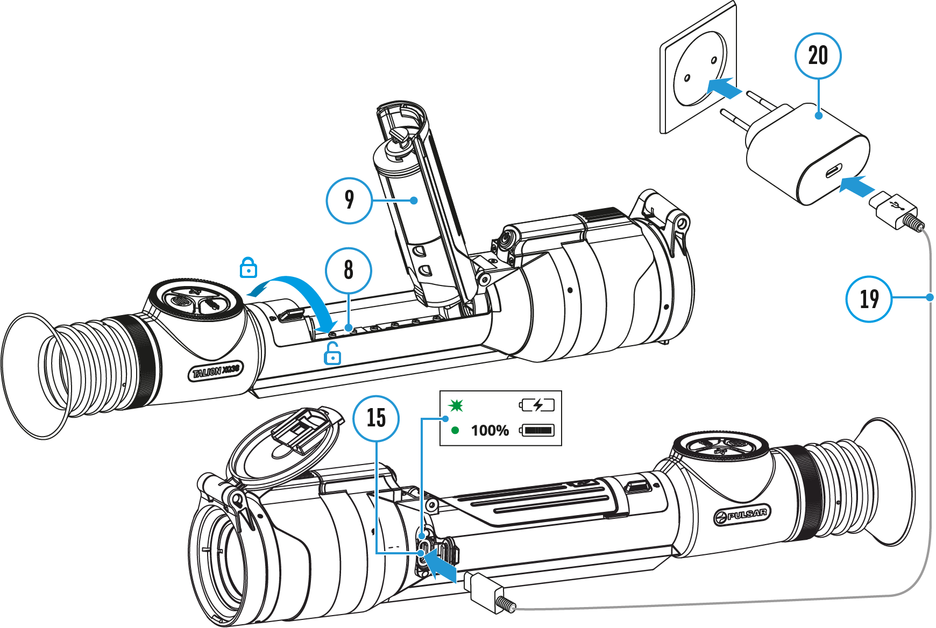
- Install the APS 5 battery (9) in the battery compartment (8) of the device.
- Connect the USB Type-C cable (19) to the USB Type-C connector (15) of the device.
- Connect the other end of the USB Type-C cable (19) to the Power Adapter (20) by removing the USB Type-A adapter.
- Plug the Power Adapter (19) into a 100-240 V socket.
- Wait until the battery is fully charged (indication in the status bar: ).
LED indication | Battery charge status
 | Battery is charging
 | Battery is fully charged

Option 2
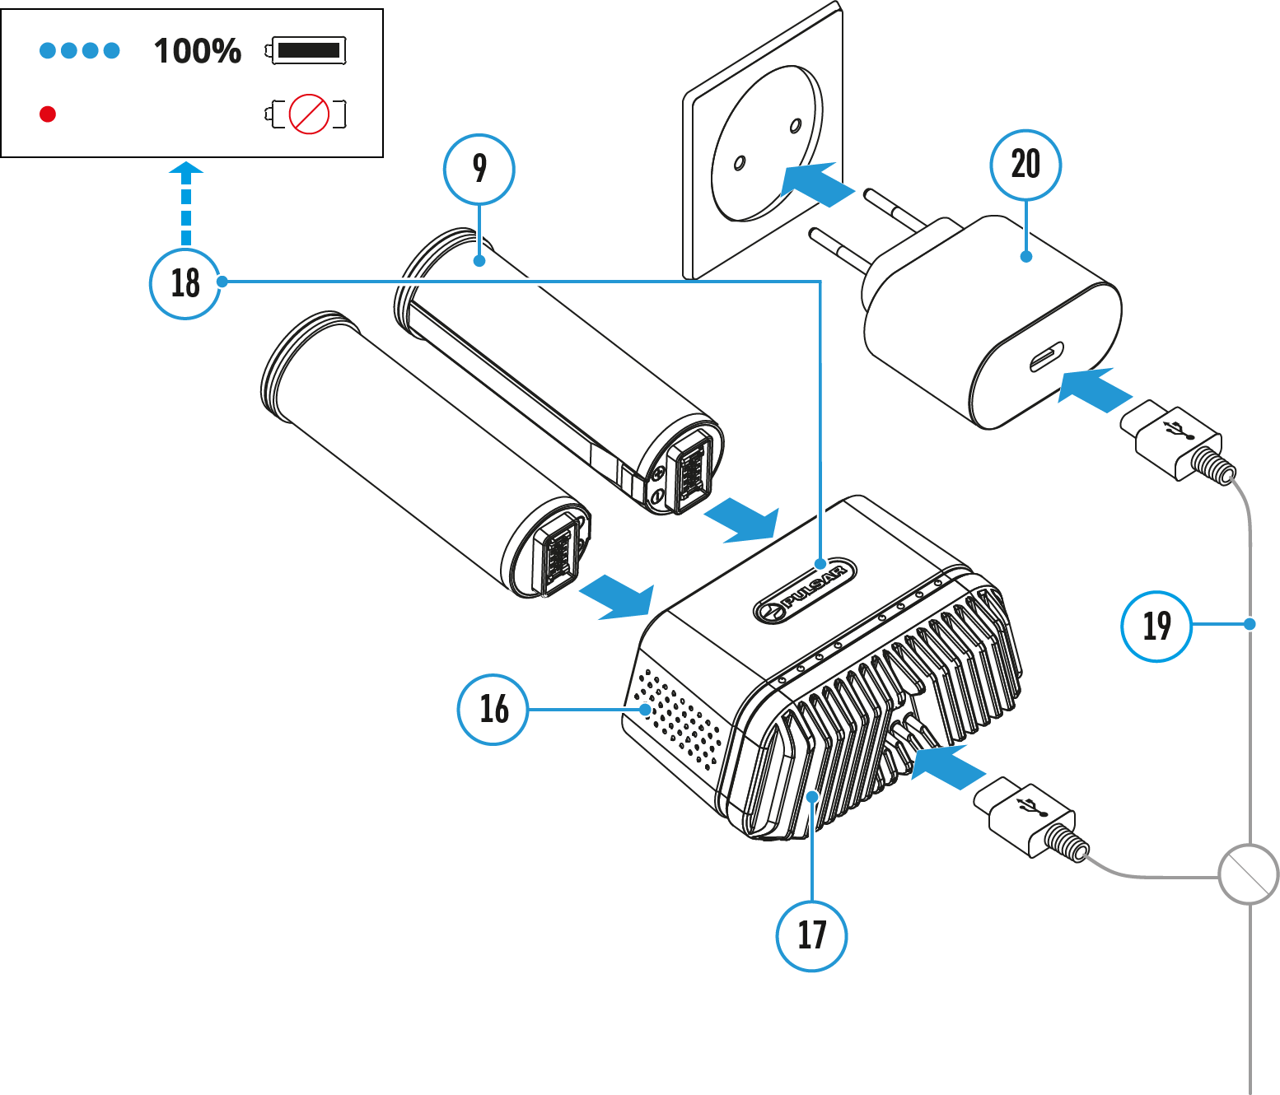
- Insert the APS 5 battery (9) along the guide into the APS 5 charger* (16) slot as far as it will go. The APS 5 charger is supplied with your device or purchased separately.
- Connect the other end of the USB Type-C cable (19) to the Power Adapter (20) by removing the USB Type-A adapter.
- Plug the Power Adapter (20) into a 100-240 V socket.
- Connect the other end of the USB Type-C cable (19) to the USB Type-C connector (17) of the charger.
- LED indicators (18) will display the battery charge level (see Table).
- Wait until the battery is fully charged (LED indication (18): ).
Note: Two batteries* can be charged at the same time, a second slot is provided for it.
LED indication (18) in the battery charging mode | Battery Level
 | Battery charge level is from 0% to 25%
 | Battery charge level is from 26% to 50%
 | Battery charge level is from 51% to 80%
 | Battery charge level is from 81% to 99%
 | Battery is fully charged. It can be disconnected from the charger.
 | Defective battery. Do not use the battery!

LED indication (18) in the standby mode** | Battery Level
 | Battery charge level is from 0% to 25%
 | Battery charge level is from 26% to 50%
 | Battery charge level is from 51% to 80%
 | Battery charge level is from 81% to 99%
 | Battery is fully charged. It can be disconnected from the charger.
 | Defective battery. Do not use the battery!
* Available separately
** Standby mode is when the batteries are in the charger but the Power Adapter is not connected. In this mode, the indicators are only on for 10 seconds.
Attention! When using a Power Adapter that does not support USB Power Delivery fast charging technology, the flicker frequency of the LED indicators decreases by a factor of 3 and the charge time increases.
Attention! The charger heats up during fast charging. Excess heat is removed through the radiator and does not affect the device operation.

Battery Installation
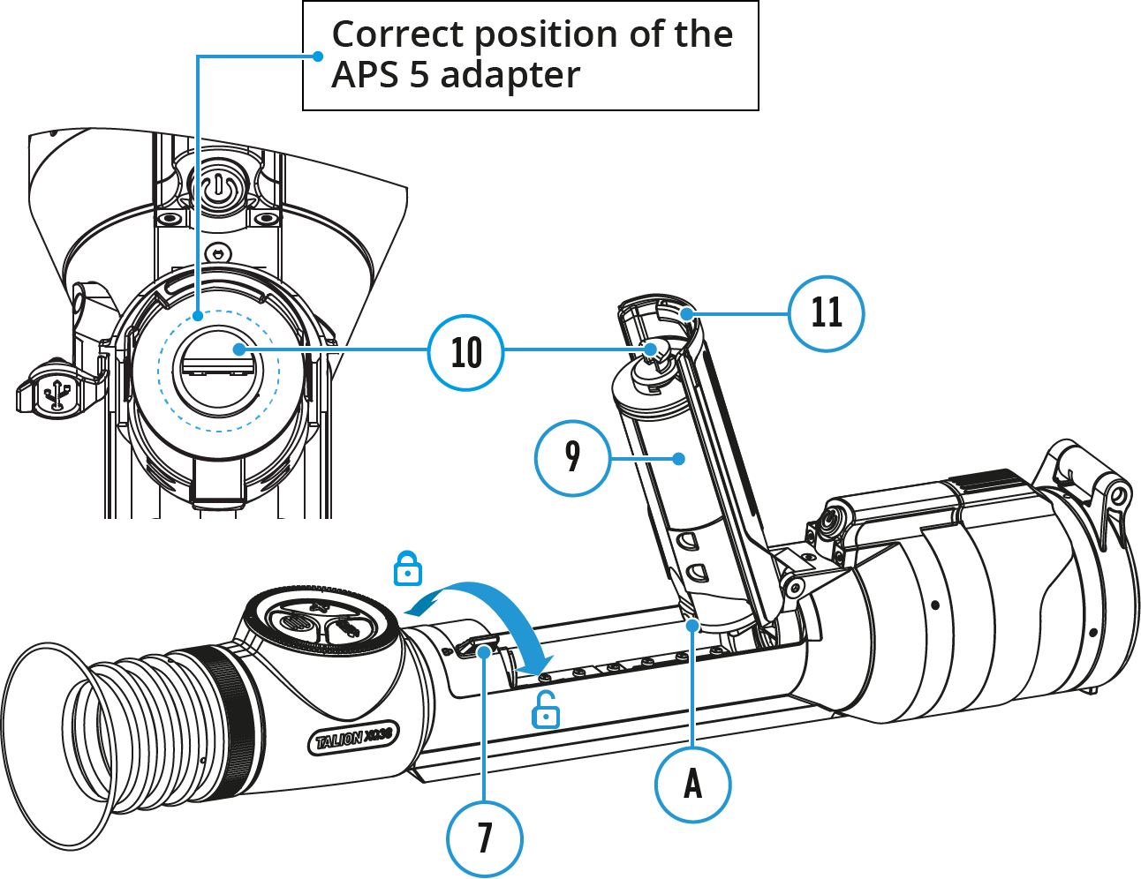
- Set the battery compartment lock (7) to the far right position .
- Open the battery compartment cover (11).
- Insert the APS5 battery (9) with the attached APS5 adapter (10) into the battery compartment as shown in the image. The protrusion (A) on the battery should fit into the groove between the fasteners under the battery compartment cover (11).
- Close the battery compartment cover (11).
- Move the lock (7) to the far left position .

External Power Supply
External power can be supplied from an external source, such as a Power Bank (5 V, 9 V).
- Connect the external power supply to the micro USB Type-C port (15) of the riflescope.
- The riflescope switches to external power source, while the APS5 Battery Pack will gradually recharge.
- A rechargeable battery icon 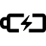 indicating a percentage of the battery life will appear in the status bar.
- If the riflescope operates on external power supply but the Battery Pack is not installed, an icon is shown.
- When external power supply is disconnected, the riflescope switches to the APS5 battery pack without powering off.

Warning! Charging APS5 batteries at air temperatures below 0° C (32° F) may reduce battery life. When using external power, connect the Power Bank to the device after it has been turned on and working for several minutes.

Precautions
- Always use the APS 5 charger supplied with the device (or purchased separately) to charge the APS 5 Battery Pack. The use of any other charger may irreparably damage the Battery Pack or the charger and may cause fire.
- Do not charge the Battery Pack immediately after bringing it from a cold environment to a warm one. Wait for 30-40 minutes for the Battery Pack to get warm.
- Do not leave the Battery Pack unattended while charging.
- Never use a modified or damaged charger.
- Do not leave the Battery Pack with a charger connected to the power adapter after charging is complete.
- Do not expose the Battery Pack to high temperatures or an open flame.
- Do not submerge the Battery Pack in water.
- Do not connect an external device with a current consumption that exceeds permitted levels.
- Do not dismantle or deform the Battery Pack.
- Do not drop or hit the Battery Pack.
- Keep the Battery Pack out of the reach of children.

Recommendations for Use
- The battery should be partially charged for long-term storage – 50 to 80 %.
- Charge the Battery Pack at a temperature from 0° C to +45° C (32° F to +113° F), otherwise the battery life will decrease significantly.
- When using the Battery Pack at sub-zero (sub 32° F) temperatures the battery capacity decreases. This is normal and is not a defect.
- Do not use the Battery Pack at temperatures above those shown in the table – this may decrease battery life.
- The Battery Pack is short circuit protected; however, any situation that may cause short-circuiting should be avoided.

Getting Started

Mounting on the Rifle
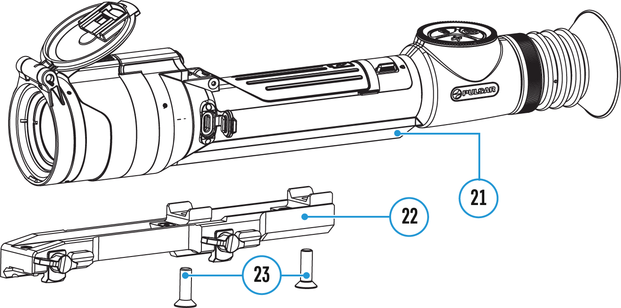
To ensure accurate shooting the Talion riflescope should be properly mounted on the rifle.
- Secure the support* (22) on the riflescope mount (21) using a hex key* and two screws* M6x20 mm (23).
- Choosing the position of the mount helps to ensure the correct eye relief, depending on the type of rifle.
- Install the riflescope with the mount on the rifle and check if the position is suitable for you, then remove it.
- Unscrew the screws (23) halfway, apply some thread sealant onto the thread of the screws (23) and tighten them fully. Let the sealant dry for the time specified in the instructions. The riflescope is ready to be installed on a rifle and to be zeroed.
- Before using the riflescope (especially for hunting), follow instructions in the Zeroing section.
* Available separately

Powering on and Image Setting
- Remove the lens cover (14).
- Turn the unit on with a short press of the ON/OFF (12) button.
- Adjust the sharpness of the symbols on the display by rotating the dioptre adjustment ring of the eyepiece (2).
- Rotate the lens focus control (13) to focus on visual target.
- Enter the main menu with a long press of the MENU (3) button and select the desired calibration mode by rotating the controller: manual (M), semi-automatic (SA) or automatic (A).
- Calibrate the image with a short press of the ON/OFF (12) button (when calibration mode SA or M has been selected). Close the lens cap before manual calibration.
- Activate the quick menu by briefly pressing the MENU (3) button to select the amplification level (“Normal” , “High” , “Ultra” ), adjust the brightness and contrast (see the Quick Menu section).
- Press the ZOOM (4) button successively to change the magnification ratio of the riflescope. While the icon is visible on the screen, rotate the controller (6) for smooth digital zooming from the current magnification.
- Power the device off with a long press of the ON/OFF (12) button.

Warning! Never point the lens at intensive energy sources such as laser radiation emitting devices or the sun. It can damage electronic components in the device. The warranty does not cover damage arising from failure to comply with operating instructions.

Button Operation
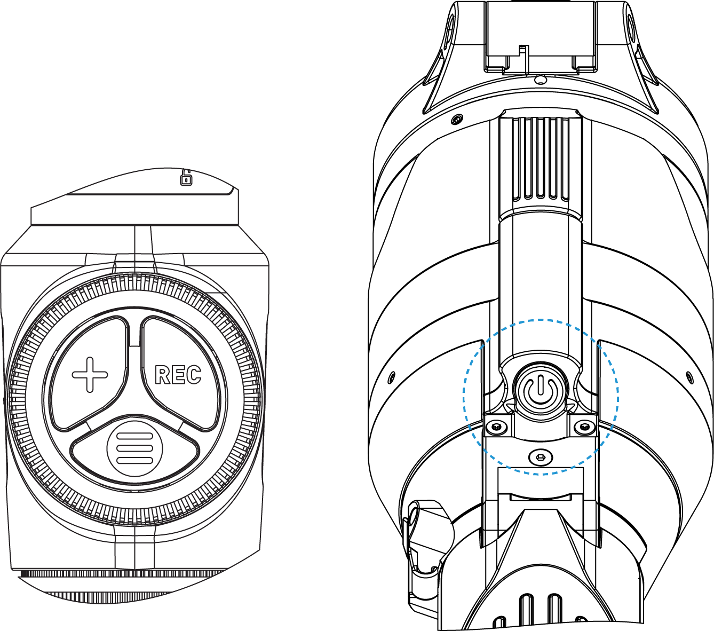
Operation | Button
Power device on | short press
Power device oﬀ | long press for 3 secs
Turn display oﬀ | long press for less than 3 secs
Turn display on | short press
Calibrate the microbolometer | short press
Control discrete digital zoom | short press
Smooth Zooming | rotation
PiP on/oﬀ | long press
Video Recorder | Button
Start/pause/resume video recording | short press
Stop video recording | long press
Switch to video / photo mode | long press
Capture Photo | short press
Main Menu | Button
Enter main menu | long press
Navigation through menu | rotation
Enter menu items | short press
Confirm value | short press
Exit menu items | long press
Exit main menu | long press
Quick Menu | Button
Enter quick menu | short press
Switch between quick menu options | short press
Parameter change | rotation
Exit quick menu | long press

Zeroing
Zeroing at a temperature close to the riflescope’s operating temperature is recommended.
Step 1. Take a shot
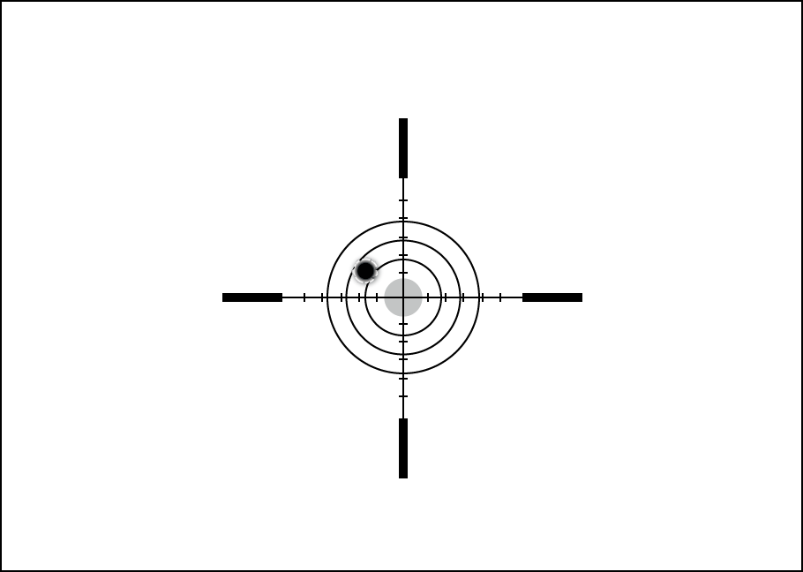
1. Shooting from a benchrest is recommended.
2. Set a target at a known distance.
3. Adjust the riflescope according to the Powering on and Image Setting section.
4. Select the zeroing profile (see Reticle & Zeroing 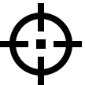 -> Zeroing Profile main menu item)
5. Point the rifle at the center of the target and shoot.

Step 2. Align the reticle with the point of impact
1. Press and hold the MENU (3) button to enter the main menu.
2. Add the distance you are aiming at (e.g. 100 meters): Reticle & Zeroing -> Add New Distance . Select the value for each distance digit by rotating the controller (6). Press the MENU (3) button briefly to switch between digits. After setting the required distance, press and hold the MENU (3) button to save it.
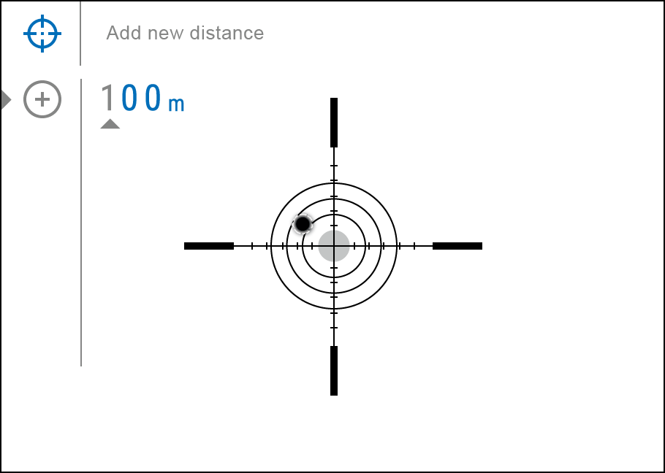
3. After adding the distance, it will switch to the Zeroing parameters settings menu . An auxiliary cross will appear in the center of the display, and X and Y coordinates of the auxiliary cross will appear in the upper right corner.
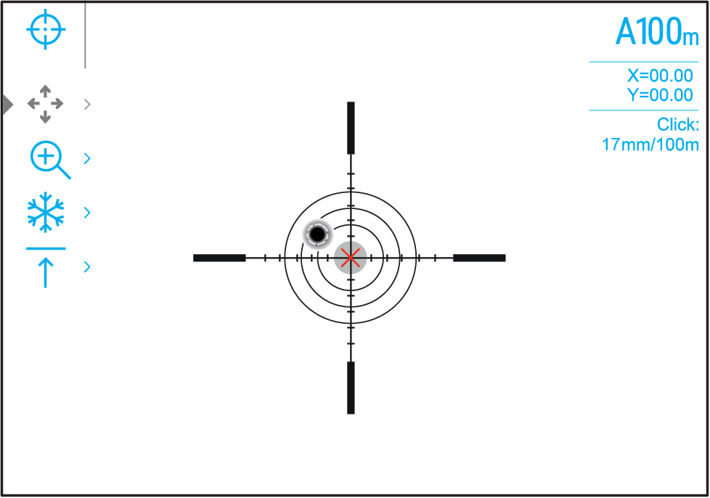
4. Press the MENU (3) button briefly to enter the Windage/Elevation submenu.
5. While holding the reticle at the aiming point, move the auxiliary cross until it is aligned with the impact point by rotating the controller (6).
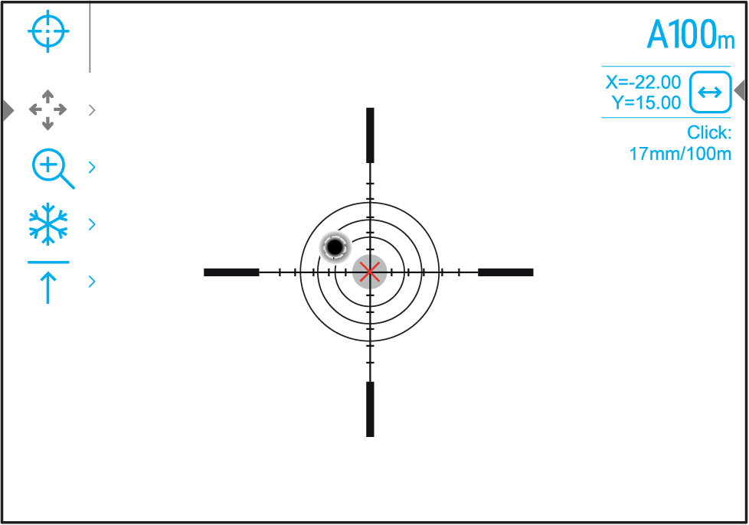
6. To change the direction of the auxiliary cross movement from horizontal to vertical, press the MENU (3) button briefly.

One-shot "Freeze Zeroing" function:
Using the Freeze function allows you to make adjustments without the need to hold the rifle precisely at the initial aiming point – freezing the zeroing screen (refer to Reticle & Zeroing menu item => Distance submenu => Zeroing Parameters Settings submenu => Freeze submenu or short pressing of the ON/OFF (12) button. The image will “freeze” and the icon will appear.

Step 3. Save the coordinates
1. Press and hold the MENU (3) button to save a new position for the reticle. The reticle will be aligned with the impact point and it will exit the Windage/Elevation submenu.
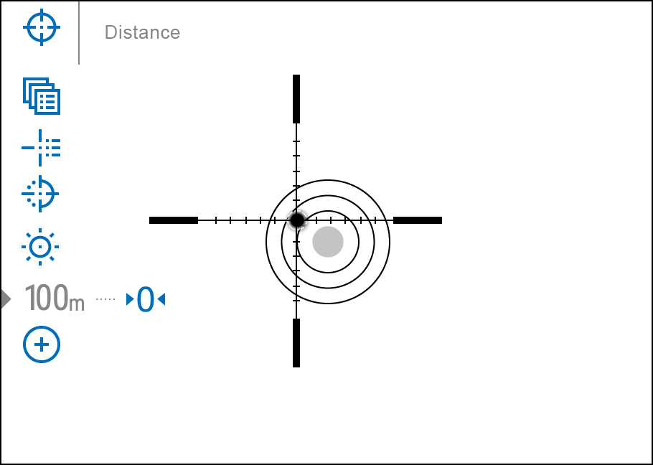
2. Press and hold the MENU (3) button again to exit the zeroing settings menu - the message “Zeroing coordinates saved” appears, confirming the successful operation.
3. Fire a second shot - now the point of impact and the aiming point must be matched.

Interface

Status Bar
The status bar at the bottom of the display shows current operating statuses via icons, including:
- Colour Mode (shown only when the Black Hot colour mode is selected)
- Actual zeroing profile (e.g., A)
- Zeroing distance (e.g., 100 m)
- Amplification level (e.g., Normal)
- Smoothing Filter (displayed when the function is on)
- Calibration mode (a countdown timer 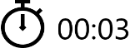 will appear instead of the calibration icon when in automatic calibration mode with 3 seconds remaining until automatic calibration)
- Magnification
- Microphone
- Wi-Fi connection
- Auto Shutdown function (e.g., 5 min.)
- Clock
- Power Indication:
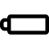 - charge level if the device is powered by a battery
- charge level if the device is charging and powered by a battery
- no battery, the device is connected to an external power supply

Quick Menu
The quick menu allows you to control the main settings of the riflescope (brightness, contrast), select the sensitivity amplifying level, measure the distance using a stadiometric rangefinder and change the zeroing distance (if there are several) to another one in the current profile.
- Press the MENU (3) button briefly to enter the quick menu.
- A short press of the MENU (3) button enables you to switch between functions, as described below.
Brightness – rotate the controller (6) to change the display brightness value from 00 to 20.
Contrast – rotate the controller (6) to change the image contrast value from 00 to 20.
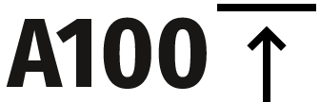 – information on the current profile and zeroing distance in this profile (e.g., profile A, zeroing distance of 100 m). This information is always displayed in the status bar. Rotate the controller (6) to switch between the zeroing distances in the selected profile. This function is available if there are two or more distances in the profile.
Amplification Levels – allows you to select one of three amplifying levels of sensitivity (Normal , High , Ultra ).
Note: To maintain brightness and contrast settings when changing amplifying levels, activate User Mode.
Stadiametric rangefinder – rotating the controller (6), change the distance between the special mark points to determine the distance to the observed object (for more details on the rangefinder, see the Stadiametric Rangefinder section).
- Press and hold the MENU (3) button to exit the menu or wait 10 seconds to exit automatically.

Main Menu

Enter the Main Menu
- Enter the main menu with a long press of the MENU (3) button.
- To move through the main menu items, rotate the controller (6).
- Press the MENU (3) button briefly to open subitems of the main menu.
- Press and hold the MENU (3) button to exit from a subitem of the main menu.
- Automatic exit from the main menu occurs after 10 seconds of inactivity.

General View of the Menu

Tab 1
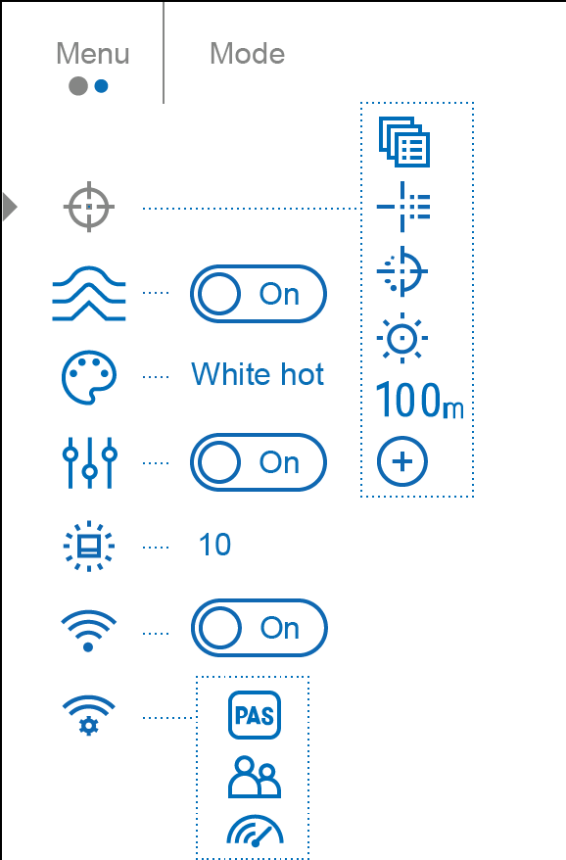

Tab 2
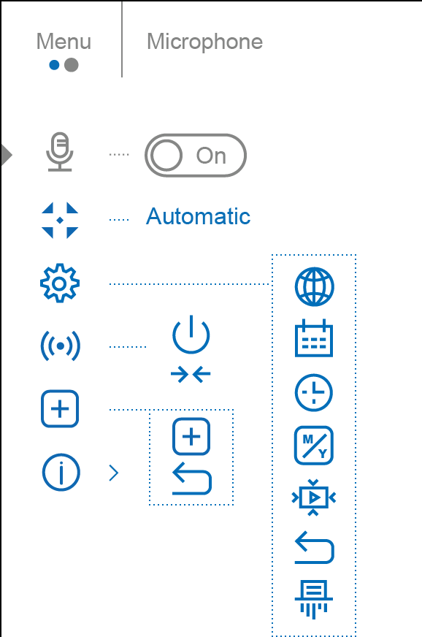

Reticle & Zeroing

Zeroing Profile
This item of the main menu allows you to select one of five profiles (А, В, С, D, E) to use. Each profile stores information on the following parameters:
- A set of zeroed distances
- Reticle colour
- Reticle type
Different profiles can be used when using the riflescope on different rifles or when shooting with different bullets.

- Press and hold the MENU (3) button to enter the main menu.
- Rotate the controller (6) to select the Reticle & Zeroing menu item.
- Press the MENU (3) button briefly to enter the Reticle & Zeroing submenu.
- Press the MENU (3) button briefly to enter the Zeroing Profile submenu.
- Rotate the controller (6) to select one of the zeroing profiles (marked with the letters A, B, C, D, E).
- Confirm your selection with a short press of the MENU (3) button.
- The name of the selected profile appears in the status bar at the bottom of the display.

Reticle Type
Selection of the aiming reticle shape.
- Press and hold the MENU (3) button to enter the main menu.
- Rotate the controller (6) to select the Reticle & Zeroing menu item.
- Press the MENU (3) button briefly to enter the Reticle & Zeroing submenu.
- Rotate the controller (6) to select the Reticle Type submenu.
- Press the MENU (3) button briefly to enter the Reticle Type submenu.
- Rotate the controller (6) to select the desired aiming reticle shape from the list that appears. The reticle type changes as the cursor goes down the reticle list.
- Press the MENU (3) button briefly to confirm the selection.

Reticle Colour
Selection of reticle colour.
- Press and hold the MENU (3) button to enter the main menu.
- Rotate the controller (6) to select the Reticle & Zeroing menu item.
- Press the MENU (3) button briefly to enter the Reticle & Zeroing submenu.
- Rotate the controller (6) to select the Reticle Colour 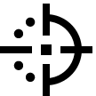 submenu.
- Press the MENU (3) button briefly to enter the Reticle Colour submenu.
- Rotate the controller (6) to select one of the colour options for the reticle: Black/Red, White/Red, Black/Green, White/Green, Red, Green, Yellow, Blue, Orange, Black/White, White/Black.
- Press the MENU (3) button briefly to confirm the selection.

Reticle Brightness
Adjust the brightness level of the aiming reticle.
- Press and hold the MENU (3) button to enter the main menu.
- Rotate the controller (6) to select the Reticle & Zeroing menu item.
- Press the MENU (3) button briefly to enter the Reticle & Zeroing submenu.
- Rotate the controller (6) to select the Reticle Brightness submenu.
- Press the MENU (3) button briefly to enter the Reticle Brightness submenu.
- Rotate the controller (6) to set the desired brightness level (1 to 10).
- Press the MENU (3) button briefly to confirm the selection.

Zeroing

Add New Distance
To zero your riflescope, you need to set a zeroing distance first in the range of 1 to 910 m (955 yards).
- Press and hold the MENU (3) button to enter the main menu.
- Rotate the controller (6) to select the Reticle & Zeroing menu item.
- Press the MENU (3) button briefly to enter the Reticle & Zeroing submenu.
- Rotate the controller (6) to select Add New Distance menu item.
- Press the MENU (3) button briefly to enter the submenu.
- Rotate the controller (6) to select a value for each digit. Press the MENU (3) button briefly to switch between digits 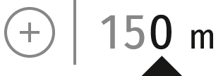.
- Having set the desired distance, press and hold the MENU (3) button to save it.

The distance you set first becomes a primary distance – shown with icon 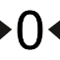 on the right to the distance value.
Note: Maximum number of zeroing distances is 10 for each profile.

Zeroing Parameters Settings
- Press and hold the MENU (3) button to enter the main menu.
- Rotate the controller (6) to select the Reticle & Zeroing menu item and enter by briefly pressing the MENU (3) button – zeroed distances are displayed at the bottom.
- The values (e.g., +7.0) shown on the right of the distance values, stand for the number of clicks along the Y axis, at which the reticle position at other distances differs from the reticle position in the primary distance.
- To zero at any distance again, rotate the controller (6) to select the required distance and briefly press the MENU (3) button.
- Rotate the controller (6) to select the Zeroing Parameters Settings and enter by briefly pressing the MENU (3) button.
- Zeroing screen, which allows the change of zeroing coordinates, will appear:

Windage/Elevation
The Windage/Elevation additional menu item in the Zeroing Parameters Settings menu allows you to adjust the reticle position. For a detailed description of the reticle adjusting, refer to the Zeroing section.

Magnification (when Zeroing)
Magnification allows you to magnify via the device’s digital zoom when zeroing, which reduces the MOA-per-click values of adjustments and improves zeroing accuracy.
- In the Zeroing Parameters Settings menu, rotate the controller (6) to select the Magnification submenu item and enter by briefly pressing the MENU (3) button.
- Rotate the controller (6) to select a digital magnification value of the riflescope (e.g., x4).
- Press the MENU (3) button briefly to confirm your selection.
The minute of angle click when using the Magnification function is indicated in the Table of Technical Specifications.

Freeze
The “freeze” function allows the user to freely move or manipulate the rifle without losing reticle placement on the point of aim during adjustments.
- In the Zeroing Parameters Settings menu, rotate the controller (6) to move the cursor to the Freeze function.
- Align the reticle with the point of aiming and press the MENU (3) button or the ON/OFF (12) button. A screenshot will be taken, an icon will appear.
- Go to the additional Windage/Elevation submenu and adjust the position of the reticle (see the Zeroing section).
- Select the Freeze submenu item again and briefly press the MENU (3) button or ON/OFF (12) button - the image will “unfreeze”.

Name Distance
- In the Zeroing Parameters Settings menu, rotate the controller (6) to select the Name Distance 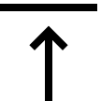 submenu item and enter it by briefly pressing the MENU (3) button​.
- Rotate the controller (6) to select a value for each digit. Press the MENU (3) button briefly to switch between digits.
- Press and hold the MENU (3) button to confirm the selection.

Change Primary Distance
- Press and hold the MENU (3) button to enter the main menu.
- Rotate the controller (6) to select the Reticle & Zeroing menu item and enter by briefly pressing the MENU (3) button – zeroed distances are displayed at the bottom.
- Select a non-primary distance and enter the submenu for operating the distance with a brief press of the MENU (3) button.
- Select Change Primary Distance item.
- Press the MENU (3) button briefly.
- Icon next to the selected distance confirms the change of primary distance.
There will also be a recalculation of corrections in clicks for other distances relative to the new primary distance.

Delete Distance
- Press and hold the MENU (3) button to enter the main menu.
- Rotate the controller (6) to select the Reticle & Zeroing menu item and enter by briefly pressing the MENU (3) button – zeroed distances are displayed at the bottom.
- Select the distance you wish to delete and enter the submenu for operating the distances with a brief press of the MENU (3) button.
- Select Delete Distance item.
- Press the MENU (3) button briefly.
- Select “Yes” in the appeared dialog box to delete a distance. “No” – to cancel deletion.
- Press the controller button (6) briefly to confirm your selection.
Attention! If the primary distance is deleted, the first distance on the list automatically becomes the new primary distance.

Smoothing Filter
Used to reduce digital distortion while maintaining a high level of sensitivity.

- Press and hold the MENU (3) button to enter the main menu.
- Rotate the controller (6) to select the Smoothing Filter icon.
- Press the MENU (3) button briefly to turn the filter on/off.

Colour Modes
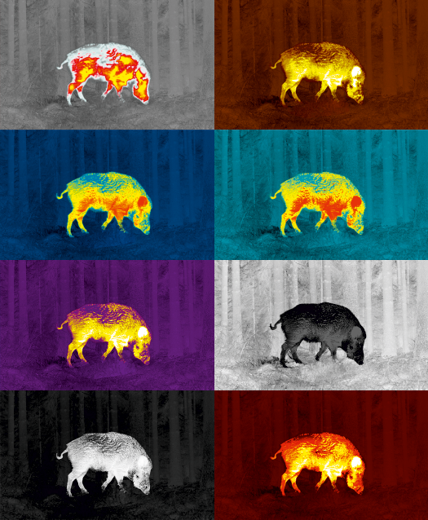
Colour mode selection.
White hot is a default display mode for an observed image.

The Colour Modes menu item allows you to select an alternative palette:
- Press and hold the MENU (3) button to enter the main menu.
- Select the Colour Modes menu item.
- Press the MENU (3) button briefly to enter the Colour Modes submenu.
- Rotate the controller (6) to select one of the palettes described below.
- Press the MENU (3) button briefly to confirm your selection.

- White hot – a black and white palette (the black colour corresponds to cold temperature, the white colour – hot temperature)
- Black hot – a black and white palette (the white colour corresponds to cold temperature, the black colour – hot temperature)
- Red Hot
- Red Monochrome
- Rainbow
- Ultramarine
- Violet
- Sepia

Attention! The device does not measure the temperature of objects being observed. The image is formed based on the temperature differences of the objects.

User Mode
This mode is used to save the user’s brightness and contrast settings. The selected settings are retained after restarting the device.

- Press and hold the MENU (3) button to enter the main menu.
- Rotate the controller (6) to select the User Mode 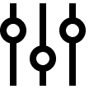 icon.
- Press the MENU (3) button briefly to turn the filter on/off.

Icon Brightness
Adjust the brightness level of the icons and screensavers (Pulsar, Display off) on the display.
- Press and hold the MENU (3) button to enter the main menu.
- Rotate the controller (6) to select the Icon Brightness menu item.
- Press the MENU (3) button briefly to enter the Icon Brightness submenu.
- Rotate the controller (6) to set the desired brightness level (1 to 10).
- Press the MENU (3) button briefly to confirm the selection.

Wi-Fi Activation
Turn on/off Wi-Fi
- Press and hold the MENU (3) button to enter the main menu.
- Rotate the controller (6) to select the Wi-Fi Activation menu item.
- To turn Wi-Fi on, briefly press the MENU (3) button. 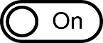
- To turn Wi-Fi off, briefly press the MENU (3) button.

Wi-Fi Settings
This item enables you to set up your riflescope for operation in a Wi-Fi network.
- Press and hold the controller MENU (3) button to enter the main menu.
- Rotate the controller (6) to select the Wi-Fi Settings submenu.
- Press the MENU (3) button briefly to enter the submenu
- Rotate the controller (6) to select the desired menu item.

Password Setup
This item enables you to set a password to access the riflescope from an external device. The password is used to connect an external device (i.e. smartphone) to the riflescope.
- Press the MENU (3) button to enter the Password Setup submenu.
- The default password (12345678) will appear on the screen.
- Rotate the controller (6) to set the desired password. Press the MENU (3) button to toggle through the digits.
- Press and hold the MENU (3) button to save the password and exit from the submenu.

Access Level Setup
This sub-function enables you to configure the appropriate level of access to your device made available to the Stream Vision 2 application.
Owner level. A Stream Vision 2 user has full access to all the device’s functions.
Guest level. A Stream Vision 2 user can only view video footage from the device in real time.
- Press the MENU (3) button to enter the Access Level Setup submenu.
- Rotate the controller (6) to select Owner or Guest.
- Confirm your selection with a short press of the MENU (3) button.

WiFi Bandwidth
This setting helps to solve a smartphone connection issue in the following cases:
- If your smartphone does not support 5 GHz WiFi band, switch to 2.4 GHz band.
- Many WiFi networks may cause interference. In this case, switching between WiFi bands can improve the connection between the device and smartphone.
- Press the MENU (3) button to enter the WiFi Bandwidth 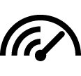 submenu.
- Rotate the controller (6) to select the WiFi bandwidth – 5 GHz or 2.4 GHz.
- Confirm your selection with a short press of the MENU (3) button.

Microphone
Turning on/off Microphone.
This item allows you to enable (or disable) the microphone for recording sound during video recording.
- Press and hold the MENU (3) button to enter the main menu.
- Rotate the controller (6) to select the Microphone menu item.
- To turn on the microphone, briefly press the controller MENU (3) button.
- To turn off the microphone, briefly press the controller MENU (3) button.

Calibration Mode
Calibration mode selection.
Calibration eliminates image flaws (such as vertical bars, phantom images, grainy field of view, etc.) by equalizing the microbolometer background temperature.
There are three calibration modes: manual, semi-automatic and automatic.
The selected calibration mode is displayed in the status bar (see Status Bar section).

Select the required mode in the Calibration Mode item:
- Press and hold the MENU (3) button to enter the main menu.
- Rotate the controller (6) to select the Calibration Mode menu item.
- Press the MENU (3) button briefly to enter the Calibration Mode submenu.
- Rotate the controller (6) to select one of the calibration modes described below.
- Press the MENU (3) button briefly to confirm your selection.

M mode (manual)
- Close the lens cover (14) and press the ON/OFF (12) button briefly.
- Open the cover after the calibration is completed.

SA mode (semi-automatic)
- The user independently determines the need for calibration (according to the image being observed).
- Press the ON/OFF (12) button briefly to activate calibration.
- There is no need to close the lens cover (internal shutter covers the microbolometer).

A Mode (automatic)
- The riflescope is calibrated autonomously according to the software algorithm.
- There is no need to close the lens cover (internal shutter covers the microbolometer).
- In this mode, the riflescope may be calibrated by the user with the ON/OFF (12) button.
Note: a display image freezes until the calibration is in progress.

General Settings
- Press and hold the MENU (3) button to enter the main menu.
- Rotate the controller (6) to select the General settings menu item.
- Press the MENU (3) button briefly to enter the submenu.
- Rotate the controller (6) to select the desired menu item.
This menu item allows you to configure the following settings:

Language
Language selection:
- Press the MENU (3) button briefly to enter the Language submenu.
- Rotate the controller (6) to select one of the available interface languages: English, German, Spanish, French, Russian, Italian, Portuguese, Dutch, Danish, Norwegian, Swedish, Polish, Czech, Hungarian.
- Confirm your selection with a short press of the MENU (3) button.
- Press and hold the MENU (3) button to save your selection and exit from the submenu.

Date
Date Setting:
- Press the MENU (3) button briefly to enter the Date submenu. The date is displayed in dd/mm/yyyy format.
- Rotate the controller (6) to select the desired year, month and date. Press the MENU (3) button briefly to switch between digits.
- Press and hold the MENU (3) button to save your selected date and exit from the submenu.

Time
Time Setting:
- Press the MENU (3) button briefly to enter the Time submenu.
- Rotate the controller (6) to select the time format - 24 or AM/PM.
- Press the MENU (3) button to proceed to the hour setting.
- Rotate the controller (6) to select the hour value.
- Press the MENU (3) button to proceed to the minute setting.
- Rotate the controller (6) to select the minutes value.
- Press and hold the MENU (3) button to save your selected time and exit from the submenu.

Units of Measure
Units of measurement selection:
- Press the MENU (3) button briefly to enter the Units of Measure submenu.
- Rotate the controller (6) to select the unit of measurement - meters or yards, press the MENU (3) button.
- Return to submenu will happen automatically.

Video Compression
When set to ON, standard video compression is applied so the video file size is reduced.
When set to OFF, minimal video compression is applied. In this case, the quality of the recorded video is better, but its size is significantly increased.
Warning! Larger video file size results in shorter total video recording time. This may lead to longer download times for video files through the Stream Vision 2 mobile application.

Enable/disable video compression:
- Press and hold the MENU (3) button to enter the main menu.
- Rotate the controller (6) to select the Video Compression 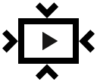 menu item.
- To turn on video compression, briefly press the MENU (3) button.
- To turn off video compression, briefly press theтMENU (3) button.

Default Settings
- Press the MENU (3) button briefly to enter the Default Settings 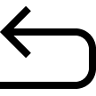 submenu.
- Rotate the controller (6) to select “Yes” to restore default settings or “No” to cancel the action.
- Confirm your selection with a short press of the MENU (3) button.
- If “Yes” is selected, display will show “Do you want to restore default settings?” and “Yes” and “No” options. Select “Yes” to restore default settings.
- If “No” option is selected: the action will be aborted and you will return to the submenu.
The following settings will be returned to their defaults:
- Video Recorder Mode – Video
- Amplification Level – Normal
- Smoothing Filter – Off
- User Mode - Off
- Calibration Mode – automatic
- Interface Language – English
- Wi-Fi – off (default password)
- Magnification – initial value (without digital zoom)
- PiP – Off
- Colour Mode – White hot
- Units of Measurement – metric
- Side Incline – Off
- Zeroing Profile – A
- Reticle selection from the riflescope’s memory – 1
- WiFi Bandwidth – 5 GHz
Attention! After restoring default settings, the date, time and user pixel map as well as the zeroing profiles data entered by the user are saved.

Format
This menu option allows you to format the device's memory card. All files will be deleted.
- Press the MENU (3) button briefly to enter the Format submenu.
- Rotate the controller (6) to select “Yes” to format the memory card, or “No” to return to the submenu.
- Confirm your selection by pressing the MENU (3) button.
- If the “Yes” option has been selected, the "Do you want to format memory?" message and “Yes” and “No” options will appear on the display. Select “Yes” to format the memory card.
- If “No” option is selected: formatting is cancelled and return to the submenu.

Accelerometer

Auto Shutdown
This item allows you to activate auto shutdown function for riflescope in a non-operating position (tilt up or down at an angle of more than 70°, right or left - at an angle of more than 30°). In this event, the controls (buttons, controller) are disabled.

- Press and hold the MENU (3) button to enter the main menu.
- Rotate the controller (6) to select the Accelerometer 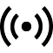 submenu.
- Confirm the selection by briefly pressing the MENU (3) button.
- Rotate the controller (6) to select Auto Shutdown .
- Press the MENU (3) button to enter the submenu.
- Rotate the controller (6) to select the time period (1 min, 3 min, 5 min) upon expiry of which the riflescope will automatically shut down, or select Switch off if you wish to deactivate Auto Shutdown.
- Confirm your selection with a short press of the MENU (3) button.

Note: If the automatic shutdown function is activated, the status bar shows an icon ​and shutdown time period as 1 min.

Side Incline
This item allows you to turn on/off the indication of horizontal (side) incline of the rifle. Side incline is indicated by “sector” arrows to the right and left of the reticle. Arrows show the direction in which you should move your rifle to eliminate incline.

There are three modes of incline:
- 5°-10° – one sector arrow;
- 10°-20° - two sector arrow;
- > 20° - three sector arrow.
A side incline of less than 5° is not displayed.

- Press and hold the MENU (3) button to enter the main menu.
- Rotate the controller (6) to select the Accelerometer menu item.
- Press the MENU (3) button briefly to enter the Accelerometer submenu.
- Rotate the controller (6) to select Side Incline 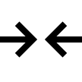.
- Press the MENU (3) button briefly to enter the Side Incline submenu.
- Rotate controller (6) to select On for turning on the incline indication or Off for turning it off.
- Confirm your selection with a short press of the MENU (3) button.

Defective Pixel Repair

Defective Pixel Repair
When using the device, defective (dead) pixels may appear on the microbolometer. These are bright or dark points of a constant brightness that are visible on the image.
Defective pixels on the microbolometer can increase in size relative to the digital-zoom power.
The Talion thermal riflescope allows the user to remove any defective pixels on the display, as well as cancel removal, via the device’s firmware.
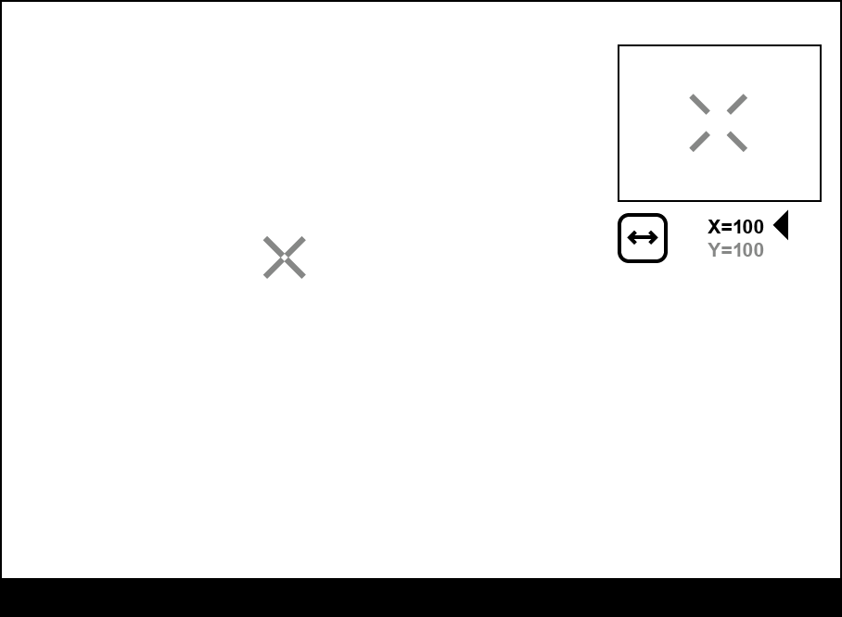

Step 1. Enter the menu to fix the defective pixels
- Press and hold the MENU (3) button to enter the main menu.
- Rotate the controller (6) to select the Defective Pixel Repair menu item.
- Press the MENU (3) button to open the submenu.
- Press the MENU (3) button briefly to select the icon .

Step 2. Select the defective pixel
- A marker will appear on the left side of the display. A “magnifying glass” will appear on the right side of the display — a rectangle with an enlarged view of the marker for precise pixel selection — and marker coordinates under the “magnifying glass” 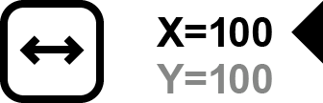.
- Rotate the controller (6) to move the marker to align its center with the defective pixel.
- Press the MENU (3) button shortly to switch the marker direction from the horizontal to the vertical and vice versa.
- Rotate the controller (6) to align the defective pixel with the fixed cross in the frame – the pixel should disappear.

Step 3. Remove the defective pixel
- Delete the defective pixel with a short press of the ON/OFF (12) button.
- Where the pixel has been successfully deleted, the OK message will appear on the screen for a short time.
- Then, by moving the marker across the display, you can delete the next defective pixel.
- Press and hold the MENU (3) button to exit the Defective Pixel Repair function.

Restore Default Pixel Map
This option allows the user to return all previously disabled defective pixels to their original state.
- Press and hold the MENU (3) button to enter the main menu.
- Rotate the controller (6) to select the Defective Pixel Repair icon.
- Press the MENU (3) button to enter the submenu.
- Rotate the controller (6) to select the Restore Default Pixel Map icon.
- Activate the function by briefly pressing the MENU (3) button.
- Rotate the controller (6) to select Yes if you want to return to the factory pixel map or select No if you do not.
- Confirm your selection with a short press of the MENU (3) button.
Attention! One or two pixels on the display of the device in the form of bright white, black or coloured (blue, red or green) points may appear. These points cannot be removed and are not a defect.

Device Information
- Press and hold the MENU (3) button to enter the main menu.
- Rotate the controller (6) to select the Device Information menu item.
- Press the MENU (3) button briefly to enter the Device Information submenu.

This item allows the user to view the following information about the riflescope:
- Full name of the riflescope
- SKU number
- Serial number of the riflescope
- Riflescope firmware version
- Hardware version
- Service information
- Battery information

Functions

Amplification Level
Sensitivity enhancement levels (Normal, High, Ultra) are software algorithms that enhance the quality of detection and recognition in various observation conditions. When the temperature contrast decreases (fog, precipitation, high humidity), it is recommended to increase the amplification level. To optimize the image, activate the Smoothing Filter in the main menu.

- Press and hold the MENU (3) button to enter the quick menu.
- By short pressing the MENU (3) button select the menu item Amplification level .
- Rotate the controller (6) to select one of the levels: Normal , High , Ultra .
- Press and hold the MENU (3) button to exit the menu or wait for 3 seconds to exit automatically.

Video Recording and Photography
The riflescope is equipped with a function for video recording (photography) of the observed image that is saved on the built-in memory card.
Before using the photo and video functions, read the Date and Time subsections of the General Settings section.

Built-in recorder operates in two modes:
- Photo (photography; the icon is displayed in the upper left corner of the display).
- Video (video recording; the icon is displayed in the upper left corner of the display, the total remaining recording time is given taking into account the current resolution in the HH:MM format (hours:minutes).
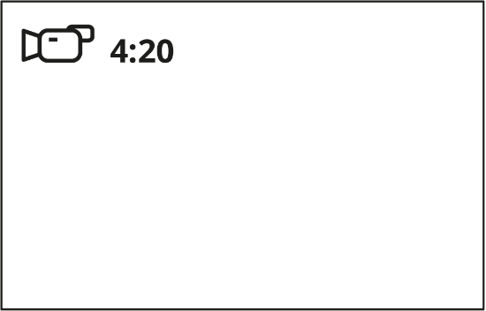
Toggle (switch) between the riflescope operating modes with a long press of the REC (5) button. Switching between the modes is cyclical (Video–> Photo–> Video...).

Photo mode. Capturing an image
1. Switch to the Photo mode with a long press of the REC (5) button.
2. Press the REC (5) button briefly to capture a photo. The icon flashes – the photo file is being saved to the built-in SD card.

Video mode. Recording a video
1. Switch to the Video mode with a long press of the REC (5) button.
2. Press the REC (5) button briefly to start video recording.
3. When the video recording starts, the icon will disappear, instead of it the REC icon as well as the video recording timer displayed in the MM:SS (minutes:seconds) format will appear 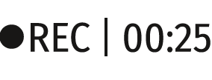.
4. Pause/continue recording by briefly pressing the REC (5) button.
5. Press and hold the REC (5) button to stop video recording.
Video files are stored in the built-in memory card:
- After turning off the video recording;
- Upon powering the riflescope off if recording was on;
- When the memory card is overfilled during recording (Memory Full message appears on the display).

Notes:
- You can enter and navigate the menu during video recording.
- Recorded videos and photos are saved to the built-in memory card of the riflescope in the format img_xxx. jpg (for photos); video_xxx. mp4 (for video).
- Maximum duration of a recorded video file is 5 minutes. After this time expires, the video is recorded to a new file. The number of recorded files is limited by the capacity of unit’s internal memory.
- Regularly check free memory within the built-in memory card and move the footage to other storage media to free up the memory card space.

Discrete Digital Zoom
Discrete digital zoom allows you to quickly increase the basic magnification (see Magnification line in the table of Technical Specifications) by 2x or 4x, as well as return to the basic magnification.
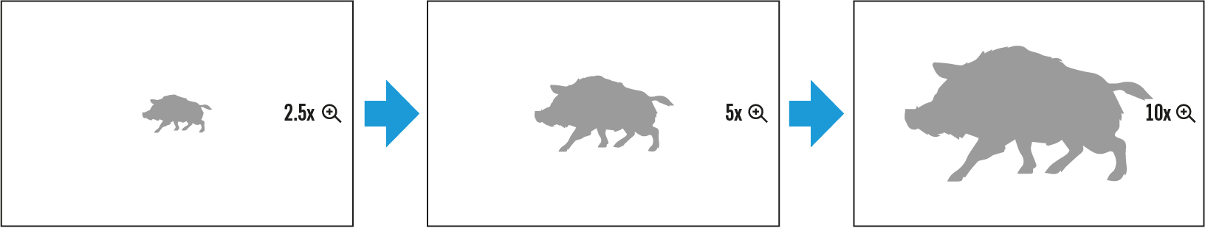
- Press the ZOOM (5) button successively to change the magnification ratio of the riflescope.
- While the icon is visible on the screen, rotate the controller ring (6) for smooth digital zooming from the current magnification.

PiP Function
The PiP function (Picture-in-Picture) allows you to see both a magnified image in a particular dialog box and the main image.
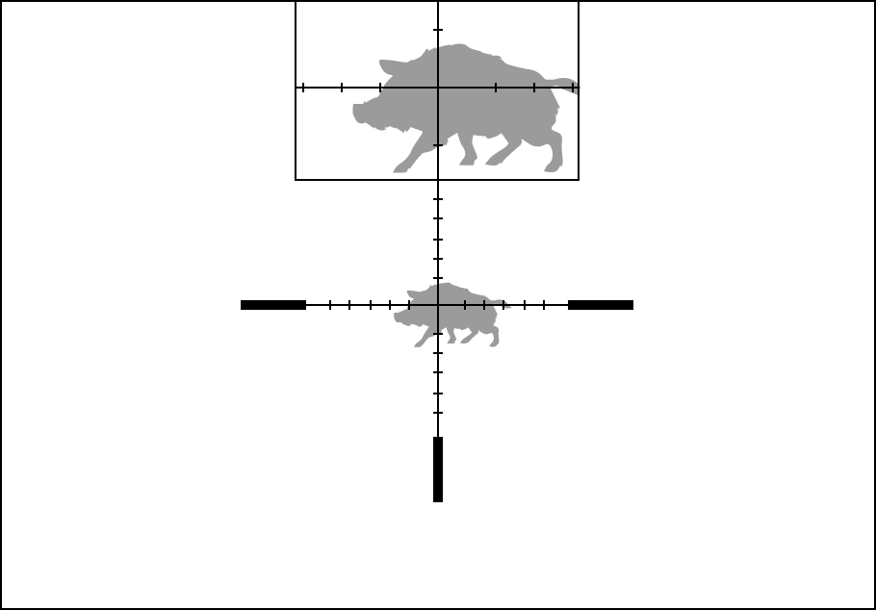
- Press and hold the ZOOM (4) button to turn on/off the PiP function.
- To change the digital zoom in the PiP window, briefly press the ZOOM (4) button or rotate the controller (6) until the icon is visible on the screen .
- The magnified image is displayed in a particular dialog box, with the full magnification being used.
- The rest of the image is displayed only with the optical zoom (digital zoom is off).
- When PiP is turned off, the display shows the full magnification set for the PiP mode.

Display-Off Function
This function deactivates the image transmission to the display by minimizing its brightness. This helps prevent accidental disclosure. However, the device stays on.
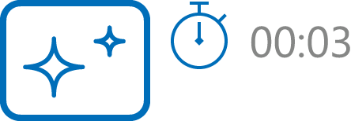

- When the device is on, press and hold the ON/OFF (12) button for less than 3 seconds. The display will turn off, the current time and the "Display off" icon will appear.
- Press the ON/OFF (12) button briefly to turn on the display.
- When you press and hold the ON/OFF (12) button, the display shows the "Display off" icon with a countdown. Holding the button down for the duration of the countdown will power the device off completely.

Wi-Fi Function
The riflescope has a function for wireless communication with mobile devices (smartphone or tablet) via Wi-Fi.
- To enable the wireless module, enter the main menu by long pressing the MENU (3) button.
- Rotate the controller (6) to select the Wi-Fi Activation menu item.
- Press the MENU (3) button briefly to turn on/off the Wi-Fi module.
Wi-Fi is displayed in the status bar as follows:
Indication in the Status Bar | Connection Status
 | Wi-Fi is switched off
 | Wi-Fi is switched on by the user, Wi-Fi connection in the riflescope is in progress.
 | Wi-Fi is switched on, there is no connection to the riflescope
 | Wi-Fi is switched on, there is connection to the riflescope
- An external device recognizes the riflescope under the name Talion_XXXX, where XXXX are the four last digits of the serial number.
- After entering the password (default: 12345678) on a mobile (see Password Setup subsection of the Wi-Fi Settings section for more information on setting a password) and setting up a connection, the icon in the riflescope status bar changes to .

Scalable Reticles
This function is designed to preserve ballistic properties of the scalable reticles X51Fi-300, M56Fi, M57Fi for all magnifications.
- Enter the main menu with a long press of the MENU (3) button.
- Enter submenu Reticle & zeroing 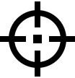 -> Reticle Type .
- Select the reticle X51Fi-300, M56Fi, M57Fi.

Notes:
- When zooming in and out the image, the selected reticle on the display and in the recorded video changes its geometrical size according to the magnification selected.
- The reticle scale changes both on the main display and in the PiP mode.

Stadiametric Rangefinder
Thermal imaging riflescopes are equipped with a stadiametric rangefinder, which allows you to determine the approximate distance to an object, if its size is known.
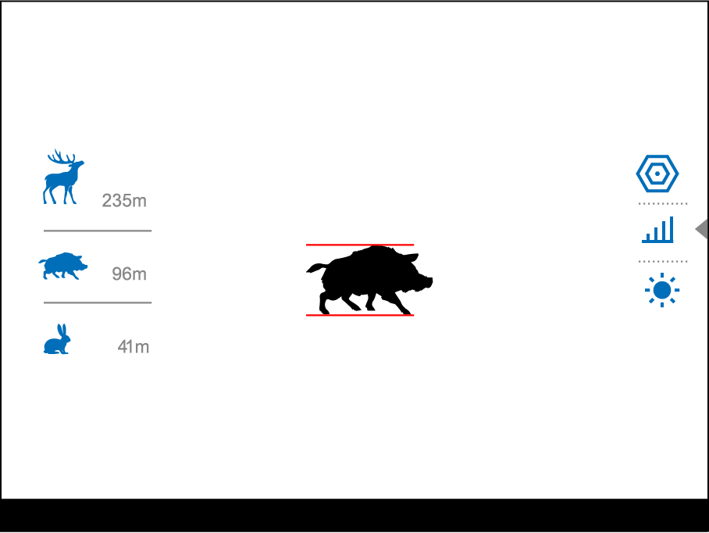
- To select the Stadiametric Rangefinder function, enter the Quick Menu by briefly pressing the MENU (3) button.
- Press the MENU (3) button briefly to select the icon .
- The display will show the lines for measurements, the icons and numbers of the measured distance for three objects.
- Place the bottom fixed line under the object.
- Rotate the controller (6) to move the upper line relative to the lower horizontal fixed line so that the object is located directly between the lines. A target range automatically recalculated along with movement.
- To exit the rangefinder mode, briefly press the MENU (3) button or wait 10 seconds to exit automatically.
Notes:
- There are three predefined values for objects: Hare – 0.3 m high, Boar – 0.7 m high, Deer – 1.7 m high.
- The measured range value is rounded off before being displayed – for large range values up to 5 m, for shorter range – up to 1 m.
- To select a unit of measurement (meters or yards), go to the General Settings menu item => Units of Measure submenu.

USB Connection
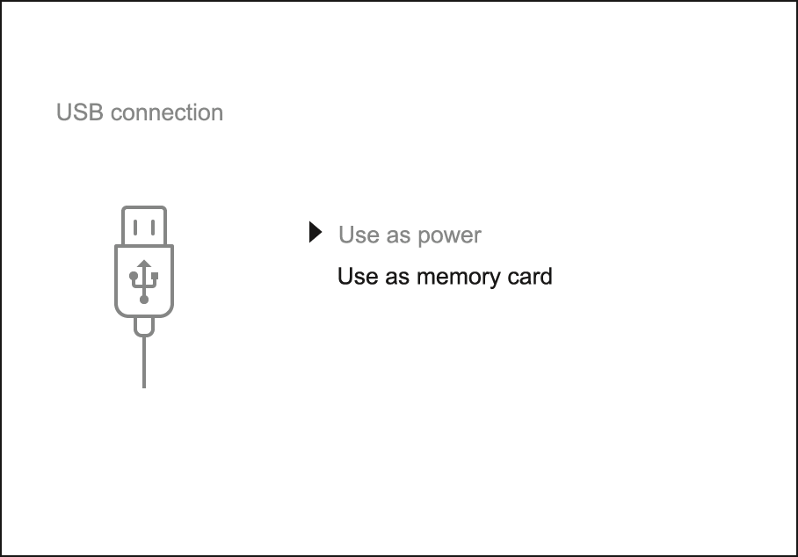
- Press the ON/OFF (12) button briefly to power the riflescope on (the computer will not detect the riflescope if it is turned off).
- Connect one end of the USB cable to the USB Type-C (15) connector of the riflescope, the other one to the port on your computer using a USB Type-A adapter.
- The riflescope is detected by the computer automatically and no installation of drivers is required.
- After a few seconds, two connection options appear on the display: Power and Memory card.
- Rotate the controller (6) to select the connection mode.
- Press the controller MENU (3) briefly to confirm your selection.

Power
- Upon choosing this mode, your PC is used as an external power supply. An icon will appear in the status bar.
- The riflescope continues operating and all functions are accessible.
- A battery recharge feasibility depends on your computer's USB port.

Memory Card
- When selecting this mode, the computer recognizes the riflescope as a memory card. This mode is designed to manage the files saved in riflescope’s memory.
- The riflescope’s functions are not available in this mode; the riflescope turns on. The device continues to operate after being disconnected from the computer.
- If a video was being recorded at the moment of connection, the recording will stop and will be saved.

USB Disconnection
- When the USB is disconnected from the riflescope, connected as the Power mode, the riflescope continues operating from the rechargeable battery if sufficiently charged.
- When the USB is disconnected from the riflescope connected in the Memory Card mode, the riflescope remains switched on.

Software

Stream Vision 2
Install the Stream Vision 2 application to download files, update firmware, control the device by remote control and broadcast images from your device to a smartphone or a tablet via WiFi.
We recommend using the latest version – Stream Vision 2.

You can find further guidelines on Stream Vision 2 here.
Download from Google Play
Download from App Store
Find answers to frequently asked questions about using Stream Vision 2 here.

Firmware Update
- Download free Stream Vision 2 App in Google Play or App Store.
- Connect your Pulsar device to your mobile device (smartphone or tablet).
- Launch Stream Vision 2 and go to section “Settings”.
- Select your Pulsar device and press “Check firmware update”.
- Wait for the update to download and install. Pulsar device will reboot and will be ready to operate.
Important:
- if your Pulsar device is connected to phone, please turn on mobile data transfer (GPRS/3G/4G) to download update;
- if your Pulsar device is not connected to your phone but is already listed in “Settings” > “My devices” section, you may use Wi-Fi to download update.

Maintenance

Technical Inspection
It is recommended to carry out a technical inspection each time before using the riflescope. Check the following:
- The riflescope appearance (there should be no cracks on the body).
- The state of the lenses of the objective, eyepiece and rangefinder (there should be no cracks, greasy spots, dirt or other deposits).
- The state of the rechargeable battery (it should be fully charged) and the electric contacts (there should be no signs of salts or oxidation).
- The controls should be in working order.

Technical Maintenance
The maintenance should be carried out at least twice a year and includes the following steps:
- Wipe the exterior surfaces of metal and plastic parts off dust and dirt with a cotton cloth. To avoid damage to the paint coating, do not use chemically active substances, solvents, etc.
- Clean the electric contacts of the battery pack and battery slots on the riflescoepe using a non-greasy organic solvent.
- Check the battery charge (must be charged to 50-80%). Recharge the battery if necessary.
- Check the lenses of the eyepiece, objective and rangefinder. If necessary, remove dust and sand from the optics (it is preferable to use a non-contact method). Cleaning of the exterior surfaces of the optics should be done with cleaners designed especially for this purpose.

Troubleshooting

The device does not turn on
Possible cause
The Battery Pack is empty
Solution
Charge the Battery Pack

The device does not operate from an external power source
Possible cause
USB cable is damaged.
Solution
Replace USB cable.

Possible cause
The external power supply is discharged.
Solution
Charge the external power supply.

The image is fuzzy. There are distortions in the form of bars of different widths lying in different directions, or dots of different size and brightness.
Possible cause
Calibration is required.
Solution
Perform image calibration according to Calibration Mode section.

Black screen after calibration
Solution
If the image does not clear after calibration, you need to recalibrate.

The reticle is blurred and cannot be focused with the dioptre ring
Possible cause
The dioptre adjustment range is not enough for your eyesight.
Solution
If you wear glasses with a range of -3/+4, keep glasses on when looking through the eyepiece.

Coloured lines appeared on display or image has disappeared
Possible cause
The device was exposed to static electricity during operation.
Solution
After exposure to static electricity, the device may either reboot automatically, or require turning off and on again.

The image is too dark
Possible cause
Brightness or contrast level is too low.
Solution
Adjust the brightness or contrast in the Quick Menu.

The reticle is crisp but an object at least 30 m away is blurry
Possible cause
Dust and condensation are covering the outside or inside optical surfaces.
Solution
Wipe the outer surface of the objective lens with a soft cotton cloth. Dry the riflescope. Let it stand for four hours in a warm room.

Possible cause
The lens is not focused.
Solution
Adjust the clarity of the picture by rotating the lens focus control.

The point of impact shifts after firing rounds
Possible cause
The riflescope is not mounted securely or the mount was not fixed with thread sealant.
Solution
Check that the riflescope has been securely mounted.
Make sure that the same cartridge type and load bullets are being used as when the scope was initially zeroed.
If your riflescope was zeroed during the summer, and is now being used in the winter (or the other way round), in the day or night, or through extreme temperature changes) slight shifts in points of impact are possible. Double-checking your zero before hunting is recommended.

The riflescope will not focus
Possible cause
Wrong settings.
Solution
Adjust the riflescope according to the Powering on and Image Setting section.
Check the outer surfaces of the objective lenses and eyepiece and, where necessary, wipe away dust, condensation, frost, etc. In cold weather, you can use special anti-fogging coatings (e.g., the same as for corrective glasses).

Smartphone or tablet cannot be connected to the device
Possible cause
Password in the riflescope was changed.
Solution
Delete network and connect again inserting the password saved in the riflescope.

Possible cause
There are too many Wi-Fi networks in the area where the riflescope is located which may cause signal interference.
Solution
To ensure stable Wi-Fi performance, move the riflescope to an area with few or no Wi-Fi networks.

Possible cause
The device has a 5 GHz network enabled, but the smartphone only supports 2.4 GHz.
Solution
Switch the device's WiFi bandwidth to 2.4 GHz.

More information on solving problems with connection to Stream Vision 2 by following the link.

Wi-Fi signal is missing or interrupted
Possible cause
Smartphone or tablet is out of range of a strong Wi-Fi signal. There are obstacles between the device and the smartphone or tablet (e.g., concrete walls).
Solution
Relocate smartphone or tablet into the Wi-Fi signal line of sight.

The image of the object being observed is missing
Possible cause
Observation through glass.
Solution
Remove the glass from the field of vision.

Poor image quality / Reduced detection distance
Possible cause
These problems may occur during observation in adverse weather conditions (snow, rain, fog etc.).

There are several light or black dots (pixels) on riflescope’s display or microbolometer
Solution
The presence of dots is caused by peculiarities of microbolometer or display production technology and is not a defect.

When the device is used in low temperature conditions the image quality is worse than in positive temperatures.
Possible cause
In positive temperature conditions, objects being observed (surroundings and background) heat up differently because of thermal conductivity, thereby generating a high temperature contrast. Consequently, the image quality produced by the thermal imager will be better.
In low-temperature conditions, objects being observed (background) will cool down to roughly the same temperature, which leads to a greatly reduced temperature contrast and a degraded image quality. This is normal for all thermal imaging devices.

Legal Compliances and Disclaimers
Attention! Talion thermal imaging riflescopes require a licence when exported outside your country.
Electromagnetic compatibility. This product complies with the requirements of European standard EN 55032: 2015, Class A.
Caution: operating this product in a residential area may cause radio interference.
Improvements may be made to the design of this product to enhance its user features.
Repair of the device is possible within 5 years.

