Digex C50 manual
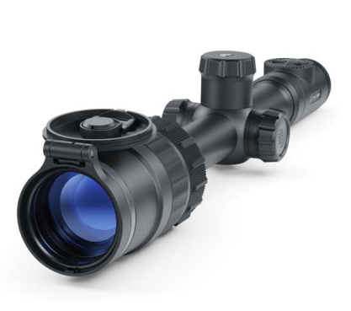

About the device

Description
The Digex C50 Digital riflescope is designed for round-the-clock use.
These riflescopes are designed for hunting, target shooting and recreational shooting, observation and orientation.
The riflescope supports day and night observation modes and colour and black and white images.
In deep twilight, when the human eye is already unable to discern details of observed objects, the Digex C50 displays a bright image with correct colour rendering, prolonging hunting time into the night.
In night conditions (absence of starlight, moonlight), it is recommended to use an infrared illuminator with an 850 nm or 940 nm wavelength.

Package Contents
Digex C50  without IR Illuminator | Digex C50  with IR Illuminator Pulsar Digex-X850S/X940S
Digex С50 Digital Riflescope
APS2 rechargeable battery – 1 pcs. | APS2 rechargeable battery – 2 pcs.
APS battery charger
Power adapter
USB Type-C - Type-C cable
USB Type-С - Micro USB Type-B cable
Carrying case
Lens-cleaning cloth
Quick Start Guide
Warranty card
APS3 battery cover (for riflescope)
Allen wrench
30 mm ring with Weaver rail | -
- | IR-illuminator
- | APS3 battery cover (for IR illuminator)

Features
- 24/7 use
- Full-colour imaging from sunset till dusk
- Contrast black and white image at night
- High contrast HD AMOLED colour display 1024x768
- Over 500 meter night viewing range
- Variable magnification from 3.5x to 14x
- SumLight™ program algorithm for additional sensitivity improvement
- High-strength aluminium alloy housing
- Heavy caliber shock resistance: 12-gauge, 9.3x64, .375H&H
- Mounting with standard 30mm rings
- Instant start
- Completely waterproof IPX7
- Customizable reticles
- Picture in Picture function
- Device firmware update using the free Stream Vision 2 App
- Storing photos and videos in Cloud when using the Stream Vision 2 App
- B-Pack mini combined power system
- Wide operating temperature range -25 °С - +50°С (-13 °F– +122 °F)

Useful Functions and Modes
- Stadiametric rangefinder (to estimate distance to object)
- Built-in 3-axis accelerometer gyroscope (slope angle indication)
- Smooth digital zoom
- Large selection of electronic reticles
- Scalable reticles (reticle graduation changes proportional to zoom)
- 5 zeroing profiles (10 distances per profile)
- One-shot zero function
- Precise “Zoom Zeroing” (reducing the minute of angle click value when zeroing at high magnification)
- “Freeze Zeroing” function
- Display Off function
- Wi-Fi. Remote control and observation with a smartphone
Video Recording:
- Built-in photo and video recorder with sound recording
- 16GB internal memory
- Integration with iOS and Android devices.
Batteries:
- Built-in 4900 mAh battery pack APS5
- Quick change Li-Ion batteries APS2/APS3
- Built-in and external batteries APS2/APS3 can be charged via USB Type-C

Components and Controls
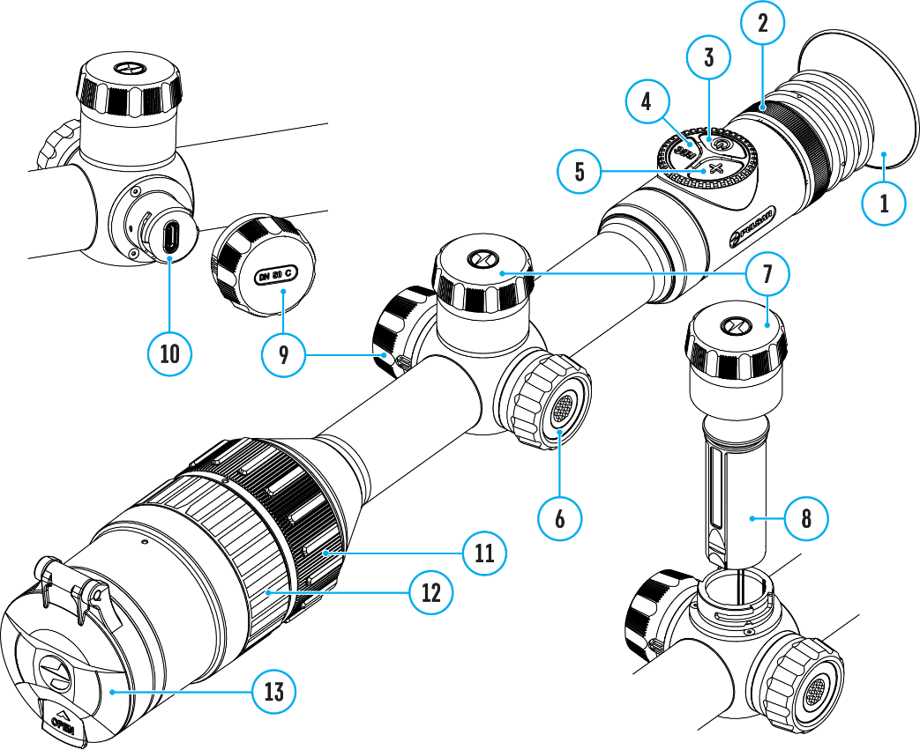

- Eyecup
- Eyepiece dioptre adjustment ring
- ON/OFF button
- REC button
- ZOOM button
- Controller
- Battery compartment cover
- Battery APS2
- USB Type-C cover
- USB Type-C port
- Objective lens focus ring
- Aperture adjustment ring
- Lens cap

Specifications
Model | C50 | С50 (With IR-Illuminator X850S) | С50 (With IR-Illuminator X940S)
SKU | 76635 | 76635L | 76635I
Optical specifications
Lens Focus, mm | F50 F/1.4
Magnification, x | 3.5-14
Eye Relief, mm | 50
Field of view (horizontal), °/m@100 m | 6.7/11.7
Dioptre adjustment, D | -3/+5
Close-up range, m/y | 5/5.47
Range of Detection at Night, (Deer Type Object), m/y | 550/601 (with IR-Illuminator X850S*),  500/547 (with IR-Illuminator X940S*) | 550/601 | 500/547
Electronic characteristics
Sensor type/resolution | FHD CMOS/1928х1088
Display Type / Resolution | AMOLED/1024x768
Aiming reticle
Click value (H/V), mm@100 m – when magnifying, x | 11.5 – 3.5х  5.75 – 7х  2.875 – 14х
Click Range (H/V), mm@100m | 2300
Operating features
Tube Diameter (for mounting rings), mm | 30
Power Supply, V | 3–4.2
Battery Type / Capacity / Rated Output Voltage | Li-Ion Battery Pack АPS2 / 2000 mAh / DC 3.7 V (removable)  or  Li-Ion Battery Pack APS3 / 3200 mAh / DC 3.7 V (removable)*,  Li-Ion Battery Pack APS5 / 4900 mAh / DC 3.7 V (built-in)
External Power Supply | 5 V, 9 V (USB Type-C Power Delivery)
Max. Battery Operating Time (built-in APS5 and removable APS2) at t = 22 °C, h** | 10
Maximum Recoil Power on Rifled Weapons, Joules | 6000
Maximum Recoil Power on Smooth-Bore Weapons, Caliber | 12
Degree of Protection, IP code (IEC60529) | IPX7
Operating Temperature, °С (°F) | -25 – +50 (-13 – +122)
Dimensions, mm / inch | 408х78х83 / 16.06x3.07x3.27 | 408х101х88 / 16.06x3.98x3.46
Weight (without removable battery), kg / oz | 1.11/39.15 | 1.26/44.45
Video recorder
Video/Photo Resolution, Pixels | 1024x768
Video Recording/Photo Format | .mp4 / .jpg
Built-In Memory | 16 GB
Wi-fi channel***
Frequency | 2.4/5 GHz
Standard | IEEE 802.11 b/g/n/ac
Detachable IR-Illuminator
Type/Wavelength, nm | - | LED/850 | LED/940
* Purchased separately
** Actual operating time will depend to what extent the Wi-Fi and built-in video recorder is used.
*** The reception range may vary depending on various factors: obstacles, other Wi-Fi networks.

Power supply

Battery Charging
Digex C50 digital riflescopes come with a built-in rechargeable lithium-ion Battery Pack APS5 and a removable rechargeable lithium-ion APS2 Battery Pack. The batteries should be charged before first use.

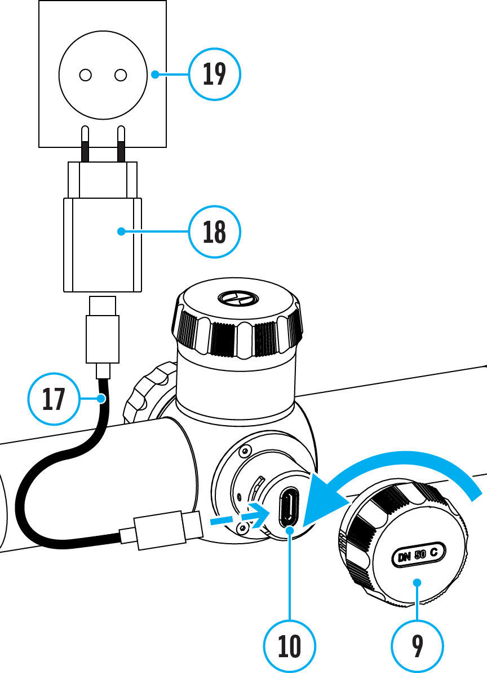
- Open the USB Type-C cover (9) by turning it counterclockwise.
- Connect the USB Type-C plug of the USB cable (17) to the USB Type-C port (10) in the body of the riflescope.
- Connect the second USB plug of the USB cable (17) to the USB port on the power adapter (18).
- Plug the device into a 100–240 V socket (19).
- Wait until the batteries are fully charged (indication in the status bar: 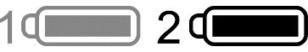, 1 - built-in battery, 2 - removable battery).
Attention! When charging rechargeable batteries with a USB Type-C connector (10) in the riflescope body section, charging priority is given to the built-in battery. When the device is off, both batteries are charged at the same time. When using the device, the external battery is discharged first.

The rechargeable lithium-ion APS2 and APS3* Battery Packs may be recharged using the APS** charger
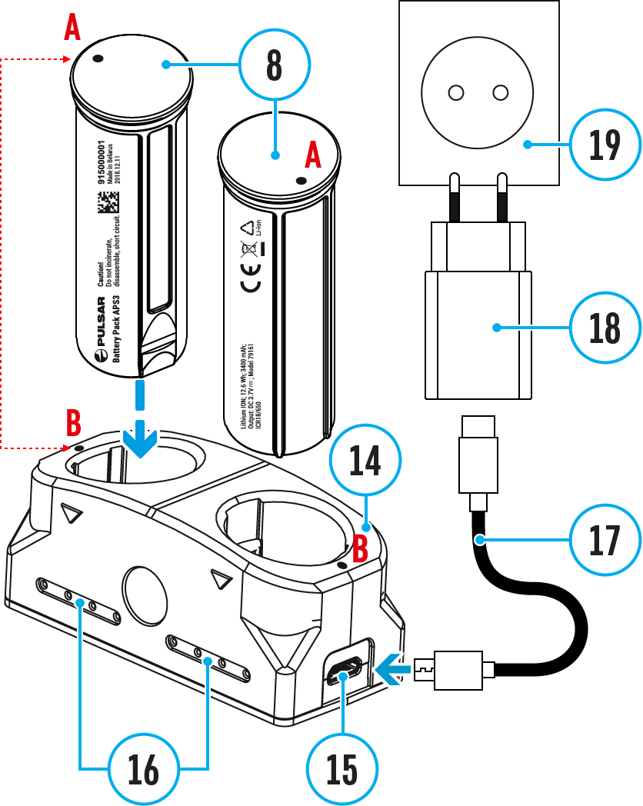
- Insert the Battery Pack (8) along the rail into the APS charger (14) slot as far as it will go. The APS charger is supplied with your device or purchased separately.
- Point A on the battery and point B on the charger should match.
- Two batteries*** can be charged at the same time: the second slot is designed for it.
- Connect the Micro USB Type-B plug of the USB cable (17) to the port (15) of the charger (14).
- Connect the second plug of the USB cable (17) to the USB port on the power adapter (18).
- Plug the device into a 100-240 V socket (19).
- The LED indicator (16) will display battery charge status.
- Wait until the battery is fully charged (LED indication (16):).
(16) LED Indicator**** | Battery Charge Status
 | Battery level is from 0% to 10%. Charger is not connected to a power supply.
 | Battery level is from 0% to 10%. Charger is connected to a power supply.
 | Defective battery. Do not use the battery.
 | Battery level is from 10% to 20%.
 | Battery level is from 20% to 60%.
 | Battery level is from 60% to 95%.
 | The battery is completely charged and can be disconnected from the charger.
* Purchased separately
** Included in the delivery package.
*** Purchased separately for models without an IR illuminator.
**** LED indicator displays the current battery charge status for 30 seconds when the APS charger is not plugged in. When the power is being supplied, the indicator is constantly displaying the current battery charge status, the LEDs are additionally flickering to display the battery charging process.

Battery Installation
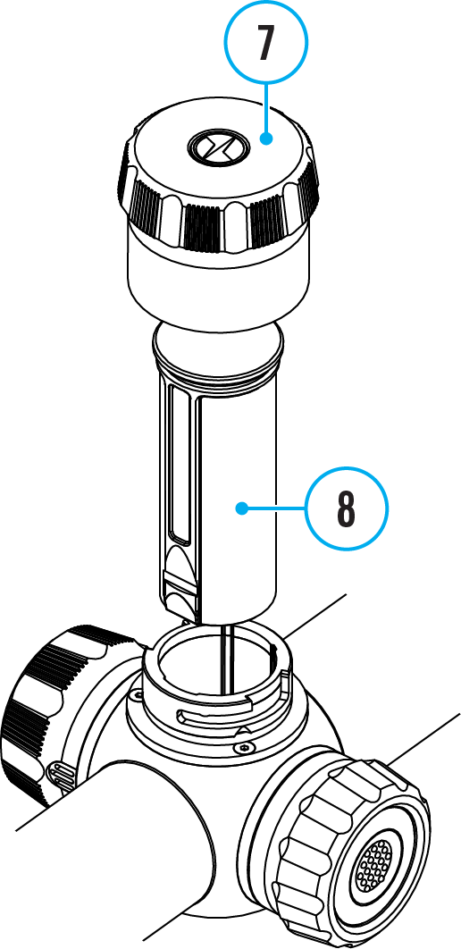
- Turn the battery cover (7) counterclockwise and remove it.
- Install the battery (8) into the battery compartment along the special guides in the device body designed for it.
- When properly installed, the battery is fixed in the battery compartment of the device.
- Close the battery cover (7) by turning it clockwise.

Switching and Changing the Batteries
Digex C50 riflescopes are powered by 2 batteries: built-in Battery Pack APS5 and removable Battery Pack APS3/APS2.

- If there are two batteries in the device, two battery icons are displayed in the status bar (1 - built-in battery, 2 - removable battery). The device battery is displayed in grey and white; it is grey when inactive.
- When there is no removable battery in the device, only one icon for the built-in battery displays in white in the status bar.
- When both batteries are fully charged, the device is powered by the removable battery. If there is low removable battery level, the device will switch to the built-in battery.
- Battery charge level is displayed in % above the icon in the status bar while charging.
- It is possible to replace removable battery with device turned on when it is powered by built-in battery (the device will continue to work properly).

Attention! When installing a removable battery with a sufficient charge level, the device will automatically switch to it.

External Power Supply
External power can be supplied from an external source, such as a Power Bank (5 V, 9 V).
- Connect the external power supply to the USB Type-C port (10) of the riflescope.
- The riflescope switches to external power source, while built-in Battery Pack APS5 and removable Battery Pack APS2 (or APS3*) will gradually recharge.
- A rechargeable battery icon 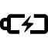 indicating a percentage of the battery life will appear in the status bar.
- When you turn off external power source, the riflescope switches over to the removable battery without turning off. When there is no removable battery or low power level the device switches to the built-in battery.
*Optional

Attention! Charging Power Bank APS2 / APS3 / internal APS5 batteries at air temperatures below 0 °C can result in reduced battery life. When using external power, connect Power Bank to the switched-on riflescope, which have worked for several minutes.

Precautions
- Only use the charger supplied with the Battery Pack. The use of any other charger may irreparably damage the Battery Pack or the charger and may cause fire.
- Do not charge the Battery Pack immediately after bringing it from a cold environment to a warm one. Wait for 30-40 minutes for the Battery Pack to get warm.
- Do not leave the Battery Pack unattended while charging.
- Never use a modified or damaged charger.
- Do not leave the Battery Pack with a charger connected to the power adapter after charging is complete.
- Do not expose the Battery Pack to high temperatures or an open flame.
- Do not submerge the Battery Pack in water.
- Do not connect an external device with a current consumption that exceeds permitted levels.
- Do not dismantle or deform the Battery Pack.
- Do not drop or hit the Battery Pack.
- Keep the Battery Pack out of the reach of children.

Recommendations for Use
- During long-term storage, the Battery Pack should be partially charged – the charge level should be between 50% and 80%.
- Charge the Battery Pack at a temperature from 0° C to +45° C (32° F to +113° F), otherwise the battery life will decrease significantly.
- When using the Battery Pack at sub-zero (sub 32° F) temperatures the battery capacity decreases. This is normal and is not a defect.
- Do not use the Battery Pack at temperatures above those shown in the table – this may decrease battery life.
- The Battery Pack is short circuit protected; however, any situation that may cause short-circuiting should be avoided.

Getting Started

Mounting on the Rifle
To ensure accurate shooting the Digex С50 riflescope should be properly mounted on the rifle.
- The riflescope is fixed using the mount, which is purchased separately. Use only high-quality mounts and rings that are designed especially for your rifle. Follow the mounting manufacturer's recommendations on the installation procedure and use the proper tool.
- When mounting the riflescope, adjust the position on the rifle so that proper (comfortable) holding of rifle ensures the distance between the riflescope and eye (eye relief) specified by the Technical Specifications. Failure to comply with this recommendation may result in injury to the shooter by the parts of the riflescope eyepiece when shooting.
- It is recommended to install the riflescope as low as possible, at the same time it should not be in contact with barrel or receiver.
- In order to avoid pinching the riflescope body, a tightening torque for the screws of the mounting rings must be not more than 2.5 Nm (22.1 Pound-force inches). A torque wrench is recommended to control the tightening torque.
- Before using the riflescope when hunting, follow instructions in the Zeroing section.
- Use of a removable eyecup is recommended (1) to eliminate backlight from the display.
- It is recommended to use an eyecup while using the riflescope in the dark in order to avoid detection of camouflage. Mounting the eyecup on the riflescope eyepiece is carried out using built-in magnets.

Powering on and Image Setting
- Open the lens cap (13).
- Press the ON/OFF (3) button briefly to power the riflescope on.
- Adjust the sharpness of the symbols on the display by rotating the dioptre adjustment ring of the eyepiece (2).
- Turn the aperture adjustment ring (12) to select the observation mode (Day - , Night - ).
- Select the image mode (colour/black-and-white) by short pressing the ON/OFF (3) button.
- Rotate the lens focus ring (11) to focus on the object being observed.
- Activate the quick menu by briefly pressing the controller button (6) to adjust the brightness and contrast of the display (see the Quick Menu Functions section for details).
- Press the ZOOM (5) button successively to change the magnification ratio of the riflescope. While the icon is visible on the screen, rotate the controller ring (6) for smooth digital zooming from the current magnification.
- Turn on the IR illuminator* and adjust the lighting power according to its operating instructions to improve the quality of observation in low light conditions.
- Power the device off with a long press of the ON/OFF (3) button.
* Purchased separately for models without an IR illuminator.

IR Illuminator

Installing Battery Pack in the IR Illuminator
The IR illuminator Pulsar Digex S* is powered by an APS2 (or APS3**) battery pack.
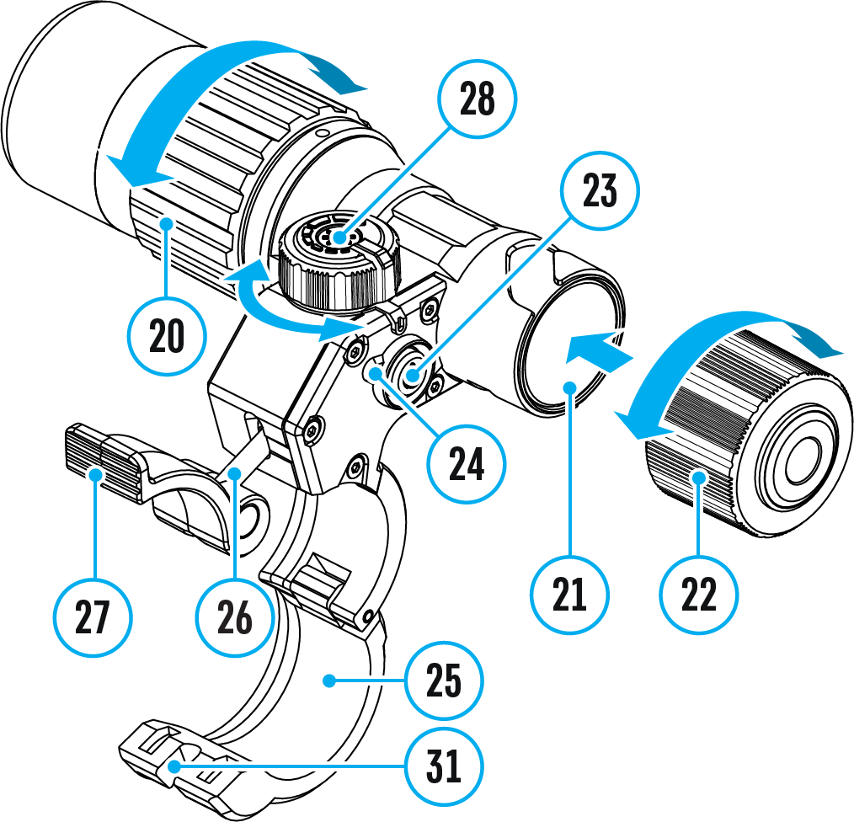
- To install the battery in the IR illuminator, turn the battery cover (22) counterclockwise and remove it.
- Install the battery into the battery compartment (21) using the special guides in the IR illuminator body designed for it.
- When properly installed, the battery is fixed in the battery compartment (21).
- Close the battery compartment cover (22), turning the cover clockwise.
* Purchased separately for models without an IR illuminator.
** Purchased separately.

Installing the IR Illuminator on Riflescope
- Open the mount ring (25) of the IR illuminator.
- Raise the eccentric lever (27) and put the mount on the riflescope body so that the mount half rings encircle the riflescope body.
- Align the eccentric axis (26) with the groove (31) of the moving half ring.
- Lock the eccentric lever (27) position by lowering it down.
- The IR illuminator mount should be as close as possible to body of the riflescope lens.
- In case of loosening or insufficient fixing of the IR-illuminator on the riflescope, raise the eccentric lever (27). Tighten the eccentric axis (26) 1-2 turns using the supplied Allen key. Then lower the lever and check the fixation of the IR-illuminator on the riflescope. If necessary, repeat the above steps until the required degree of fixation of the IR-illuminator is achieved.

Powering on and Adjusting the IR Illuminator
Use the IR illuminator to improve the quality of observation in lowlight conditions at night.
- Turn on the IR illuminator by pressing the button (23) on the side of the light housing.
- Turn the knob (28) of the IR illuminator to control the illuminator power.
- To adjust the IR light position in the riflescopes field of view, loosen the ring (20) of the IR illuminator by turning it in the direction of the arrow.
- Turn on the riflescope to control the position of the light spot on the display. Adjust the IR illuminator lens using its hinge system to align the IR illumination in the riflescopes field of view. Once adjusted, tighten the IR illuminator ring (20).
- Press the IR button (23) to turn off the IR illuminator.
The illuminator is equipped with an LED indicator (24) making it possible to monitor the battery level. Indication modes are in the table below:
(24) Indicator Colour | IR Operating Mode
 | The IR illuminator is on. The battery is charged
The IR illuminator is on. The battery is discharged.
Approximate operating time before the IR illuminator
turns off is 30 minutes
– | The IR illuminator is off

Installing the IR Illuminator on the Weaver Rail
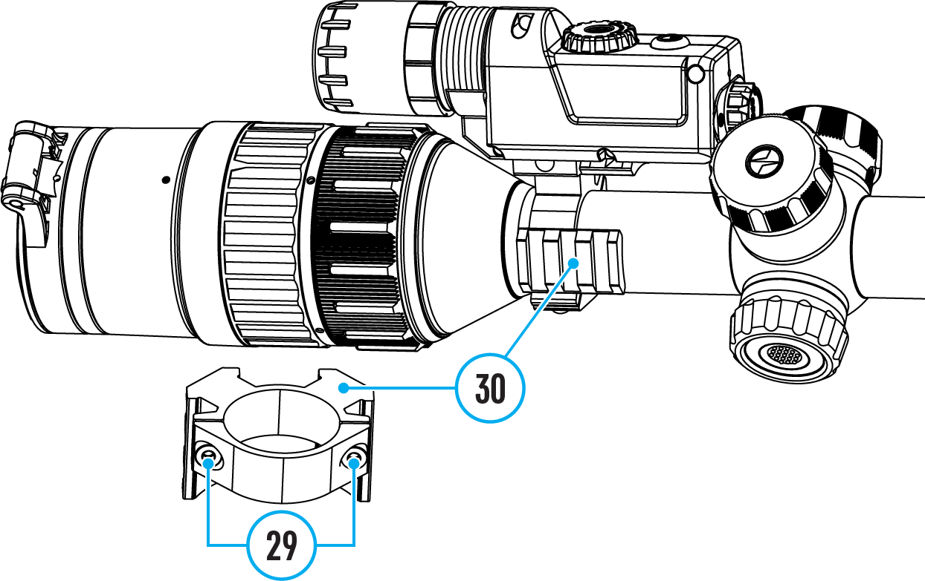
To install an IR illuminator with a Weaver mount*, you will need to install a 30 mm ring with Weaver rail** on the riflescope:
- Unscrew the screws (29) with the Allen key.
- Install the ring (30) on the riflescope body.
- Adjust the position of the Weaver rail (left/top/right) depending on the seat of the IR illuminator.
- Tighten the screws (29).
- Install the IR illuminator on the Weaver rail according to the installation instructions.
* Purchased separately.
** Supplied with models without an IR illuminator.

Button Operation
Operation | Button
Power riflescope on | short press
Power riﬂescope oﬀ | long press for 3 secs
Turn display oﬀ | long press for less than 3 secs
Turn display on | short press
Colour/Black & white mode switch | short press
Changes magnification (zoom) | short press
Smooth Zooming | rotation
PiP on/oﬀ | long press
Video Recorder | Button
Start/pause/resume video recording | short press
Stop video recording | long press
Switch to video / photo mode | long press
Capture Photo | short press
Main Menu | Button
Enter main menu | long press
Navigation through menu | rotation
Enter menu items | short press
Confirm value | short press
Exit menu items | long press
Exit main menu | long press
Quick Menu | Button
Enter quick menu | short press
Switch between quick menu options | short press
Parameter change | rotation
Exit quick menu | long press

Zeroing
Zeroing at a temperature close to the riflescope’s operating temperature is recommended.
Step 1. Take a shot
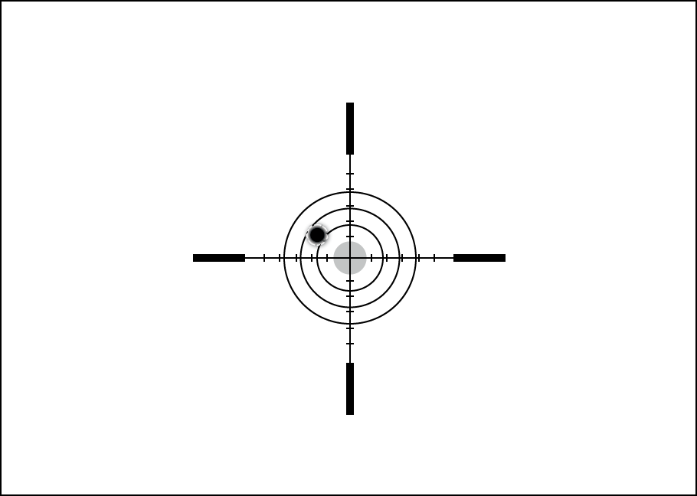
1. Shooting from a benchrest is recommended.
2. Set a target at a known distance.
3. Adjust the riflescope according to the Powering on and Image Setting section.
4. Select the zeroing profile (see Reticle & Zeroing 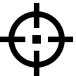 -> Zeroing Profile main menu item)
5. Point the rifle at the center of the target and shoot.

Step 2. Align the reticle with the point of impact
1. Press and hold the controller button (6) to enter the main menu.
2. Add the distance you are aiming at (e.g. 100 meters): Reticle & Zeroing -> Add New Distance . Select the value for each distance digit by rotating the controller ring (6). Press the controller button (6) briefly to switch between digits. After setting the required distance, press and hold the controller button (6) to save it.
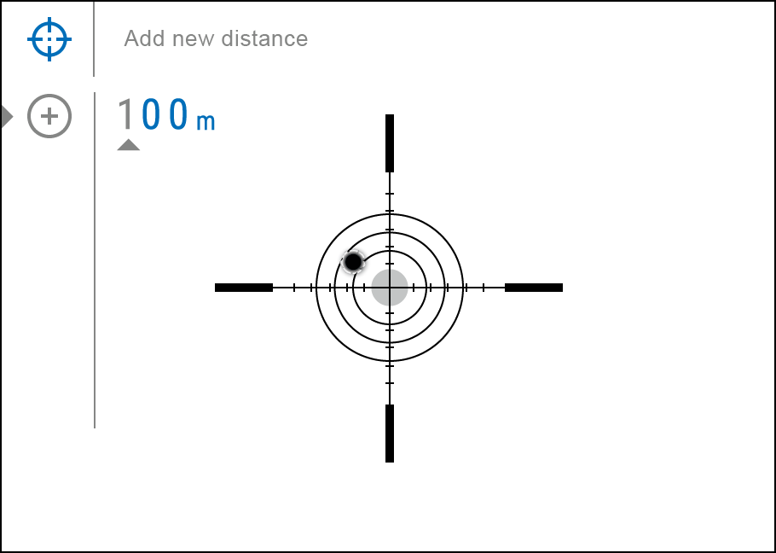
3. After adding the distance, it will switch to the Zeroing parameters settings menu . An auxiliary cross will appear in the center of the display, and X and Y coordinates of the auxiliary cross will appear in the upper right corner.
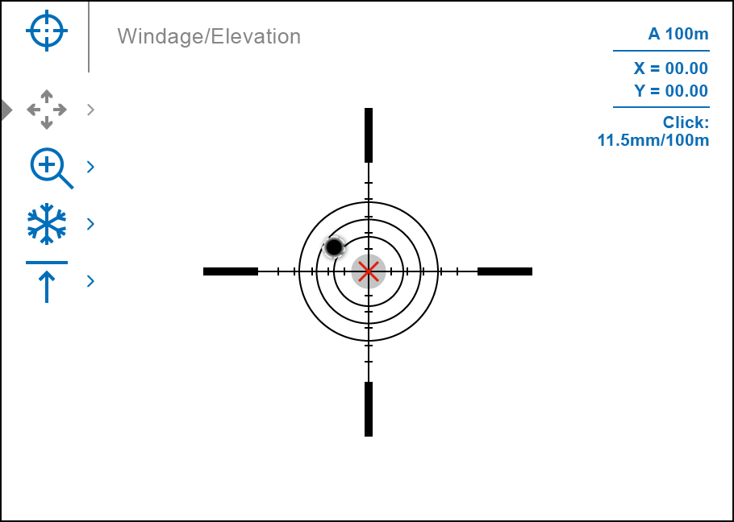
4. Press the controller button (6) briefly to enter the Windage/Elevation submenu.
5. While holding the reticle at the aiming point, move the auxiliary cross until it is aligned with the impact point by rotating the controller ring (6).
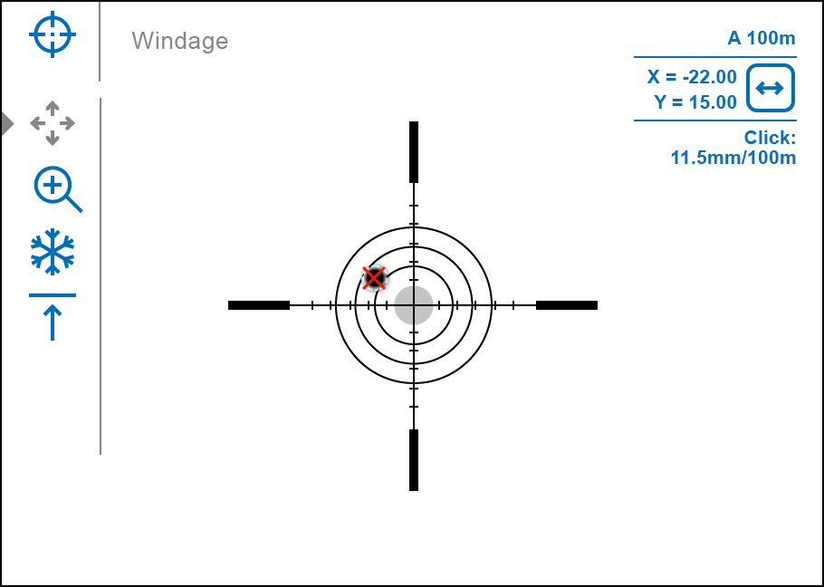
6. To change the direction of the auxiliary cross movement from horizontal to vertical, press the controller button (6) briefly.

One-shot "Freeze Zeroing" function:
Using the Freeze function allows you to make adjustments without the need to hold the rifle precisely at the initial aiming point – freezing the zeroing screen (refer to Reticle & Zeroing menu item => Distance submenu => Zeroing Parameters Settings submenu => Freeze submenu or short pressing of the ON/OFF (3) button. The image will “freeze” and the icon will appear.

Step 3. Save the coordinates
1. Press and hold the controller button (6) to save a new position for the reticle. The reticle will be aligned with the impact point and it will exit the Windage/Elevation submenu.
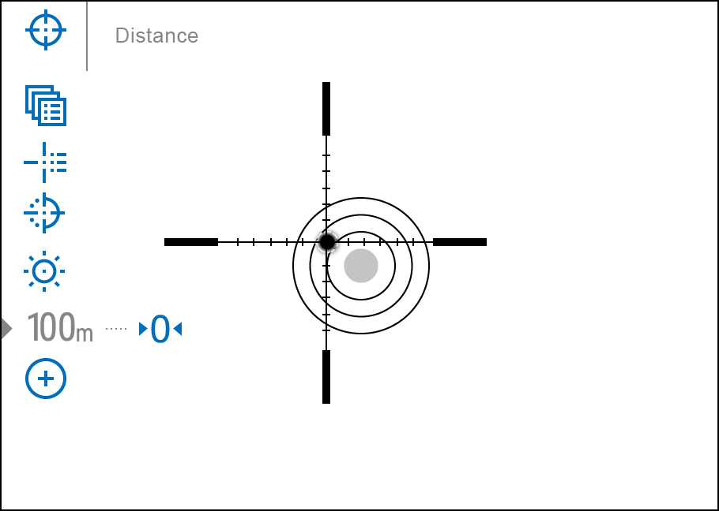
2. Press and hold the controller button (6) again to exit the zeroing settings menu - the message “Zeroing coordinates saved” appears, confirming the successful operation.
3. Fire a second shot - now the point of impact and the aiming point must be matched.

Interface

Status Bar
The status bar is at the bottom of the display and shows information on the actual operating status of the riflescope, including:
- Actual zeroing profile (e.g., A)
- Zeroing distance (e.g., 100 m)
- SumLight™ (on/off)
- Mode of operation (colour, black and white)
- Microphone (on or off)
- Current magnification
- Wi-Fi connection
- Auto Shutdown function (e.g., 5 minutes)
- Clock
- Power supply:
- Battery discharge level 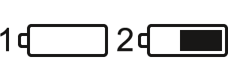 (when riflescope is powered by a built-in or removable battery).
- External battery power indicator (if the riflescope is powered by an external power supply).
- Battery indicator with current percentage of charge (when charging from an external power source).

Quick Menu Functions
The basic settings (adjusting brightness and contrast, smooth digital zoom function, stadiametric rangefinder, current profile and distance information) can be changed using the quick menu.
- Press the controller button (6) briefly to enter the quick menu.
- A short press of the controller button (6) enables you to switch between functions, as described below.
Brightness – rotate the controller ring (6) to change the display brightness value from 00 to 20.
Contrast – rotate the controller ring (6) to change the image contrast value from 00 to 20.
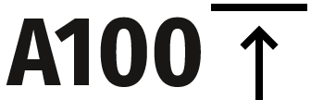 - information on the current profile and zeroing distance in this profile (e.g., profile A, zeroing distance of 100 m). This information is always displayed in the status bar. Rotate the controller ring (6) to switch between the zeroing distances in the adjusted profile. This function is available if there are two or more distances in the profile.
Stadiametric Rangefinder – rotating the controller ring (6), change the distance between the special mark points to determine the distance to the observed object (for more details on the rangefinder, see the Stadiametric Rangefinder section).
- Press and hold the controller button (6) to exit the menu or wait 10 seconds to exit automatically.

Main Menu Functions

Enter the Main Menu
- Enter the main menu with a long press of the controller button (6).
- To move through the main menu items, rotate the controller ring (6).
- Press the controller button (6) briefly to open subitems of the main menu.
- Press and hold the controller button (6) to exit from a subitem of the main menu.
- Automatic exit from the main menu occurs after 10 seconds of inactivity.

General View of the Menu

Tab 1
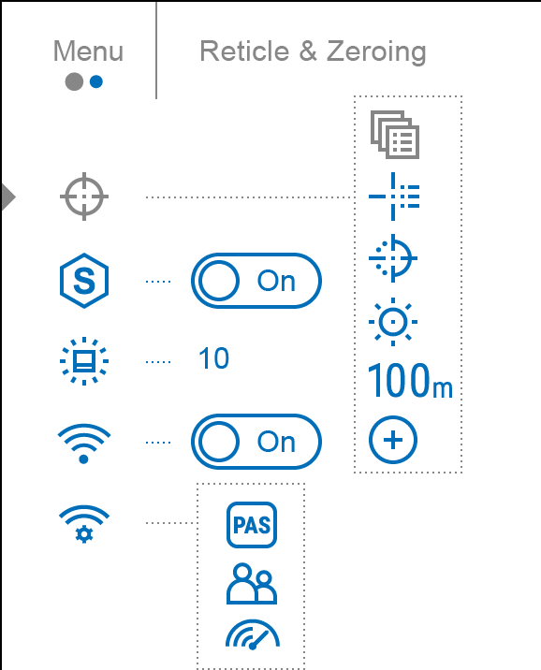

Tab 2
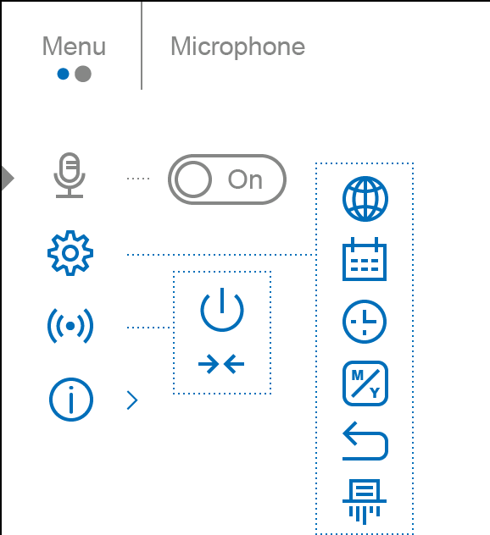

Reticle & Zeroing

Zeroing Profile
This item of the main menu allows you to select one of five profiles (А, В, С, D, E) to use. Each profile stores information on the following parameters:
- A set of zeroed distances
- Reticle colour
- Reticle type
Different profiles can be used when using the riflescope on different rifles or when shooting with different bullets.

- Press and hold the controller button (6) to enter the main menu.
- Rotate the controller ring (6) to select the Reticle & Zeroing menu item.
- Press the controller button (6) briefly to enter the Reticle & Zeroing submenu.
- Press the controller button (6) briefly to enter the Zeroing Profile submenu.
- Rotate the controller ring (6) to select one of the zeroing profiles (marked with the letters A, B, C, D, E).
- Confirm your selection with a short press of the controller button (6).
- The name of the selected profile appears in the status bar at the bottom of the display.

Reticle Type
Selection of the aiming reticle shape.
- Press and hold the controller button (6) to enter the main menu.
- Rotate the controller ring (6) to select the Reticle & Zeroing menu item.
- Press the controller button (6) briefly to enter the Reticle & Zeroing submenu.
- Rotate the controller ring (6) to select the Reticle Type submenu.
- Press the controller button (6) briefly to enter the Reticle Type submenu.
- Rotate the controller ring (6) to select the desired aiming reticle shape from the list that appears. The reticle type changes as the cursor goes down the reticle list.
- Press the controller button (6) briefly to confirm the selection.

Reticle Colour
Selection of reticle colour.
- Press and hold the controller button (6) to enter the main menu.
- Rotate the controller ring (6) to select the Reticle & Zeroing menu item.
- Press the controller button (6) briefly to enter the Reticle & Zeroing submenu.
- Rotate the controller ring (6) to select the Reticle Colour submenu.
- Press the controller button (6) briefly to enter the Reticle Colour submenu.
- Rotate the controller ring (6) to select one of the colour options for the reticle: Black/Red, White/Red, Black/Green, White/Green, Red, Green, Yellow, Blue, Orange, Black/White, White/Black.
- Press the controller button (6) briefly to confirm the selection.

Reticle Brightness
Adjust the brightness level of the aiming reticle.
- Press and hold the controller button (6) to enter the main menu.
- Rotate the controller ring (6) to select the Reticle & Zeroing menu item.
- Press the controller button (6) briefly to enter the Reticle & Zeroing submenu.
- Rotate the controller ring (6) to select the Reticle Brightness submenu.
- Press the controller button (6) briefly to enter the Reticle Brightness submenu.
- Rotate the controller ring (6) to set the desired brightness level (1 to 10).
- Press the controller button (6) briefly to confirm the selection.

Zeroing

Add New Distance
To zero your riflescope, you need to set a zeroing distance first in the range of 1 to 910 m (955 yards).
- Press and hold the controller button (6) to enter the main menu.
- Rotate the controller ring (6) to select the Reticle & Zeroing menu item.
- Press the controller button (6) briefly to enter the Reticle & Zeroing submenu.
- Rotate the controller ring (6) to select Add New Distance menu item.
- Press the controller button (6) briefly to enter the submenu.
- Rotate the controller ring (6) to select a value for each digit. Press the controller button (6) briefly to switch between digits 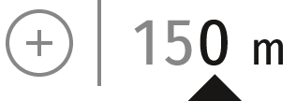.
- Having set the desired distance, press and hold the controller button (6) to save it.

The distance you set first becomes a primary distance – shown with icon 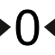 on the right to the distance value.
Note: Maximum number of zeroing distances is 10 for each profile.

Zeroing Parameters Settings
- Press and hold the controller button (6) to enter the main menu.
- Rotate the controller ring (6) to select the Reticle & Zeroing menu item and enter by briefly pressing the controller button (6) – zeroed distances are displayed at the bottom.
- The values (e.g., +7.0) shown on the right of the distance values, stand for the number of clicks along the Y axis, at which the reticle position at other distances differs from the reticle position in the primary distance.
- To zero at any distance again, rotate the controller ring (6) to select the required distance and briefly press the controller button (6).
- Rotate the controller ring (6) to select the Zeroing Parameters Settings and enter by briefly pressing the controller button (6).
- Zeroing screen, which allows the change of zeroing coordinates, will appear:

Windage/Elevation
The Windage/Elevation additional menu item in the Zeroing Parameters Settings menu allows you to adjust the reticle position. For a detailed description of the reticle adjusting, refer to the Zeroing section.

Magnification (when Zeroing)
Magnification allows you to magnify via the device’s digital zoom when zeroing, which reduces the MOA-per-click values of adjustments and improves zeroing accuracy.
- In the Zeroing Parameters Settings menu, rotate the controller ring (6) to select the Magnification submenu item and enter by briefly pressing the controller button (6).
- Rotate the controller ring (6) to select a digital magnification value of the riflescope (e.g., x4).
- Press the controller button (6) briefly to confirm your selection.
The minute of angle click when using the Magnification function is indicated in the Table of Technical Specifications.

Freeze
The “freeze” function allows the user to freely move or manipulate the rifle without losing reticle placement on the point of aim during adjustments.
- In the Zeroing Parameters Settings menu, rotate the controller ring (6) to move the cursor to the Freeze function.
- Align the reticle with the point of aiming and press the controller (6) or ON/OFF (3) button. A screenshot will be taken, an icon will appear.
- Go to the additional Windage/Elevation submenu and adjust the position of the reticle (see the Zeroing section).
- Select the Freeze submenu item again and briefly press the controller (6) or ON/OFF (3) button - the image will “unfreeze”.

Name Distance
- In the Zeroing Parameters Settings menu, rotate the controller ring (6) to select the Name Distance submenu item and enter it by briefly pressing the controller button (6)​.
- Rotate the controller ring (6) to select a value for each digit. Press the controller button (6) briefly to switch between digits.
- Press and hold the controller button (6) to confirm the selection.

Change Primary Distance
- Press and hold the controller button (6) to enter the main menu.
- Rotate the controller ring (6) to select the Reticle & Zeroing menu item and enter by briefly pressing the controller button (6) – zeroed distances are displayed at the bottom.
- Select a non-primary distance and enter the submenu for operating the distance with a brief press of the controller button (6).
- Select Change Primary Distance item.
- Press the controller button (6) briefly.
- Icon next to the selected distance confirms the change of primary distance.
There will also be a recalculation of corrections in clicks for other distances relative to the new primary distance.

Delete Distance
- Press and hold the controller button (6) to enter the main menu.
- Rotate the controller ring (6) to select the Reticle & Zeroing menu item and enter by briefly pressing the controller button (6) – zeroed distances are displayed at the bottom.
- Select the distance you wish to delete and enter the submenu for operating the distances with a brief press of the controller button (6).
- Select Delete Distance item.
- Press the controller button (6) briefly.
- Select “Yes” in the appeared dialog box to delete a distance. “No” – to cancel deletion.
- Press the controller button (6) briefly to confirm your selection.
Attention! If the primary distance is deleted, the first distance on the list automatically becomes the new primary distance.

SumLight™
he SumLight™ function increases the sensor sensitivity. Available in the “Night” observation mode.
- Turn off the IR illuminator before using the SumLight™ function.
- Press and hold the controller button (6) to enter the main menu.
- Rotate the controller ring (6) to select the SumLight™ menu item.
- To turn SumLight™ on or off, briefly press the controller button (6).
- SumLight™ icon (on or off ) is shown in the status bar.

Attention! When the SumLight™ function is activated, the noise level in the image increases, the frame rate decreases and the image slows down. Any sharp movement of the device may cause the image to become “blurred”. Such effects are not defects. Luminous white dots (pixels) may be visible on the device’s display. The number of dots may increase when the SumLight™ function is enabled. This is due to the peculiarities of this function and is also not a defect.
Attention! Due to peculiarities of AMOLED display technology, after switching between various reticles, you may notice on the riflescope’s display semitransparent white lines of the previous reticle. They may appear if a new reticle does not contain elements (such as lines, circles, bars etc.) of the previous reticle. After a while, the “ghost image” becomes less noticeable. The appearance of “ghost images” on the display after repeatedly changing the reticle is not a defect and is not considered as a warranty case.

Icon Brightness
Adjust the brightness level of the icons and screensavers (Pulsar, Display off) on the display.
- Press and hold the controller button (6) to enter the main menu.
- Rotate the controller ring (6) to select the Icon Brightness menu item.
- Press the controller button (6) briefly to enter the Icon Brightness submenu.
- Rotate the controller ring (6) to set the desired brightness level (1 to 10).
- Press the controller button (6) briefly to confirm the selection.

Wi-Fi Activation
Turn on/off Wi-Fi
- Press and hold the controller button (6) to enter the main menu.
- Rotate the controller ring (6) to select the Wi-Fi Activation menu item.
- To turn Wi-Fi on, briefly press the controller button (6).
- To turn Wi-Fi off, briefly press the controller button (6).

Wi-Fi Settings
This item enables you to set up your riflescope for operation in a Wi-Fi network.
- Press and hold the controller button (6) to enter the main menu.
- Rotate the controller ring (6) to select the Wi-Fi Settings submenu.
- Press the controller button (6) briefly to enter the submenu
- Rotate the controller ring (6) to select the desired menu item.

Password Setup
This item enables you to set a password to access the riflescope from an external device. The password is used to connect an external device (i.e. smartphone) to the riflescope.
- Press the controller button (6) to enter the Password Setup submenu.
- The default password (12345678) will appear on the screen.
- Rotate the controller ring (6) to set the desired password. Press the controller button (6) to toggle through the digits.
- Press and hold the controller button (6) to save the password and exit from the submenu.

Access Level Setup
This sub-function enables you to configure the appropriate level of access to your device made available to the Stream Vision 2 application.
Owner level. A Stream Vision 2 user has full access to all the device’s functions.
Guest level. A Stream Vision 2 user can only view video footage from the device in real time.
- Press the controller button (6) to enter the Access Level Setup submenu.
- Rotate the controller ring (6) to select Owner or Guest.
- Confirm your selection with a short press of the controller button (6).

WiFi Bandwidth
- Press the controller button (6) to enter the WiFi Bandwidth 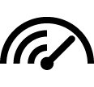 submenu.
- Rotate the controller ring (6) to select the WiFi bandwidth – 5 GHz or 2.4 GHz.
- Confirm your selection with a short press of the controller button (6).

Microphone
Turning on/off Microphone.
This item allows you to enable (or disable) the microphone for recording sound during video recording.
- Press and hold the controller button (6) to enter the main menu.
- Rotate the controller ring (6) to select the Microphone menu item.
- To turn on the microphone, briefly press the controller button (6).
- To turn off the microphone, briefly press the controller button (6).

General Settings
- Press and hold the controller button (6) to enter the main menu.
- Rotate the controller ring (6) to select the General settings menu item.
- Press the controller button (6) briefly to enter the submenu.
- Rotate the controller ring (6) to select the desired menu item.
This menu item allows you to configure the following settings:

Language
Language selection:
- Press the controller button (6) briefly to enter the Language submenu.
- Rotate the controller ring (6) to select one of the available interface languages: English, German, Spanish, French, Russian, Italian, Portuguese, Dutch, Danish, Norwegian, Swedish, Polish, Czech, Hungarian.
- Confirm your selection with a short press of the controller button (6).
- Press and hold the controller button (6) to save your selection and exit from the submenu.

Date
Date Setting:
- Press the controller button (6) briefly to enter the Date submenu. The date is displayed in dd/mm/yyyy format.
- Rotate the controller ring (6) to select the desired year, month and date. Press the controller button (6) briefly to switch between digits.
- Press and hold the controller button (6) to save your selected date and exit from the submenu.

Time
Time Setting:
- Press the controller button (6) briefly to enter the Time submenu.
- Rotate the controller ring (6) to select the time format - 24 or AM/PM.
- Press the controller button (6) to proceed to the hour setting.
- Rotate the controller ring (6) to select the hour value.
- Press the controller button (6) to proceed to the minute setting.
- Rotate the controller ring (6) to select the minutes value.
- Press and hold the controller button (6) to save your selected time and exit from the submenu.

Units of Measure
Units of measurement selection:
- Press the controller button (6) briefly to enter the Units of Measure submenu.
- Rotate the controller ring (6) to select the unit of measurement - meters or yards, press the controller button (6).
- Return to submenu will happen automatically.

Default Settings
- Press the controller button (6) briefly to enter the Default Settings submenu.
- Rotate the controller ring (6) to select “Yes” to restore default settings or “No” to cancel the action.
- Confirm your selection with a short press of the controller button (6).
- If “Yes” is selected, display will show “Do you want to restore default settings?” and “Yes” and “No” options. Select “Yes” to restore default settings.
- If “No” option is selected: the action will be aborted and you will return to the submenu.
The following settings will be returned to their defaults:
- Image Mode – Colour
- Video Recorder Mode – Video
- Interface language – English
- Wi-Fi – Off (default password)
- Magnification – initial value
- PiP – Off
- Unit of Measurement - Metric
- Side Incline – Off
- Zeroing Profile – A
- Reticle selection from the riflescope’s memory – 1
Attention! After restoring default settings, the date, time and user pixel map as well as the zeroing profiles data entered by the user are saved.

Format
This menu option allows you to format the device's memory card. All files will be deleted.
- Press the controller button (6) briefly to enter the Format submenu.
- Rotate the controller ring (6) to select “Yes” to format the memory card, or “No” to return to the submenu.
- Confirm your selection by pressing the controller button (6).
- If the “Yes” option has been selected, the "Do you want to format memory?" message and “Yes” and “No” options will appear on the display. Select “Yes” to format the memory card.
- If “No” option is selected: formatting is cancelled and return to the submenu.

Accelerometer

Auto Shutdown
This item allows you to activate auto shutdown function for riflescope in a non-operating position (tilt up or down at an angle of more than 70°, right or left - at an angle of more than 30°). In this event, the controls (buttons, controller) are disabled.

- Press and hold the controller button (6) to enter the main menu.
- Rotate the controller ring (6) to select the Accelerometer submenu.
- Confirm the selection by briefly pressing the controller (6).
- Rotate the controller ring (6) to select Auto Shutdown .
- Press the controller button (6) briefly to enter the submenu.
- Rotate the controller ring (6) to select the time period (1 min, 3 min, 5 min) upon expiry of which the riflescope will automatically shut down, or select Switch off if you wish to deactivate Auto Shutdown.
- Confirm your selection with a short press of the controller button (6).

Note: If the automatic shutdown function is activated, the status bar shows an icon ​and shutdown time period as 1 min.

Side Incline
This item allows you to turn on/off the indication of horizontal (side) incline of the rifle. Side incline is indicated by “sector” arrows to the right and left of the reticle. Arrows show the direction in which you should move your rifle to eliminate incline.

There are three modes of incline:
- 5°-10° – one sector arrow;
- 10°-20° - two sector arrow;
- > 20° - three sector arrow.
A side incline of less than 5° is not displayed.

- Press and hold the controller button (6) to enter the main menu.
- Rotate the controller ring (6) to select the Accelerometer menu item.
- Press the controller button (6) briefly to enter the Accelerometer submenu.
- Rotate the controller ring (6) to select Side Incline 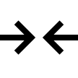.
- Press the controller button (6) briefly to enter the Side Incline submenu.
- Rotate controller ring (6) to select On for turning on the incline indication or Off for turning it off.
- Confirm your selection with a short press of the controller button (6).

Device Information
- Press and hold the controller button (6) to enter the main menu.
- Rotate the controller ring (6) to select the Device Information menu item.
- Press the controller button (6) briefly to enter the Device Information submenu.

This item allows the user to view the following information about the riflescope:
- Full name of the riflescope
- SKU number
- Serial number of the riflescope
- Riflescope firmware version
- Hardware version
- Service information
- Battery information

Functions

Observation and Image Modes
The device has two image modes: colour and black and white.
Optimal combinations of modes: during daytime – colour, at twilight – colour or black-white, at night – black-white.
Toggle between modes:
- Turn the aperture adjustment ring (12) to select the observation mode (Day - , Night - ).
- Select the image mode (colour/black-and-white) by short pressing the ON/OFF (3) button.

Video Recording and Photography
The riflescope is equipped with a function for video recording (photography) of the observed image that is saved on the built-in memory card.
Before using the photo and video functions, read the Date and Time subsections of the General Settings section.

Built-in recorder operates in two modes:
- Photo (photography; the icon is displayed in the upper left corner of the display).
- Video (video recording; the icon is displayed in the upper right corner of the display, the total remaining recording time is given taking into account the current resolution in the HH:MM format (hours:minutes).
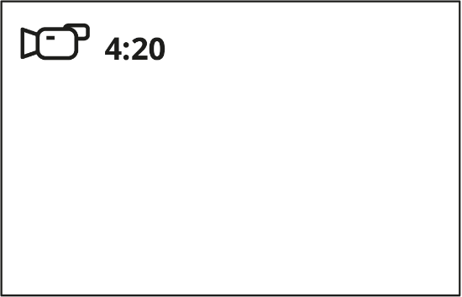
Toggle (switch) between the riflescope operating modes with a long press of the REC (4) button. Switching between the modes is cyclical (Video–> Photo–> Video...).

Photo mode. Capturing an image
- Switch to the Photo mode with a long press of the REC (4) button.
- Press the REC (4) button briefly to capture a photo. The icon flashes – the photo file is being saved to the built-in SD card.

Video mode. Recording a video
- Switch to the Video mode with a long press of the REC (4) button.
- Press the REC (4) button briefly to start video recording.
- When the video recording starts, the icon will disappear, instead of it the REC icon as well as the video recording timer displayed in the MM:SS (minutes:seconds) format will appear 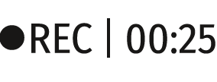.
- Pause/continue recording by briefly pressing the REC (4) button.
- Press and hold the REC (4) button to stop video recording.
Video files are stored in the built-in memory card:
- After turning off the video recording;
- Upon powering the riflescope off if recording was on;
- When the memory card is overfilled during recording (Memory Full message appears on the display).

Notes:
- You can enter and navigate the menu during video recording.
- Recorded videos and photos are saved to the built-in memory card of the riflescope in the format img_xxx. jpg (for photos); video_xxx. mp4 (for video).
- Maximum duration of a recorded video file is 5 minutes. After this time expires, the video is recorded to a new file. The number of recorded files is limited by the capacity of unit’s internal memory.
- Regularly check free memory within the built-in memory card and move the footage to other storage media to free up the memory card space.

Discrete Digital Zoom
The riflescope functionality allows you to quickly increase the basic magnification (see Magnification line in the table of Technical Specifications) by 2 and 4 times, as well as to return to the basic magnification.
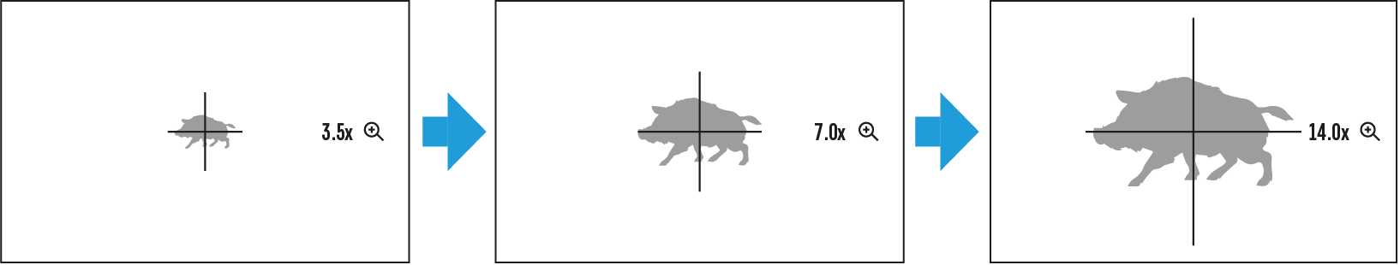
- Press the ZOOM (5) button successively to change the magnification ratio of the riflescope.
- While the icon is visible on the screen, rotate the controller ring (6) for smooth digital zooming from the current magnification.

PiP Function
The PiP function (Picture-in-Picture) allows you to see both a magnified image in a particular dialog box and the main image.
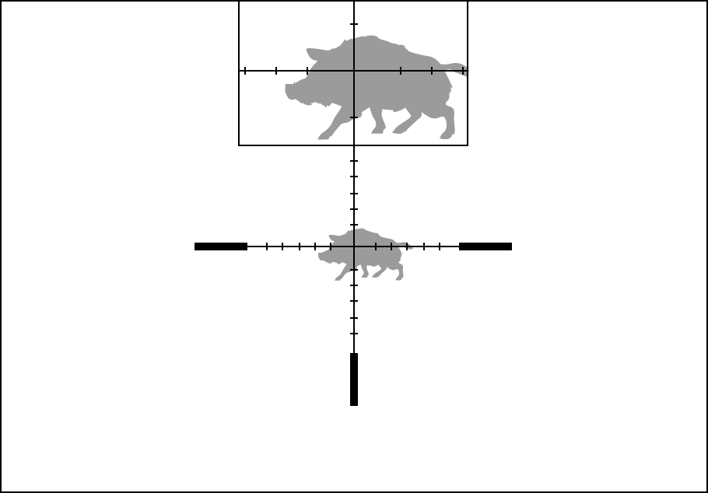
- Press and hold the ZOOM (5) button to turn on/off the PiP function.
- To change the digital zoom in the PiP window, briefly press the ZOOM (5) button or rotate the controller ring (6) until the icon is visible on the screen .
- The magnified image is displayed in a particular dialog box, with the full magnification being used.
- The rest of the image is displayed only with the optical zoom (digital zoom is off).
- When PiP is turned off, the display shows the full magnification set for the PiP mode.

Display-Off Function
This function deactivates the image transmission to the display by minimizing its brightness. This helps prevent accidental disclosure. However, the device stays on.
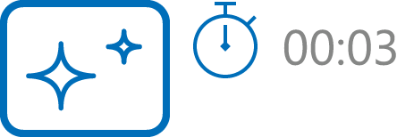

- When the device is on, press and hold the ON/OFF (3) button for less than 3 seconds. The display will turn off, the current time and the "Display off" icon will appear.
- Press the ON/OFF (3) button briefly to turn on the display.
- When you press and hold the ON/OFF (3) button, the display shows the "Display off" icon with a countdown. Holding the button down for the duration of the countdown will power the device off completely.

Wi-Fi Function
The riflescope has a function for wireless communication with mobile devices (smartphone or tablet) via Wi-Fi.
- To enable the wireless module, enter the main menu by long pressing the controller button (6).
- Rotate the controller ring (6) to select the Wi-Fi Activation menu item.
- Press the controller button (6) briefly to turn on/off Wi-Fi module.
Wi-Fi is displayed in the status bar as follows:
Indication in the Status Bar | Connection Status
 | Wi-Fi is switched off
 | Wi-Fi is switched on by the user, Wi-Fi connection in the riflescope is in progress.
 | Wi-Fi is switched on, there is no connection to the riflescope
 | Wi-Fi is switched on, there is connection to the riflescope
- An external device recognizes the riflescope under the name Digex_XXXX, where XXXX are the four last digits of the serial number.
- After entering the password (default: 12345678) on a mobile (see Password Setup subsection of the Wi-Fi Settings section for more information on setting a password) and setting up a connection, the icon in the riflescope status bar changes to .

Smart Reticle Function
Available for scalable reticles X51Fi-300, M56Fi, M57Fi.
When changing the riflescope digital magnification, the reticle that appears on the display is scaled; the reticle appearance will change (enlarge or reduce) proportionally to the magnification. It allows the use of the rangefinder reticles with any digital magnification.

Scalable Reticles
This function is designed to preserve ballistic properties of the scalable reticles X51Fi-300, M56Fi, M57Fi for all magnifications.
- Enter the main menu with a long press of the controller button (6).
- Enter submenu Reticle & zeroing 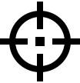 -> Reticle Type .
- Select the reticle X51Fi-300, M56Fi, M57Fi.
Please find the available scalable reticles in the catalogue in the Downloads section on our website).

Notes:
- When zooming in and out the image, the selected reticle on the display and in the recorded video changes its geometrical size according to the magnification selected.
- The reticle scale changes both on the main display and in the PiP mode.

Stadiametric Rangefinder
Thr night vision digital riflescope is equipped with a stadiametric rangefinder, allowing you to determine the approximate distance to an object if its size is known.
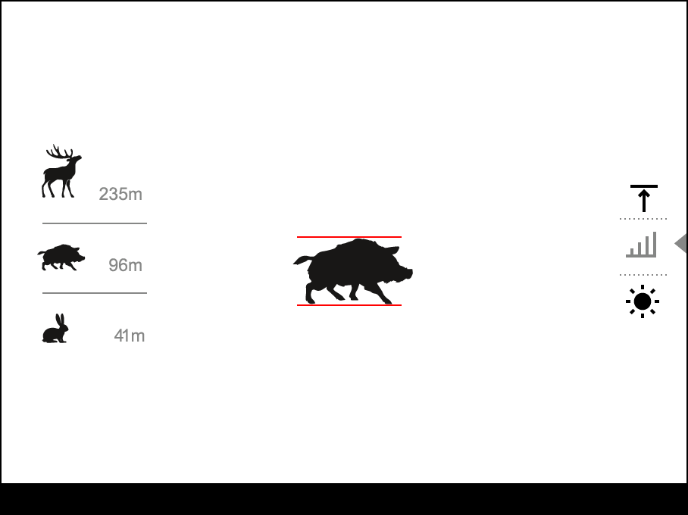

- To select the Stadiametric Rangefinder function, enter the Quick Menu by briefly pressing the controller button (6).
- Press the controller button (6) briefly to select the icon .
- The display will show the lines for measurements, the icons and numbers of the measured distance for three objects.
- Place the bottom fixed line under the object.
- Rotate the controller ring (6) to move the upper line relative to the lower horizontal fixed line so that the object is located directly between the lines. A target range automatically recalculated along with movement.
- To exit the rangefinder mode, briefly press the controller button (6) or wait 10 seconds to exit automatically.

Notes:
- There are three predefined values for objects: Hare – 0.3 m high, Boar – 0.7 m high, Deer – 1.7 m high.
- The measured range value is rounded off before being displayed – for large range values up to 5 m, for shorter range – up to 1 m.
- To select a unit of measurement (meters or yards), go to the General Settings menu item => Units of Measure submenu.

USB Connection
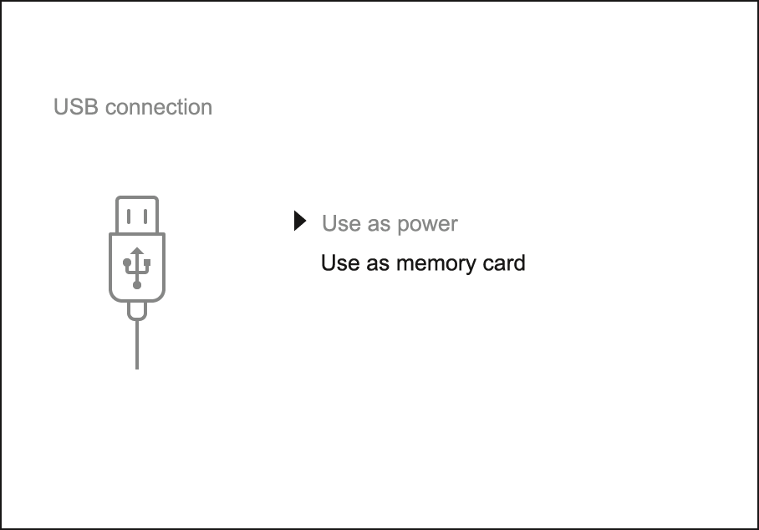
- Press the ON/OFF (3) button briefly to power the riflescope on (the computer will not detect the riflescope if it is turned off).
- Connect one end of the USB cable to the riflescope micro USB Type-C (10) and the other one to the port on your computer.
- The riflescope is detected by the computer automatically and no installation of drivers is required.
- After a few seconds, two connection options appear on the display: Power and Memory card.
- Rotate the controller ring (6) to select the connection mode.
- Press the controller button (6) briefly to confirm your selection.

Power
- Upon choosing this mode, your PC is used as an external power supply. An icon will appear in the status bar.
- The riflescope continues operating and all functions are accessible.
- Battery recharge feasibility depends on your computer's USB port.

Memory Card
- When selecting this mode, the computer recognizes the riflescope as a memory card. This mode is designed to manage the files saved in riflescope’s memory.
- The riflescope’s functions are not available in this mode; the riflescope turns on. The device continues to operate after being disconnected from the computer.
- If a video was being recorded at the moment of connection, the recording will stop and will be saved.

USB Disconnection
- When the USB is disconnected from the riflescope connected in the Power mode, the riflescope continues to operate on battery packs when they are sufficiently charged.
- When the USB is disconnected from the riflescope connected in the Memory Card mode, the riflescope remains switched on.

Software

Stream Vision 2
Install the Stream Vision 2 application to download files, update firmware, control the device by remote control and broadcast images from your device to a smartphone or a tablet via WiFi.
We recommend using the latest version – Stream Vision 2.

You can find further guidelines on Stream Vision 2 here.
Download from Google Play
Download from App Store
Find answers to frequently asked questions about using Stream Vision 2 here.

Firmware Update
- Download free Stream Vision 2 App in Google Play or App Store.
- Connect your Pulsar device to your mobile device (smartphone or tablet).
- Launch Stream Vision 2 and go to section “Settings”.
- Select your Pulsar device and press “Check firmware update”.
- Wait for the update to download and install. Pulsar device will reboot and will be ready to operate.
Important:
- if your Pulsar device is connected to phone, please turn on mobile data transfer (GPRS/3G/4G) to download update;
- if your Pulsar device is not connected to your phone but is already listed in “Settings” > “My devices” section, you may use Wi-Fi to download update.

Is your firmware up to date?
Click here to check the latest firmware for your device.

Maintenance

Technical Inspection
It is recommended to carry out a technical inspection each time before using the riflescope. Check the following:
- The riflescope appearance (there should be no cracks on the body).
- The state of the objective lenses, eyepiece and IR illuminator (there should be no cracks, greasy spots, dirt or other deposits).
- The state of the battery pack (must be charged to a level of 50-70%) and the electric contacts within it (there should be no signs of salts or oxidation).
- The controls should be in working order.

Technical Maintenance
The maintenance should be carried out at least twice a year and includes the following steps:
- Wipe the exterior surfaces of metal and plastic parts off dust and dirt with a cotton cloth. To avoid damage to the paint coating, do not use chemically active substances, solvents, etc.
- Clean the electrical contacts of the battery and battery slot on the riflescope and IR illuminator using a non-greasy organic solvent.
- Check the lenses of the eyepiece, objective and IR illuminator. If necessary, remove dust and sand from the optics (it is preferable to use a non-contact method). Cleaning of the exterior surfaces of the optics should be done with cleaners designed especially for this purpose.

Troubleshooting

The riflescope will not turn on
Possible cause
The Battery Pack is empty.
Solution
Charge the Battery Pack.

The riflescope will not operate on external power supply
Possible cause
USB cable is damaged.
Solution
Replace USB cable.

Possible cause
The external power supply is discharged.
Solution
Charge the external power supply.

The reticle is blurred and cannot be focused with the dioptre ring
Possible cause
The dioptre adjustment range is not enough for your eyesight.
Solution
If you wear glasses with a range of -3/+5, keep glasses on when looking through the eyepiece.

Possible cause
Condensation on the external surface of the eyepiece lens.
Solution
Wipe the lens with a cloth.

Coloured lines appeared on display or image has disappeared
Possible cause
The device was exposed to static electricity during operation.
Solution
After exposure to static electricity, the device may either reboot automatically, or require turning off and on again.

The image is too dark
Possible cause
Brightness or contrast level is too low.
Solution
Adjust the brightness or contrast in the Quick Menu.

Possible cause
The aperture is closed during night observation.
Solution
Open the aperture by turning the control ring to the position .

With a crisp image of the reticle, the image of the observed target that is at least 30 m away is blurred
Possible cause
Dust and condensate are covering the outside or inside optical surfaces.
Solution
Wipe the outer surface of the objective lens with a soft cotton cloth. Dry the riflescope. Let it stand for four hours in a warm room.

Possible cause
The lens is not focused.
Solution
Adjust the image sharpness by rotating the lens focus ring.

The point of impact shifts after firing rounds
Possible cause
The riflescope is not mounted securely or the mount was not fixed with thread sealant.
Solution
Check that the riflescope has been securely mounted.
Make sure that the same type and calibre bullets are being used as when the scope was initially zeroed.
If your riflescope was zeroed during the summer, and is now being used in the winter (or the other way round), in the day or night, a slight shift of the aiming point is possible.

The riflescope will not focus
Possible cause
Wrong settings.
Solution
Adjust the riflescope according to the Powering on and Image Setting section. Check the outer surfaces of the objective lenses and eyepiece and, where necessary, wipe them from dust, condensation, frost, etc. In cold weather, you can use special anti-fogging coatings (e.g., the same as for corrective glasses).

Smartphone or tablet cannot be connected to the riflescope
Possible cause
Password in the riflescope was changed.
Solution
Delete network and connect again inserting the password saved in the riflescope.

Possible cause
There are too many Wi-Fi networks in the area where the riflescope is located which may cause signal interference. Problems described may arise in adverse weather conditions (snow, rain, fog etc.).
Solution
To ensure stable Wi-Fi performance, move the riflescope to an area with few or no Wi-Fi networks.

Possible cause
The device has a 5 GHz network enabled, but the smartphone only supports 2.4 GHz.
Solution
Switch the device's WiFi bandwidth to 2.4 GHz.

Wi-Fi signal is missing or interrupted
Possible cause
Smartphone or tablet is out of range of a strong Wi-Fi signal. There are obstacles between the device and the smartphone or tablet (e.g., concrete walls).
Solution
Relocate smartphone or tablet into the Wi-Fi signal line of sight.

Poor image quality/ Reduced detection distance
Possible cause
These problems may occur during the observation in adverse weather conditions (snow, rain, fog etc.).

There are several light or black dots (pixels) on riflescope’s display or sensor
Solution
Presence of dots is caused by peculiarities of sensor or display production technology and is not a defect.

Legal Compliances and Disclaimers
Attention! Digex digital riflescopes require a licence when exported outside your country.
Electromagnetic compatibility. This product complies with the requirements of European standard EN 55032: 2015, Class A.
Caution: Operating this product in a residential area may cause radio interference.
Improvements may be made to the design of this product to enhance its user features.
Repair of the device is possible within 5 years.

